**Sheerwater Regeneration Project**

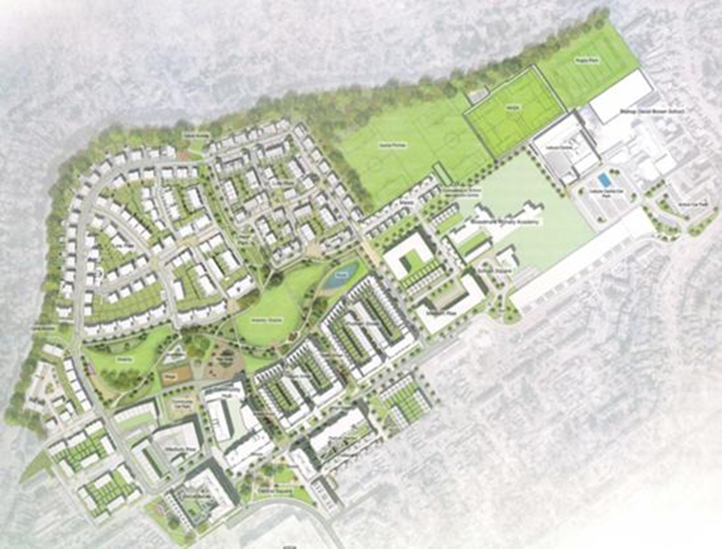

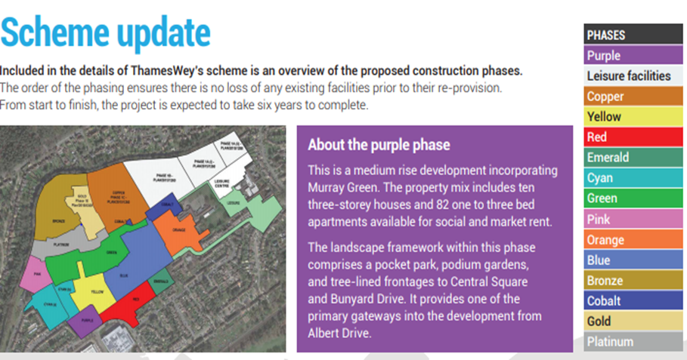

**Sheerwater Health Centre currently located in Green phase and proposal to be relocated to Yellow Phase in 2023**

**Impact of Sheerwater Regeneration Project on Sheerwater Health Centre**

1 Sheerwater Health Centre is located in a part of Woking which has been undergoing a significant regeneration project over a number of years [1]. During this ongoing process a significant number of people have been relocated and as a result, the list size of the practice has suffered.

2 With the help of North West Surrey CCG, we produced a business case for compensating the practice income as a result of reduced patient numbers [2]. To justify the loss of income, the practice used information published by NHS England for income paid to the practice per registered patient.

3 After much persuasion, the Woking Borough Council admitted that the practice had suffered as a result of the regeneration programme and paid the practice a sum of £45,780 claimed as loss of income to end of December 2019

*“The Council acknowledges that there has been a gradual decline in patient numbers registered at the Practice, albeit with a time lag, as residents move to homes outside of the development area.  This reduction in turn results in a loss to the Practice of the revenue from the NHS, whose payments are (in the main) calculated on a ‘per registered patient’ basis.*

*We have now considered your revised Business Case, V3 dated October 2019, and decided to pay the full amount of £45,780 as requested.  As stated in my email below, the Council will provide the premises rent free to the Practice for two years from 14 October 2019.*

*This subsidy position will be reviewed in June/July 2021, i.e., before the end of the two year rent holiday period on 14 October 2021.” - Paola Capel-Williams* (Woking Borough Council)

4 Besides loss of income, the practice is also experiencing difficulties in recruiting and retaining staff who see better working environment in neighbouring practices. With ongoing building works in virtually all directions of the surgery, there is also concern for patient and staff safety particularly when the days go shorter.

5 The Council expected that as building work progressed, the practice list size would rise significantly. They have only managed to build 90 one-bedroom dwellings till now. Consequently, the list has only increased slowly. For the years 2020 to end of 2021, the practice loss of capitation income due to list size reduction was £93,360.

Since the Council had given rent relief, the loss reduced to £93,360 - £56,550 (rent) or **£36,810**. The Council are refusing to pay this amount and are expecting the practice to justify the impact of this on practice accounts which we are clearly not willing to do. Below is a letter we received from the Council following a meeting we had with them

*“Following our meeting regarding your loss of profit claim and request for a business rate support I unfortunately have to report that we currently cannot support this.*

*A payment purely based on a loss of income is not something we can consider and would need a full and transparent view of your accounts to understand what mitigating measures were taken to reduce the losses in profit once you knew that patients numbers were dropping. Once we know this shortfall a grant may be possible especially if it can be demonstrated that a reduction in service may occur without any funding.*

*I apologise that it has taken some time to come back to you with this answer and we would very happy to meet again to go through the accounts in more detail if you so wish.” – Steve May* (Woking Borough Council)

6 WBC are aware that our list is open. In fact, WBC had put an advertisement for Sheerwater in one of their regeneration newsletters.

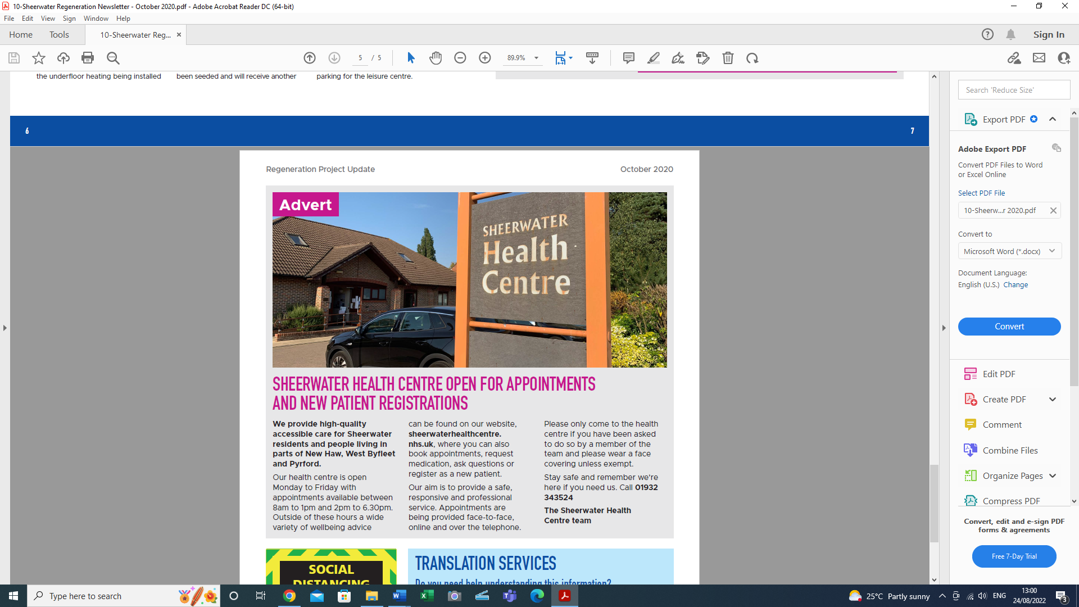

7 We wrote to Julie Fisher, the CEO of Woking Borough Council but we have not had any success in getting the financial compensation.

8 The CCG have suggested seeking help from the LMC and the ward borough councillors. We are in touch with the councillors and hope to pursue this matter further.

9 We would very much like the LMC to support us in obtaining financial compensation from the Council who is responsible for the losses we have suffered and continue to do so until perhaps we move to the new surgery premises. How should we proceed forward?

If you require any further information, please let us know

You are most welcome to visit/meet at the practice premises to see for yourselves the difficult conditions we have to endure daily during the regeneration programme of works.

**References**

1 Sheerwater Regeneration Programme

<https://www.woking.gov.uk/major-developments/sheerwater-regeneration-project-0>

2 Business Case – Impact of Sheerwater Regeneration Project on Sheerwater Health Centre, prepared by Sheerwater Health Centre, August 2019 - revised October 2019 v3