**Business Case – Impact of Sheerwater Regeneration Project on Sheerwater Health Centre**

**Prepared by: Sheerwater Health Centre**

**For: Woking Borough Council**

**Purpose: Options for Supporting Sheerwater Health Centre**

**August 2019 - revised October 2019 v3**

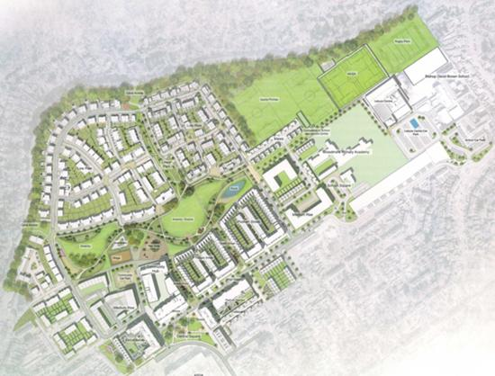

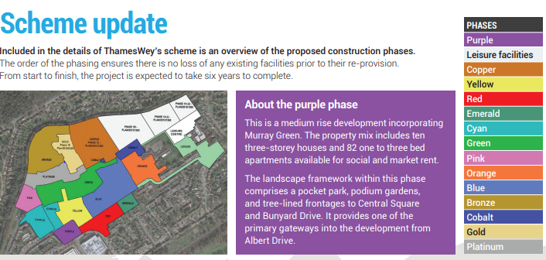

**\*Sheerwater Health Centre currently located in Green phase and proposal to**

**be relocated to Yellow Phase in 2023**

**Background**

Sheerwater Regeneration Project was approved by Woking Borough Council (WBC) in 2017. The redevelopment is part of a 10-year plan to redevelop the entire Sheerwater area. Currently Sheerwater is primarily a council owned neighbourhood, whereas the new development will have a mix of owner occupied and social housing alongside new leisure and retail facilities.

Revised plans were approved by WBC in April 2019. The existing 576 properties will be demolished over a number of phases spanning six years. Outline planning consent has been granted for 1,142 new homes – a mix of one bedroom to five bedroom homes.

The first phase, including 92 properties and new leisure facilities, has commenced and will take approximately two years to complete. The existing GP practice is due to move to a new site in 2023.

**Impact of development on Sheerwater Health Centre**

The practice understood that current Sheerwater residents would be relocated within the development as the new housing was being built, retaining as many residents as possible. However, many residents have been rehoused in other areas of Woking and their properties have remained vacant. The population of Sheerwater is therefore declining and is likely to reduce further in the short term.

GP practices are paid per patient, so the declining population has a direct effect on practice income and could threaten the sustainability of the practice. In addition to the declining income, the area has changed in character as residents have been rehoused. There is a large and growing number of empty and boarded up properties which has had a negative impact on the area and has led to issues with staff recruitment and retention in the practice.

In addition the practice is incurring additional travel time for GPs attending house calls to patients that have moved away but have remained registered at the practice.

The practice is concerned about their sustainability over the course of the development.

**Patient Calculation Information**

Calculations to show loss of practice income as a result of decreasing practice list size.

1. Fig 1 shows the numbers of patients registered at the practice since 2015
2. Fig 2 shows the trend in list size before work commenced on the regeneration. The list size was steadily rising, leading to increased income for the practice
3. Fig 3 shows the reversal of this trend since the regeneration project received planning permission in 2017. The practice’s list size has been steadily declining since this date, with a subsequent reduction in income.
4. Table 1 shows the practice income over this time. Column 3 shows the payments to the practice, at £120 per patient. Payments to all practices in England are published annually by NHS England (see Annex).

Column 3 shows that payments have been steadily declining with time.

Column 4 shows the income if list size had remained constant at 3224. This is a reasonable assumption as this value would be increasing with time under normal circumstances.

Column 5 shows the loss of income as a result of reduced list size.

The combined loss to date is £45,780.

Fig 1: Practice list size variation with time

**Fig 2:**

**Fig 3:**

**Table 1:**



**Impact to the Practice - sustainability**

Once the development is complete the practice list size will recover, and will grow from the impact of the increased number of homes. However, in the six year period whilst the development is being built, practice income will be adversely affected.

**Business options**

**Option 1 – Do Nothing**

If no action is taken to support the practice financially its income will continue to decline.

**Risks**

1. The practice may not be financially viable and may close. Remaining residents will have to register at other practices locally, which may cause pressure on surrounding practices. As phases of the development is completed, there will be no GP practice on site for patients to register with, so they will have to register with practices further away.
2. If the practice closes the current premises will be difficult to rent to an alternative tenant and will likely remain empty until it is demolished.
3. When the development is completed there will be no existing practice to move into the new health centre.
4. Commissioning a new primary care service to move into the new health centre may not be straightforward. The local commissioner of primary care may either have to:
   1. commission a new primary care contract – this may not be straightforward as there will not be an existing patient list to make the new health centre attractive to a provider.
   2. encourage an existing local GP practice to open a branch surgery – branch surgeries often present logistical and financial issues for GP practices and local surgeries may not have the appetite to expand.

Alternatively, the commissioner may decide that a new service is not required, as patients will have registered at alternative practices. In this case the new development will be without a health provider and will have an unused healthcare facility.

**Benefits**

1. There is no cost to WBC for this option.

**Option 2 – WBC support Sheerwater via a rent holiday on the current premises**

Table 1 shows that the practice has already suffered income loss of £28,950. If the practice is able to stay in its current premises rent-free until the new health centre is built it would enable the practice to remain financially viable in this interim period, provided that the list size does not decline steeply in the near future.

**Risks**

1. There is cost to WBC - £28,120 per annum (rental costs), £7,266 per annum (rates).

**Benefits**

1. Ensures the continuity of the current practice, which is beneficial to its existing patients, many of whom are amongst the most deprived patients in Woking borough.
2. Ensures there is a local GP practice for patients in the early phases of the development to register with, before the new health centre is built
3. Ensures there is a GP practice willing to move into the new health centre once built, providing local health services to the new development, making it a more attractive proposition to potential new residents.

**Practice Preferred Option**

A joint commitment from WBC and NWS CCG to support the practice to ensure health services are available and provided to the registered population of Sheerwater.

Due to the upheaval and relocation of the residents in this area throughout the redevelopment project, and therefore financial destabilisation of the practice, year on year, WBC could commit to providing the practice rent relief for the duration of the redevelopment.

This would assist the practice with staffing issues, additional travel for possible home visits and help to stabilise the financial aspect with regard to patient population decline during the demolition and construction.

**Acknowledgement**

Assistance from NWS CCG in preparing this report is gratefully acknowledged.

**Annex – Justification for using £120 per patient payment**

NHS payments per patient are published annually [1] [2] [3] [4] [5]

The table below shows the average payments per registered patient for Sheerwater Health Centre [1]-[5]. The average payments per registered patient over the last five and three years are respectively £125.48 and £130.92 respectively.

|  |  |  |  |  |
| --- | --- | --- | --- | --- |
| **Year** | **Quarter used for patient data** | **Number of registered patients** | **Average payment per registered patient** | **Average payment per weighted patient** |
| 2014/15 | Q2 | 3146 | £120.26 | £122.27 |
| 2015/16 | Q2 | 3241 | £121.65 | £126.00 |
| 2016/17 | Q4 | 3228 | £123.89 | £129.71 |
| 2017/18 | Q4 | 3160 | £138.13 | £145.66 |
| 2018/19 | Q4 | 3099 | £123.49 | £130.96 |

**Reference 1**

<https://digital.nhs.uk/data-and-information/publications/statistical/nhs-payments-to-general-practice/nhs-payments-to-general-practice-england-2014-15#key-facts>

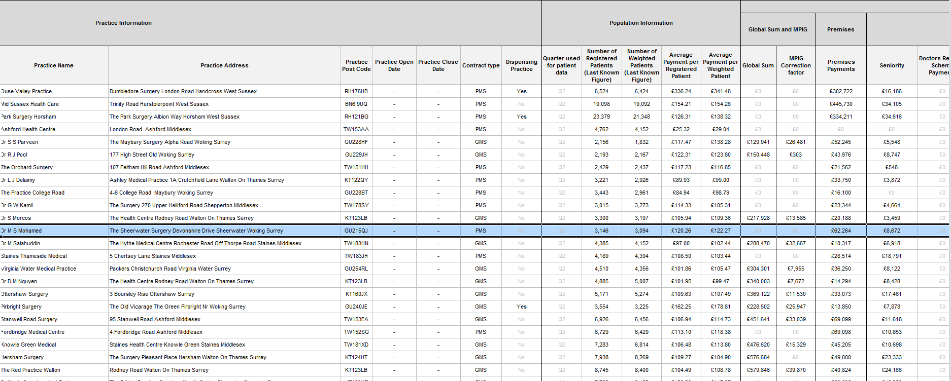

**Reference 2**

<https://digital.nhs.uk/data-and-information/publications/statistical/nhs-payments-to-general-practice/nhs-payments-to-general-practice-england-2015-16#key-facts>

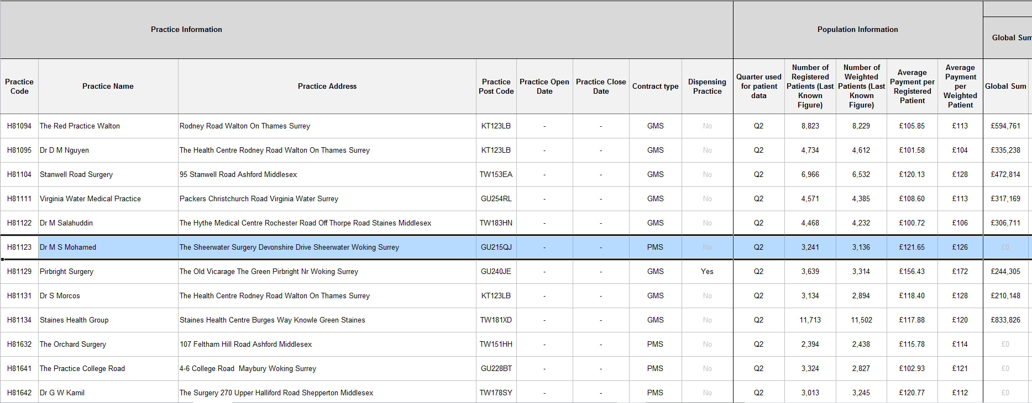

**Reference 3**

<https://digital.nhs.uk/data-and-information/publications/statistical/nhs-payments-to-general-practice/nhs-payments-to-general-practice-england-2016-17#key-facts>

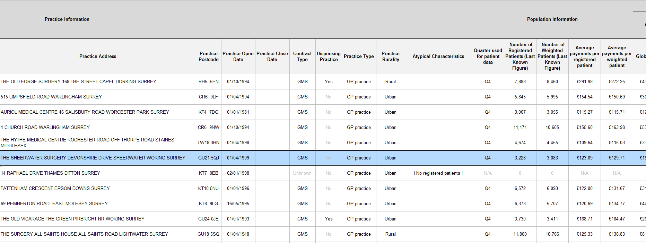

**Reference 4**

<https://digital.nhs.uk/data-and-information/publications/statistical/nhs-payments-to-general-practice/england-2017-18>

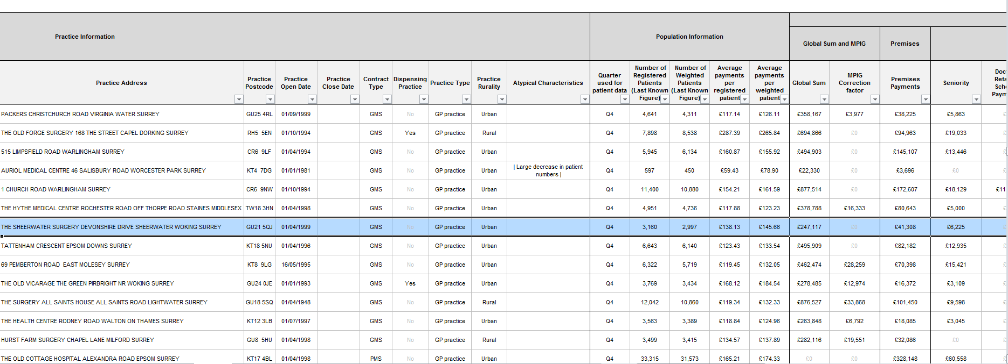

**Reference 5**

<https://digital.nhs.uk/data-and-information/publications/statistical/nhs-payments-to-general-practice/england-2018-19>

