Allergies, Intolerances and Sensitivities Guidance Document

Version: | Review date: | Edited by: | Approved by: | Comments:
v1.4 | 20/03/2024 | Sultan Mohamed | Munira Mohamed
 | April 2026 |  |  | Next review

Table of contents
1 Introduction 2
1.1 Guidance statement 2
1.2 Status 2
2 Allergies 2
2.1 Definition 2
2.2 Latex 2
2.3 Cleaning products 3
2.4 Foodstuffs 3
2.5 Medicines in first aid kits 3
2.6 Staff with allergies 3
2.7 Patients with allergies 4
3 Sensitivity 4
3.1 Sensitivity 4
4 Intolerance 4
4.1 Causes of intolerance 4
5 Anaphylaxis 5
5.1 Definition 5
5.2 Recognition 5
5.3 Triggers 5
5.4 Treatment 6
6 Yellow Card reporting site 6
6.1 Reporting side effects 6

Introduction

Guidance statement

This policy is to ensure that staff and patients at Sheerwater Health Centre are protected from any potential exposure to allergic reactions that may cause severe harm such as anaphylaxis.

To ensure that staff and patient safety is maintained, the organisation will conduct the appropriate risk assessments (including COSHH) to protect individuals who may encounter products that could cause an allergic reaction.

Status

The organisation aims to design and implement policies and procedures that meet the diverse needs of our service and workforce, ensuring that none are placed at a disadvantage over others, in accordance with the Equality Act 2010. Consideration has been given to the impact this policy might have regarding the individual protected characteristics of those to whom it applies.

This document and any procedures contained within it are non-contractual and may be modified or withdrawn at any time. For the avoidance of doubt, it does not form part of your contract of employment. Furthermore, this document applies to all employees of the organisation and other individuals performing functions in relation to the organisation such as agency workers, locums and contractors.

Allergies

Definition

NHS Leeds Teaching Hospital defines allergy as an over-reaction of the immune system to a food or substance in the environment (called an allergen) which would be otherwise harmless to most people. The body recognises the allergen as a threat and produces antibodies to remember the allergen.

In an allergic reaction, the antibodies recognise the allergen and trigger the immune system to react. Common allergens include foods, pollens, dust mites, mould, animal dander, medication, latex and venom.

Latex

The most common item to be found in the organisation that can give rise to an allergic reaction is latex. Latex can be found in products such as examination gloves, tourniquets, BP cuffs etc. Guidance on the use of latex gloves can be found in the National Infection Prevention and Control Manual for England and on the HSE website.

Cleaning products

Commonly used cleaning materials such as furniture polish, disinfectants, all-purpose cleaners, detergents, soaps and disinfectants may often contain several chemicals that can cause an allergic reaction.

A risk assessment is carried out on the cleaning materials used to ensure that they do not cause an allergic reaction to the user. Cleaning staff are to be instructed on the potential hazards of all cleaning materials that are used at this organisation.

Foodstuffs

Should the organisation provide food for its employees, it is a requirement for the organisation to then ensure that any potential allergen contained in that food is highlighted to its employees.

Employees who have known food allergies also have a responsibility to take the necessary precautions to ensure that they do not consume any food provided to which they know they have an allergy. Additionally, they are responsible for carrying their EpiPen as part of their reaction plan.

Particular care should be taken when employees contribute food that they may have cooked or purchased themselves. Often the packaging that warns of any potential allergen may have been discarded and baked products would not ordinarily be labelled.

Shared food preparation, storage and eating areas carry a risk if patients or staff have a severe allergy. Under Health and Safety Law, employers must “so far as reasonably practicable” protect the health and safety of employees by removing or reducing workplace risks.

Additional information can be found in Anaphylaxis UK’s Managing Allergens in the Workplace guidance document.

Medicines in first aid kits

In accordance with the British Standard (BS8599-1) for first aid kits and HSE First aid at work regulations, first aid kits should not contain any medicines such as aspirin, paracetamol or ibuprofen that may give rise to an allergic reaction.

Hypoallergenic plasters are a preferred form of plaster due to the associated risk of an allergy to an ‘Elastoplast’ type plaster. If in doubt, the person being treated should be asked whether they are allergic to plasters before any are applied.

Further information can be sought within the First Aid Policy.

Staff with allergies

Staff who become symptomatic should be referred to the local occupational health team. Members of staff diagnosed as having an allergy will require a risk assessment to be undertaken. Once the source of the reaction has been identified, all reasonably practicable measures will be taken to remove the source and prevent further reactions.

Patients with allergies

Patients with a known allergy will have this information recorded in their medical record. If a patient reports a reaction to staff, post-procedure or examination, it may be necessary (depending upon the severity) to refer the patient to a dermatologist and, if they are diagnosed as having an allergy, their healthcare record will be updated accordingly.

Sensitivity

Sensitivity

Sensitivity is the body’s reaction to the normal side effects produced by a substance. While a sensitivity does not trigger an immune system response, it may cause symptoms such as fatigue, a feeling of being unwell, lack of concentration, headaches and other symptoms.

Intolerance

Causes of intolerance

Intolerance can be defined as the inability to properly metabolise or absorb a substance, such as food or medication. The following are common causes of intolerances:

- Alcohol
- Caffeine
- Gluten
- Histamine
- Lactose
- Medications
- Monosodium glutamate
- Salicylates
- Sulphites

Clinicians at this organisation must follow the approved diagnosis and treatment pathways when assessing and treating patients with suspected food or medication intolerance.

Anaphylaxis

Definition

NICE Clinical guideline CG134 defines anaphylaxis as a severe, life-threatening, generalised or systemic hypersensitivity reaction.

Recognition

A diagnosis of anaphylaxis is likely if a patient who is exposed to a trigger develops a sudden illness with rapidly progressing skin changes (flushing, urticaria or angioedema) and life-threatening airway and/or breathing and/or circulation problems.

Triggers

Anaphylaxis has several triggers as detailed in the Resuscitation Council UK (RCUK) image below:

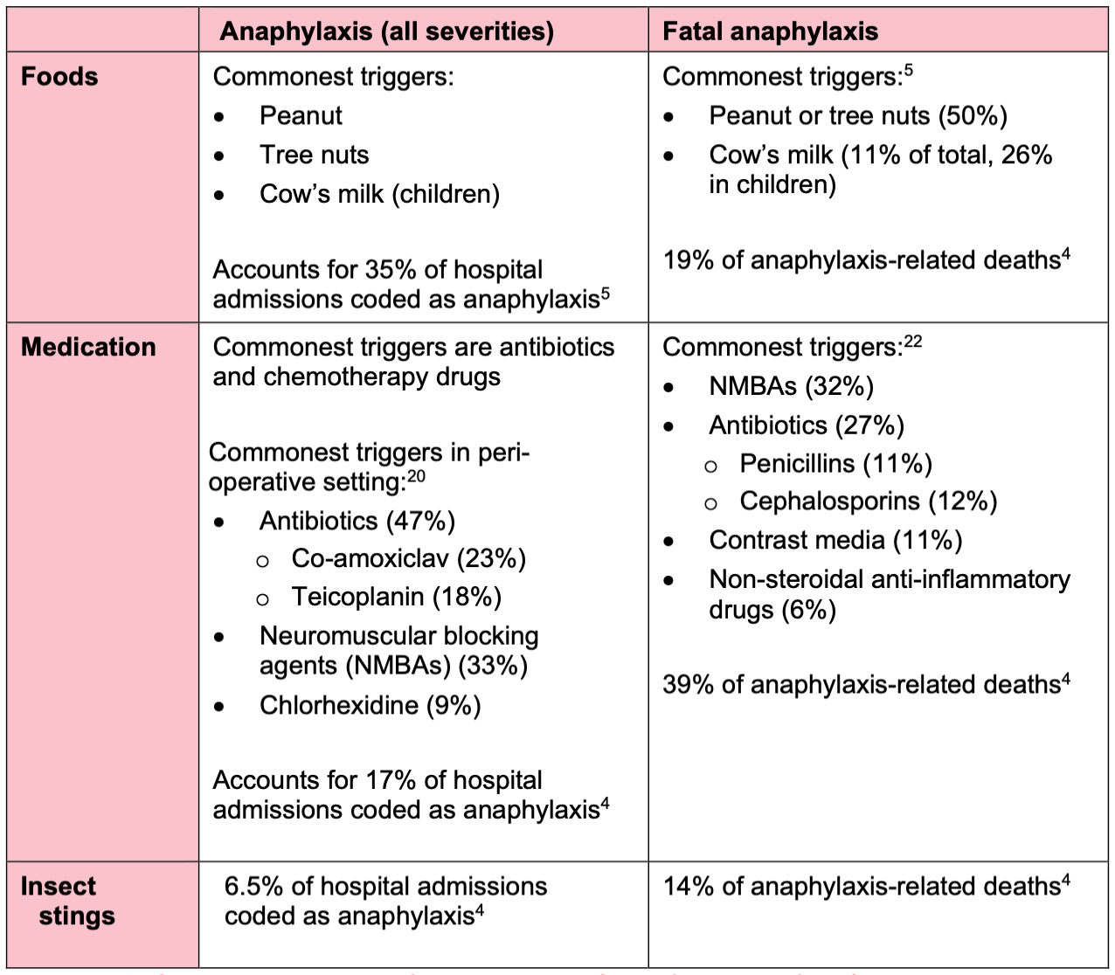

Treatment

Treatment of anaphylaxis is illustrated in the RCUK anaphylaxis algorithm.

Anaphylaxis training is available on e-learning platform Blue Stream Academy.

Yellow Card reporting site

Reporting side effects

Should an individual experience side effects to medicines or vaccines, this should be reporting to the Medicines and Healthcare products Regulatory Agency using the Yellow Card reporting site.

