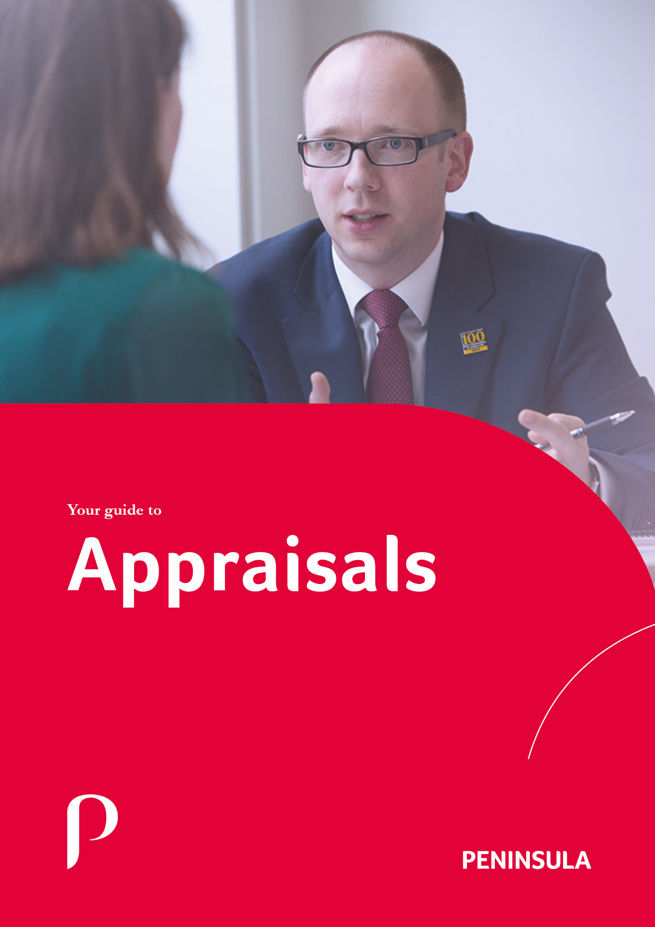

# Contents

Contents 1

Introduction 2

Benefits of Appraisals 3

Why do Appraisals? 4

Objectives 5

The Procedure 6

Preparation for Appraisal 7

How to Complete the Preparation Form 8

The Appraisal Interview 9

Completion of Performance Appraisal Form 10

After the Interview 11

# Introduction

The successful operation of any company depends primarily on using the full potential of its workforce.

This necessitates certain criteria being met which are to the benefit of both you, the employee, and the company and requires a strategy to be put in operation to achieve this aim.

Both Supervisors and staff have to be aware of the requirements of the individual job. This is best served by having a Job Description for your job.

Supervisors have to be able to identify the development needs of the company and their employees. To meet this aim there is a requirement for Supervisors to carry out a formal appraisal scheme.

Appraisals should be made up of four elements, namely:

|  |  |
| --- | --- |
| Preparation for appraisals | By employee |
| Appraisal form completion | By appraiser |
| Appraisal interview | Appraiser and employee |
| Actions plans | Agreed between appraiser and employee |

The most important asset that a company has is its employees.

The interests of the company and its clients/customers are best served by a workforce, which as individuals and a team, are carrying out their tasks to the most effective performance level.

This is what performance appraisals are seeking to achieve and why they can have an impact on employees and company performance.

Supervisors and the employee should be working together to achieve the aims of that employee being better equipped for his/her present or future roles within the company.

This booklet has been produced to inform employees of what appraisals are, why they are needed and what the procedures are in operating an appraisal scheme.

It identifies all aspects of the company's appraisal scheme, particularly the input by you (as an employee) in the completion of a Preparation for Appraisal Form (Self- Appraisal) prior to your appraisal interview.

The purpose of an appraisal scheme is a recognition by the company of the need to maximise the use of its human resources, to aid the development of its employees and the business.

For performance appraisal to be effective it requires us all to play our part:

1. Supervisors are required to give full commitment to the scheme by allowing time for preparation, discussion and monitoring but, above all, to be clear about its objectives.
2. You equally need to be fully committed to the scheme by allowing time for honest and frank completion a Preparation for Appraisal Form.

The overall objective of the scheme is one of being **POSITIVE, NOT NEGATIVE**, namely:

TO IMPROVE THE EMPLOYEE'S CURRENT JOB PERFORMANCE AND FUTURE DEVELOPMENT AND THEREBY THE PERFORMANCE OF THE COMPANY SO THAT BOTH BENEFIT

# Benefits of Appraisals

Appraisals record an assessment of an employee's performance, potential and development needs. They are an opportunity for discussion to take place regularly, in a formal manner, on the overall view of work, content and volume and to review what has been achieved during the last appraisal period and to agree objectives for the next.

Appraisals are not implemented solely for the benefit of the individual, but are a means of improving the performance of the whole company. By improving all round job performance, job satisfaction, improved communication and understanding, increased awareness and participation, better planning and co-ordination, the business will be in a position to provide **an improved service for our clients.**

It will also assist in developing employees for future roles within the company, especially in times of growth.

# Why do Appraisals?

The system of appraisal will provide the means for you and your supervisor to jointly review your performance and in doing so it will:

1. Help improve your future job performance by identifying strengths and weaknesses and determining how strengths can best be utilised and how weaknesses can be overcome.
2. Help reveal problems which may be restricting your progress and causing inefficient work practices.
3. Encourage regular dialogue between yourself and your supervisor about your work performance which will result in improved communications and clearer direction.
4. Develop a greater degree of consistency by ensuring that you and your supervisor meet formally and regularly to discuss performance and potential.
5. Assist succession planning and determine your suitability for promotion.
6. Move away from us reacting to an event into preparing for the event.

The purpose of this scheme is to:

1. Ensure an understanding and awareness of your/the business objectives and the barriers preventing their achievement.
2. Develop a knowledge and agreement of what is expected from you and how your contribution fits into the organisation.
3. Review your performance, giving a formal opportunity to discuss progress and identify improvements and build on strengths.
4. Review potential development needs and to predict your future capabilities and how these can be developed.
5. Review progression and to assess your eligibility to achieve promotion.
6. Develop you so that job satisfaction and job performance is maximised, thus increasing effectiveness and efficiency resulting in the provision of an improved service for our clients/customers.
7. Ensure we use our workforce in the most effective way.

# Objectives

The most potent factor in achieving our overall objective is the development and maintenance of an open relationship between you and your immediate Supervisor (Appraiser). There is, nevertheless, a need to summarise this in a formal way, by ensuring that you discuss your job performance, in terms of:

What are the most important parts of their job?

* What are the most important parts of your job?
* Which parts of the job they have done well and why?
* What can be done to build on their strengths?
* What they have not done so well and why?
* What action can be taken to overcome these shortcomings?
* Achievement or non-achievement of their current targets.
* Agreement on their future targets.
* Define an action plan for the future setting further targets.

# 

# The Procedure

The person who is responsible for conducting your appraisal (the Appraiser) will see you, and:

1. Ensure that you have a copy of the required documentation and suggest that you read it thoroughly.
2. Give you a Preparation for Appraisal Form, asking you to complete it and return it within two weeks.
3. Give any further guidance or clarification on any aspect of the appraisal scheme which you may want.
4. Arrange a mutually convenient date, time and place for the appraisal interview (about four weeks after the Preparation for Appraisal Form is returned to your Appraiser).

You need to complete your Preparation for Appraisal Form, and return this as agreed to your Appraiser.

The appraisal interview will be conducted and the Performance Appraisal Form completed. Amendments to the job description can also be discussed and made at this time.

After the appraisal interview the outcome will be put in writing including any objectives for the next period. This will be saved on file for future reference with the completed appraisal form.

If any dates are specified on the Action Plan Letter with regards actions you should meet with your Appraiser, and together review the agreed actions.

# Preparation for Appraisal

Before completing the Preparation for Appraisal Form, you should read the "explanatory notes" on the front page of the form.

The benefits of completing the Preparation for Appraisal Form fully and frankly are considerable.

It forms the basis for your appraisal interview as to what the job is really about, how you perform it, and what needs to be done by you, your Appraiser or the company.

It helps you and your Appraiser to get to know each other better, and to help each other with common problems. This is only true if the Preparation for Appraisal Form is fully and frankly completed. It is your opportunity to express how you think you have performed. You and your Appraiser may not agree on the answers to the questions on the Preparation for Appraisal Form. But both parties, at least, are thinking about the same questions, especially as the Performance Appraisal Form is in the same format and the same details will be discussed during the appraisal interview.

You may influence your Appraiser’s judgement of your performance. The comments on your Preparation for Appraisal Form may give your Appraiser new information or lead to a fresh consideration of your performance (either generally or in some particular matter).

Remember the Appraisal is for your benefit now and in the future, so it is in your interests to be frank and honest about your performance. If that means indicating weakness in your performance so be it.

# How to Complete the Preparation Form

You may feel that your job as described in the job description is not accurate or up to date, your appraisal interview provides an ideal opportunity to talk about and update the Job Description.

Question 1

You are asked to think about and write down what you consider you have done well over the past year. Initially, you should think about the most important areas of your job, but you may consider that a particular task, not directly within these areas, was accomplished well. This should be noted down.

To further identify things which have been done well, you should think back to when you achieved personal satisfaction or received some kind of praise or recognition, or met a particularly difficult deadline when under pressure, etc.

The second part of this question may require deeper thought. You need to think about why you performed well in the areas previously identified. You should consider how you tackled them, what skills were needed, what difficulties you had to overcome, and how eventually you accomplished the results. You should not be loath to "blow your own trumpet". It is important that you and your Appraiser are aware of your strengths.

Question 2

To answer this question about what areas of your job could have been done better over the past year, you should think initially about the most important areas of your job. You should also consider particular tasks or occasions not involved with these important areas, and note them down if you feel they could have been better achieved.

The second part of this question asks what prevented you from performing better in those areas which you have identified. Some possible reasons maybe another person's or department's influence, your lack of knowledge, time constraints, relationship with others, Company rules, etc. These are possible suggestions to help you identify the things preventing a better performance. You need to think about yourself and all the things which affect you and your job, including people (your Appraiser, peers and subordinates), your training to date, department and company matters, etc.

Question 3

This final question looks to the future. It asks you to suggest how your performance can be improved. These future actions may relate to yourself, your Appraiser or Department Manager, the company, or anyone else. Again you should try to think beyond yourself only, and consider every aspect of your job and the environment which could have had an influence on your performance.

It is particularly important when considering the answers to Questions 2 and 3 that you put down exactly what you think, however unrealistic, unimportant or unmentionable you feel your thoughts to be. You should remember that your Appraiser needs your knowledge and experience of your job difficulties, and needs your help in trying to overcome them.

When you complete your Preparation for Appraisal form remember that your appraisal is a joint process between your Appraiser and yourself. Your Preparation for Appraisal Form is part of that process. It can contribute significantly if it is completed fully and in an open committed manner.

The particular questions on the Form confine themselves to looking at strengths and weaknesses, and future action on them, but space is also provided on the Preparation for Appraisal Form for you to make a note of any other topics you may wish to raise during the appraisal interview.

# The Appraisal Interview

The appraisal interview should be a **FRANK** and **OPEN DISCUSSION**. It should not be a stressful, highly pressurised situation where the parties involved are unaware of the objectives of the interview. You and your appraiser should bear in mind that the interview should be a discussion with several purposes. These are:

* To agree what the job is really about.
* To discuss your job performance
* Your strengths, and ways of building on them both for your benefit and the company’s.
* Your shortcomings, and ways of overcoming them, as they affect both you and your department.
* To discuss the overall grading of your performance.

Remember to bring with you your Preparation for Appraisal Form.

# Completion of Performance Appraisal Form

The appraisal interview revolves around the completion of the Performance Appraisal Form by your Appraiser. Your Appraiser may ask you to sign the form to signify that you "have seen and discussed this appraisal" at the conclusion of the interview, or the Performance Appraisal Form may be completed in pencil and notes made during the interview, with the form being formally completed afterwards. You and your Appraiser will then briefly meet again for you to sign the form.

Sections 1 and 2 of the Performance Appraisal Form correspond to the questions on the Preparation for Appraisal Form. Completion of these sections follows from the discussion between you and your Appraiser, and provides the basis for the agreed future action plan.

The third section of the form is the overall grading of your performance. Having carefully considered his/her own and your view of your job performance, your Appraiser will decide which of the ratings most accurately reflects and summarises your work over that year.

It is important to understand exactly what the ratings mean, their definitions, and how they relate to an individual's performance, the department and the company. The overall performance is evaluated on a five point scale related to degrees of effectiveness (the sixth box applies to new employees or those who have been in the current job for less than three months).

Normally, about 60% of the Company's employees would be rated in the middle box - "Effective" (C). The meaning of this rating is important. It does not mean "average", "satisfactory" or a performance which is less than worthwhile. It means that the Employee is **"EFFECTIVE AND MAKING A POSITIVE AND VALUABLE CONTRIBUTION"**. To attain this standard of performance means that he/she is performing his/her total job in a competent and altogether effective manner, and is a valuable asset to the department and company.

You and your Appraiser may feel that training could provide some specific assistance to improve or build on your performance. This should be indicated in Section 4 of the Performance Appraisal Form.

Section 5 of the Performance Appraisal Form is provided for you to make any comments about your appraisal, if you so wish. You may record anything you feel regarding the discussion, the rating or any aspect of the appraisal process.

You are required to sign the Performance Appraisal Form to confirm that you "have seen and discussed this appraisal". If you wish to discuss the appraisal further, then you may request a further interview with your Appraiser or one with your Appraiser's Manager.

# After the Interview

Action Plan Letter

This should be completed by your Appraiser, either fully or in draft form, during the appraisal interview. In either case, you will receive a completed copy during or after the interview.

Normally its contents will be a summary and written confirmation of the future actions agreed upon, by you and your Appraiser, during the discussion on your "strengths" and "shortcomings". The letter also contains dates throughout the year, when you and your Appraiser should jointly review progress on the contents of this Action Plan Letter.

After The Interview

As indicated above, any dates specified on the Action Letter, you and your Appraiser should meet and review progress on the actions discussed and agreed during the appraisal interview. This means that the formal discussion of your performance ceases to be just an annual event and becomes more continuous and developing process between you and your Appraiser.

Agreed Targets & Objectives

If you are **not** already working to an Action Plan, you will receive a blank copy of the Agreed Action Plan, with your Action Plan Letter.

Your Appraiser should then explain the philosophy and mechanics of the form to you, and possibly discuss in general terms your targets/objectives. The form should be roughly completed before a further meeting is arranged to discuss, amend if necessary, and jointly formulate the Action Plan. Remember to use your previously completed Action Plan as the basis.

Reviewing and updating these targets provides another occasion for you to meet and discuss your performance with your Appraiser.

Through these means - the Preparation for Appraisal Form, the Appraisal Interview, the Action Plan Letter and the Agreed Action Plan Forms, with follow-up and revision during the year - a combined effort can be made by you and your Appraiser, to build on your job strengths and to overcome your shortcomings. Thus you can both ensure that you achieve the overall objective of our appraisal scheme, namely "to improve your current and future job performance and, thereby, the performance of the company".

**Form PREP1**

**Preparation for Appraisal**

|  |  |  |
| --- | --- | --- |
| **Name:** |  | **Date of Appraisal:** |
|  |  |  |
| **Position:** |  | **Department:** |
|  |  |  |

**The comments you make on this form are to assist in your appraisal.**

**On the Appraisal Form itself a space is provided for you to make any comment you may wish regarding your appraisal.**

**If you disagree with the outcome or are unhappy with your appraisal, discuss with your Manager for the appropriate action to be taken.**

Please consider your performance during the period under review and complete the following:-

|  |
| --- |
| **Which parts of the job have you performed best? How did you achieve this?** |
|  |

|  |
| --- |
| **Which parts of the job have you performed less well? Were there any circumstances which prevented a better performance?** |
|  |

|  |
| --- |
| **What could or should be done by you, your Appraiser, the Company, or anyone else to help improve your performance in any way:** |
|  |

|  |
| --- |
| **Notes to bring to the Appraisal interview:** |
|  |

