**Central Alerting System Policy**

|  |  |  |  |  |
| --- | --- | --- | --- | --- |
| **Version:** | **Review date:** | **Edited by:** | **Approved by:** | **Comments:** |
| v1 | 09/03/2021 | Sultan Mohamed | Nine Taylor |  |
| v1.6 | 29/12/2022 | Sultan Mohamed | Nine Taylor | Policy updated |
| v1.6--- | 20/03/2024 | Sultan Mohamed | Nine Taylor |  |
|  | March 2026 |  |  | Next review |
|  |  |  |  |  |

**Table of contents**

1 Introduction 2

1.1 Policy statement 2

1.2 Status 2

2 CAS alerts 2

2.1 Types of alert 2

2.2 Responding to alerts 3

2.3 CQC expectations 3

2.4 Searching for alerts 3

2.5 The Yellow Card Scheme 4

3 Estates defects and failures 4

3.1 Reporting estates defects and failures 4

4 Summary 5

Annex A – Processing alerts – flow chart 6

# Introduction

## Policy statement

Providing a safe and effective working environment is fundamental to delivering a high standard of care to the entitled patient population. Having systems in place to receive, review and action Central Alerting System (CAS) alerts will support the organisation in maintaining patient, staff and visitor safety at all times.

This policy will explain how CAS alerts are processed within Sheerwater Health Centre, ensuring the timely dissemination of pertinent alerts to the team. This will enable the team to take the necessary required actions to prevent harm by minimising risk, thereby enhancing patient safety.

It is the responsibility of all staff at Sheerwater Health Centre to take the necessary actions regarding CAS alerts. The Practice Manager is responsible for the timely dissemination of all alerts and ensuring that subsequent actions are taken to demonstrate compliance with the alert(s).

## Status

Sheerwater Health Centre aims to design and implement policies and procedures that meet the diverse needs of our service and workforce, ensuring that none are placed at a disadvantage over others, in accordance with the [Equality Act 2010](https://www.legislation.gov.uk/ukpga/2010/15/contents). Consideration has been given to the impact this policy might have with regard to the individual protected characteristics of those to whom it applies.

This document and any procedures contained within it are non-contractual and may be modified or withdrawn at any time. For the avoidance of doubt, it does not form part of your contract of employment.

# CAS alerts

## Types of alert

The following alerts are available on the [CAS system](https://www.cas.mhra.gov.uk/Home.aspx):

* NHS Improvement Patient Safety Alerts (PSA) and Estates Alerts
* Medicines and Healthcare products Regulatory Agency (MHRA) Dear Doctor letters
* Medical Device Alerts (MDA) and Drug Alerts
* Chief Medical Officer (CMO) Alerts
* Department of Health and Social Care Supply Disruption alerts

The CAS[1] is a web-based cascading system for issuing patient safety alerts, important public health messages and other critical safety information and guidance to the NHS and others including independent providers of health and social care.

## Responding to alerts

In the interests of patient safety, it is vital that Sheerwater Health Centre has efficient and effective systems in place to process, disseminate and act on the information received in CAS alerts. A safety alert can be defined as a notification to prevent or avoid unexpected or avoidable harm or injury to a patient, carer, staff or visitor, or to prevent fraud.

The flow chart at Annex A details the process for actioning all alerts.

## Care Quality Commission (CQC) expectations

The CQC will expect Sheerwater Health Centre to have a system in place to ensure that alerts are received, disseminated and acted upon in a timely manner. This includes ensuring there is appropriate clinical involvement where applicable.[2]

Sheerwater Health Centre must:

* Consider who should receive alerts and information within the organisation
* Make sure there are effective processes in place to act upon alerts received
* Arrange cover for annual leave or staff absences

## Searching for alerts

If there is a requirement to search for a previously issued alert, click on [this](https://www.cas.mhra.gov.uk/SearchAlerts.aspx) link as shown below and search by using the ‘Search all alerts and broadcasts tab’ or by simply adding a key word.

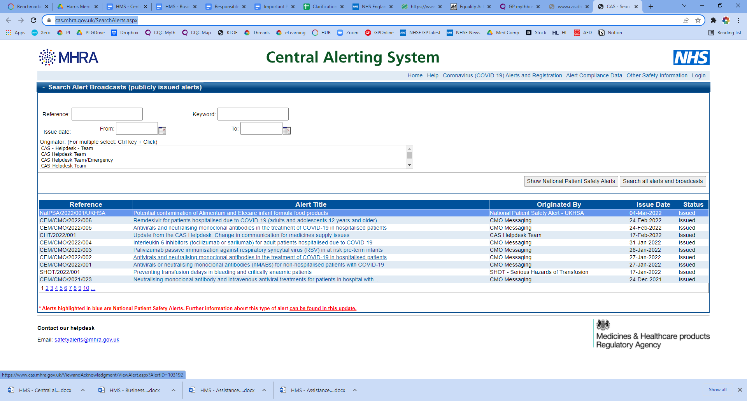

## The Yellow Card Scheme

Staff at Sheerwater Health Centre have a duty to report any adverse reactions to medicines, or an adverse incident relating to a medical device, using the Yellow Card Scheme.

The Yellow Card reporting site is accessible via [this](https://yellowcard.mhra.gov.uk/) link. The [Yellow Card Scheme](https://yellowcard.mhra.gov.uk/) helps the MHRA to monitor the safety of all healthcare products in the UK to ensure they are acceptably safe for patients and those who use them.

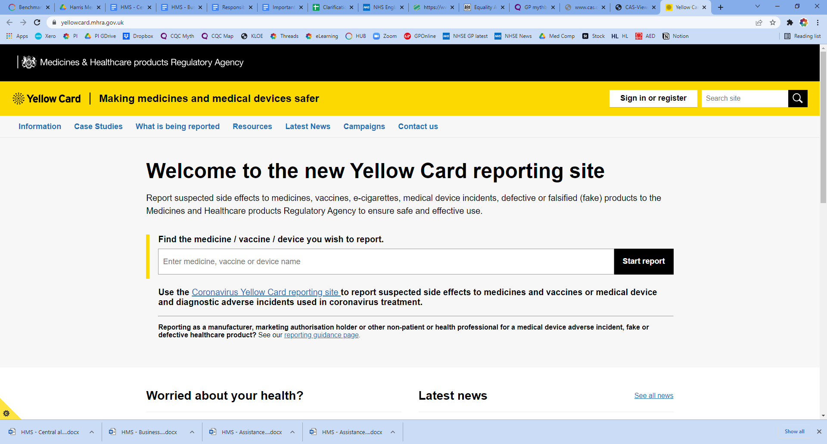

The Yellow Card alerting system is also available via the [Yellow Card App](https://www.gov.uk/drug-safety-update/yellow-card-app-download-the-updated-app-to-receive-the-latest-mhra-safety-news-and-report-suspected-side-effects-including-in-pregnancy).

# Estates defects and failures

## Reporting estates defects and failures

NHS healthcare providers should report defects and failures involving engineering plant, infrastructure and non-medical devices to the Department of Health.

Defects and failures are to be reported online using the efm-information system which can be accessed via this [link](https://efm.digital.nhs.uk/).

Any defects or failures reported must be recorded in the organisation’s defect log.

# Summary

Effective CAS alert handling and defect reporting is fundamental to the delivery of safe and effective patient care, as is the timely dissemination of alerts received by the organisation.

All staff have a responsibility to report adverse reactions, incidents, defects or failures to the Practice Manager to ensure swift rectification, enabling service delivery to continue in an effectual manner.

# Annex A – Processing alerts – flow chart

**Alert received by the Practice Manager**

**CMO Messages**

Is alert applicable?

Staff to acknowledge receipt of alert

No, record in alert log

Staff to acknowledge receipt of alert

No, record in alert log

No, record in alert log

Determine target group

Is alert applicable?

Stage One, Two or Three

Is alert applicable?

**Estates & Facilities**

**Patient Safety Alert**

**MHRA Device Alert**

**MHRA Drug Alert**

Necessary actions to be taken as advised

If yes, [xxx] to take necessary action

Clinicians will determine any subsequent action(s)

If yes, [xxx] to take necessary action

If yes, DM to take necessary action

Email to relevant group(s)

Yes, issue to [building manager] +/- PM

Emailed to all clinical staff

Yes, issue to [insert role]

Yes, issue to dispensary manager (DM)

Search for patients affected, follow instructions; once required actions are complete, advise [xxx] and alert will be closed

Search for patients affected, follow instructions; once required actions are complete, advise [xxx] and alert will be closed

Once requested actions have taken place and clinicians are satisfied, advise [xxx] and alert will be closed

Once necessary actions have been completed, PM is to be advised and the alert will be closed

Once requested actions have taken place and clinicians are satisfied, advise [xxx] and alert will be closed

# Annex B – Alert log

|  |  |  |  |  |  |  |  |
| --- | --- | --- | --- | --- | --- | --- | --- |
| **Date of issue** | **Reference (link)** | **Originator** | **Title or description** | **Action required**  **Yes/No** | **Emailed to**  **(Lead for action)** | **Actions completed (by)** | **Date closed** |
| 04/08/22 | [NatPSA/2022/007/MHRA](https://www.cas.mhra.gov.uk/ViewandAcknowledgment/ViewAlert.aspx?AlertID=103161) | NPSA | Recall of Mexiletine hydrochloride 50mg, 100mg and 200mg hard Capsules | Yes | Practice nurse | 08/08/2022 | 12/08/22 |
|  |  |  |  |  |  |  |  |
|  |  |  |  |  |  |  |  |
|  |  |  |  |  |  |  |  |
|  |  |  |  |  |  |  |  |
|  |  |  |  |  |  |  |  |
|  |  |  |  |  |  |  |  |
|  |  |  |  |  |  |  |  |
|  |  |  |  |  |  |  |  |
|  |  |  |  |  |  |  |  |
|  |  |  |  |  |  |  |  |
|  |  |  |  |  |  |  |  |
|  |  |  |  |  |  |  |  |
|  |  |  |  |  |  |  |  |
|  |  |  |  |  |  |  |  |
|  |  |  |  |  |  |  |  |

1. [NHS Central Alerting System](https://www.cas.mhra.gov.uk/Home.aspx)
2. [CQC GP mythbuster 91](https://www.cqc.org.uk/guidance-providers/gps/gp-mythbuster-91-patient-safety-alerts)