**Clinical Guidance Document –**

**Learning Disability**

|  |  |  |  |  |
| --- | --- | --- | --- | --- |
| **Version:** | **Review date:** | **Edited by:** | **Approved by:** | **Comments:** |
| v1.3 | 29/11/2022 | Sultan Mohamed | Munira Mohamed |  |
|  | February 2024 |  |  | Next review |
|  |  |  |  |  |
|  |  |  |  |  |

**Table of contents**

1 Introduction 2

1.1 Policy statement 2

1.2 Status 2

2 Scope 2

2.1 Learning disability 2

2.2 Learning difficulties 3

2.3 Severity scales of a learning disability 3

2.4 Annual LD health check 3

2.5 Consent 4

2.6 Accessibility Information Standard (AIS) 4

3 LD health check scheme 4

3.1 Requirements 4

3.2 Process 4

3.3 Learning disability register inclusion tool 5

4 Training 5

5 Summary 6

Annex A – Learning disability health check poster 7

Annex B – Learning disability health check invitation letter 8

# Introduction

## Guidance statement

The [NHS Long Term Plan](https://www.longtermplan.nhs.uk/) commits to improve the care of people with a learning disability (LD) and autism. As such, practices must improve the uptake of the existing learning disability annual health check in primary care. A minimum of 75% of eligible people, aged over 14 years, should have a learning disability health check each year.

Although research is underway to resolve health inequalities, autistic people without a learning disability do not currently have an annual health check and they are therefore out of scope of this protocol. Therefore, where LD is used within this document, this only relates to those autistic patients with LDs.

This protocol gives guidance on how to achieve the required uptake and how best to provide care for our patients with an LD. Additional reference material can be found within the NHS E [Learning disability and autism](https://www.england.nhs.uk/learning-disabilities/) webpage.

Staff at Sheerwater Health Centre must be aware of the importance of providing care and support to patients with an LD and the [learning disability improvement standards for NHS trusts](https://www.england.nhs.uk/wp-content/uploads/2020/08/v1.17_Improvement_Standards_added_note.pdf). Additionally, staff need to know how to maintain the LD register, how to input the correct LD coding into healthcare records and how to ensure LD health check requirements are completed and reached annually.

This guidance should be read in conjunction with [GP Mythbuster 53: Care of people with a learning disability in GP practices](https://www.cqc.org.uk/guidance-providers/gps/gp-mythbuster-53-care-people-learning-disability-gp-practices).

## Status

The organisation aims to design and implement policies and procedures that meet the diverse needs of our service and workforce, ensuring that none are placed at a disadvantage over others, in accordance with the [Equality Act 2010](https://www.legislation.gov.uk/ukpga/2010/15/2022-01-01). Consideration has been given to the impact this policy might have regarding the individual protected characteristics of those to whom it applies.

This document and any procedures contained within it are non-contractual and may be modified or withdrawn at any time. For the avoidance of doubt, it does not form part of your contract of employment.

# Scope

## Learning disability

[Mencap](https://www.mencap.org.uk/learning-disability-explained/what-learning-disability) defines an LD as a reduced intellectual ability and difficulty with everyday activities such as household tasks, socialising or managing money. An LD affects someone for their whole life.

The [NHS Data model and dictionary states](https://www.datadictionary.nhs.uk/nhs_business_definitions/learning_disability.html) that someone is considered to have an LD when they function at a level of intellectual ability which is significantly lower than their chronological age. This is usually considered to be equivalent of an IQ of 70 or lower.

Within the NHS, an LD is sometimes referred to as an intellectual disability. There are around 1.4 million people with an LD in the UK.

People with an LD tend to take longer to learn and may need support to develop new skills, understand complicated information and interact with other people.

## Learning difficulties

Learning difficulties can include dyslexia, attention deficit-hyperactivity disorder (ADHD), dyspraxia and dyscalculia. A person can have one or a combination. A learning *disability* is different from a learning *difficulty*, a learning difficulty does not affect general intellect. A learning difficulty is a type of special educational need (SEN).

## Severity scales of a learning disability

An LD can be mild or moderate-profound. Some people will be able to communicate effectively and look after themselves but others will be unable to communicate at all. The severity definitions are:

* Mild LD: Roughly an IQ of 50-70 and equivalent to the educational term, “moderate learning *difficulty*”. It is usually caused by a combination of restricted learning and lack of social opportunities; it is further likely there is low-average intellectual ability and LD in close relatives.
* Moderate-profound LD: Roughly an IQ below 50 and comparable to the educational term, “severe learning *difficulty.*” It usually has a specific biological cause.

Some people with an LD are diagnosed at birth in conditions such as Downs Syndrome although others do not become apparent until the child is at walking and talking age.

## Annual LD health check

Annual health checks are made available for all patients over the age of 14 who are on the practice LD register. The health check is designed to assess the patient and discuss their health and needs plus identify and manage any medical needs.

NHS England and NHS Improvement have supported the production of the [London learning disability annual health check toolkit](https://www.ndti.org.uk/assets/files/Annual-Health-Check-Toolkit-Final.pdf) to support general practice. The effective use of the toolkit supports positive experiences and outcomes for patients.

A patient advice poster providing advice on the LD annual health check can be found at Annex A.

An LD health check invitation letter can be found at Annex B.

Note that those on the LD register are also eligible for a free NHS flu jab annually.

## Consent

During the LD health check, it may be necessary to discuss care, interventions and treatment with the individual’s family or carer. To be able to do this, consent is required from the individual.

Consideration is to be given to the capacity of the patient to provide informed consent. Further information can be sought in the [Consent Policy](https://practiceindex.co.uk/gp/forum/resources/consent.707/).

## Accessibility Information Standard (AIS)

This organisation aims to meet the AIS. This standard applies to all patients who have information or communication needs because of disability, impairment or sensory loss including those patients with a LD.

The standard sets out a specific, consistent approach to identifying, recording, flagging, sharing and meeting the information and communication support needs of patients, service users, carers and parents with a disability.

Refer to the [Accessibility Information Standard Policy](https://practiceindex.co.uk/gp/forum/resources/accessible-information-standard-policy.1361/).

# LD health check scheme

## Requirements

The LD health check scheme is an enhanced service agreed with the general practitioners committee of the British Medical Association (BMA) which supports the delivery and payment of the scheme.

Organisations participating in the scheme are required to assess their LD register and undertake annual health checks.

## Process

The following process is to be followed when undertaking the LD health check scheme:

* The LD register must be checked and assessed and the guidelines followed within the NHS E publication titled [Improving identification of people with a learning disability: guidance for general practice](https://www.england.nhs.uk/wp-content/uploads/2019/10/improving-identification-of-people-with-a-learning-disability-guidance-for-general-practice.pdf)
* As per the publication, the correct codes must be utilised when updating the patient’s healthcare record. The following information must be considered when compiling the LD register:
  + Appendix 1 of the above publication lists the codes that Sheerwater Health Centre *must* use to identify patients and then subsequently invite for an LD health check.
  + Appendix 2 uses a list of codes given to identify conditions that *may* indicate an LD. Any patients identified should then be assessed for an LD.
  + Appendix 3 details codes that are no longer viable and steps should be taken to re-code patients accordingly
* Patients eligible for the LD health check are to be correctly coded as having an LD and must be over the age of 14
* Claims are to be made via CQRS and data is collected quarterly. Guidance on how to make the relevant claims can be found [here](https://welcome.cqrs.nhs.uk/)
* CQRS performs extraction of data under the codes LD001 (patients aged 14 and over who have received a health check and are on the LD register) and LD002 (patients aged 14 and over who are on the LD register)

## Learning disability register inclusion tool

Appendix 4 of the NHS England publication referenced at Section 3.2 provides an inclusion tool to assist clinicians. The checklist is not a diagnostic tool but can be used to identify patients with an LD.

The inclusion tool will ensure improved coding of all LD patients, plus assist with recalling patients for their annual LD health check. Additionally, this also ensures that the CQRS data extraction is more accurate.

# Training

In July 2022, the [Health and Care Act](https://www.gov.uk/government/news/health-and-care-bill-granted-royal-assent-in-milestone-for-healthcare-recovery-and-reform) introduced the requirement to ensure that staff receive training on learning disability and autism appropriate to the person’s role. The [Oliver McGowan mandatory training](https://www.hee.nhs.uk/our-work/learning-disability/current-projects/oliver-mcgowan-mandatory-training-learning-disability-autism) is the government’s preferred and recommended direction for health and social care staff.

Training is separated into the following tiers:

* Tier 1: For people who require general awareness of the support autistic or people with LDs may need. This is suitable for non-clinical staff.
* Tier 2: For people who may need to provide care and support for autistic people or people with an LD. This is suitable for clinical staff and includes Tier 1 content.

In accordance with Health Education England, courses undertaken prior to 1 November 2022 are not part of the Oliver McGowan mandatory training. All staff at Sheerwater Health Centre will complete the required e-learning package in preparation for the full roll-out of courses from early 2023.

Relevant training courses are available on e-learning platform, Blue Stream Academy.

Furthermore, there are e-LFH courses that are also available on HUB titled:

* ELFH - Inappropriate medication prescribing (MindEd Stopping Over Medication of People with a Learning Disability and Autistic People)
* ELFH - Learning Disabilities Autism: Supporting People (MindEd Learning Disability)
* ELFH - The Oliver McGowan Mandatory Training on Learning Disability and Autism

# Summary

The learning disability health check scheme is designed to ensure better healthcare is provided to patients with learning disabilities.

At Sheerwater Health Centre, we will take the necessary steps to establish, assess and evaluate the LD register to ensure all LD patients are recorded on the register.

Our aim is to ultimately achieve the following:

* Ensure patients have a timely health check
* Recall those on the LD register for their annual flu check
* Fundamentally improve the healthcare for LD patients

Practices are financially incentivised for providing this higher level of care and the current payment for 2022/23 is £140.00 per health check.

# Annex A – Learning disability health check poster

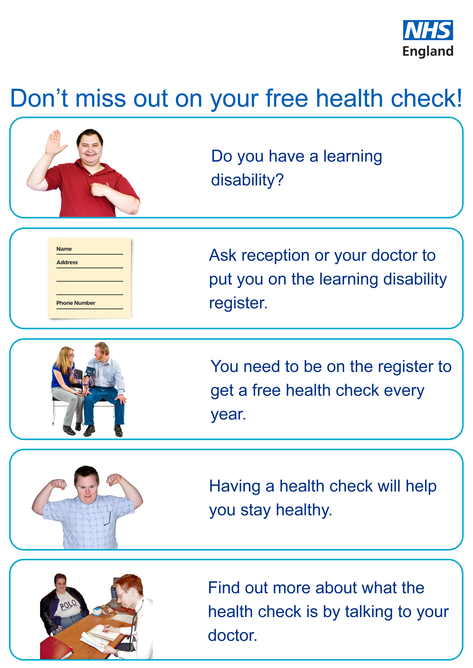

# Annex B – Learning disability health check invitation letter

Dear [insert patient name],

I note from your healthcare record that you have a learning disability.

You may be aware that the NHS offers a free annual health check for patients who have a learning disability.

Please contact the surgery on [insert number] or by email on [insert email address] explaining that you have received this learning disability health check invitation letter and one of our team will gladly book an appointment for you.

Please see the information below regarding this free health check.

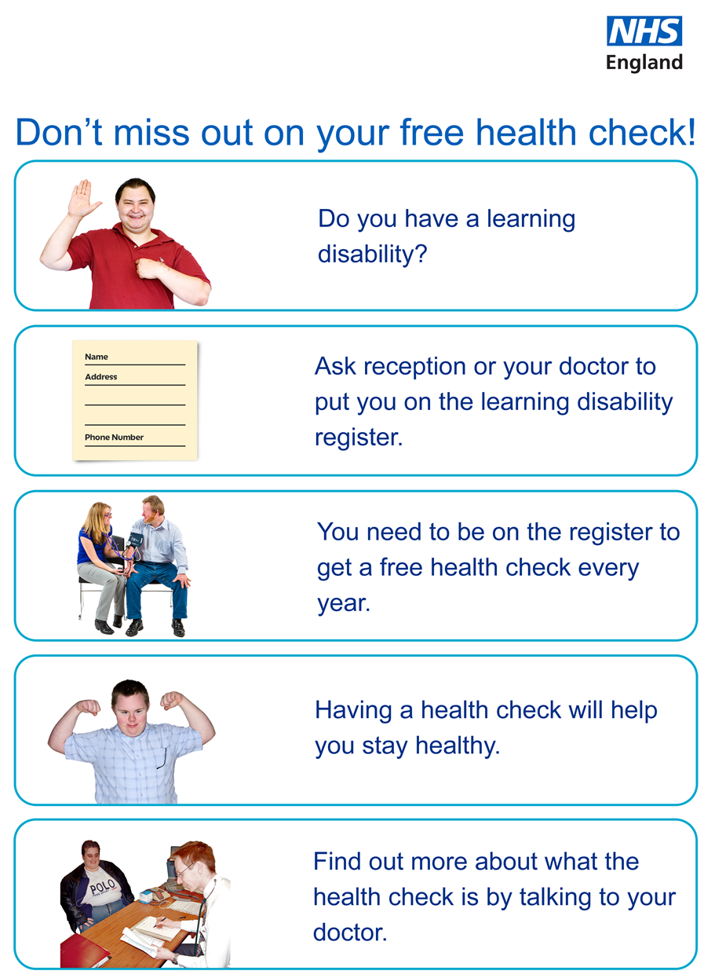

Yours sincerely,

[Signature]

[Name]