**Learning Disabilities Guidance Document**

|  |  |  |  |  |
| --- | --- | --- | --- | --- |
| **Version:** | **Review date:** | **Edited by:** | **Approved by:** | **Comments:** |
| v1.3 | 29/08/2024 | Sultan Mohamed | Munira Mohamed |  |
| v1.4 | 14/08/2025 | Sultan Mohamed | Munira Mohamed | revised |
|  | August 2026 |  |  | Next review |
|  |  |  |  |  |

**Table of contents**

1 Introduction 2

1.1 Guidance statement 2

1.2 Status 2

2 Scope 2

2.1 Learning disability 2

2.2 Learning difficulties 3

2.3 Annual LD health check 3

2.4 Consent 3

2.5 Accessibility Information Standard (AIS) 4

2.6 Reasonable Adjustment Digital Flag 4

3 The LDHC 4

3.1 Guidance 4

3.2 Templates and codes 4

3.3 Identifying patients with a LD 4

4 Training 5

5 Reimbursement 5

Annex A – Learning disability health check poster 6

Annex B – Learning disability health check invitation letter 7

# Introduction

## Guidance statement

This guidance document outlines how staff at Sheerwater Health Centre can support patients with a learning disability (LD), ensuring they can access and receive the necessary level of care, including annual health checks, while working in partnership with the patient to ensure their individual needs are met.

This guidance should be read in conjunction with [GP mythbuster 53: Care of people with a learning disability in GP practices](https://www.cqc.org.uk/guidance-providers/gps/gp-mythbuster-53-care-people-learning-disability-gp-practices).

## Status

The organisation aims to design and implement policies and procedures that meet the diverse needs of our service and workforce, ensuring that none are placed at a disadvantage over others, in accordance with the [Equality Act 2010](https://www.legislation.gov.uk/ukpga/2010/15/contents). Consideration has been given to the impact this policy might have regarding the individual protected characteristics of those to whom it applies.

This document and any procedures contained within it are non-contractual and may be modified or withdrawn at any time. For the avoidance of doubt, it does not form part of your contract of employment. Furthermore, this document applies to all employees of the organisation and other individuals performing functions in relation to the organisation such as agency workers, locums and contractors.

# Scope

## Learning disability

The [Department of Health and Social Care (DHSC)](https://www.gov.uk/government/publications/learning-disability-applying-all-our-health/learning-disabilities-applying-all-our-health) defines a learning disability as “a significantly reduced ability to understand new or complex information, to learn new skills (impaired intelligence), with a reduced ability to cope independently (impaired social functioning), which started before adulthood”.

Learning disabilities vary and include:

* Mild disabilities (such as minor difficulties with speech or writing)
* Moderate disabilities
* Severe disabilities (where an individual requires support in most, or all areas of daily life)
* Profound and multiple learning disabilities (these are diagnosed when an individual has a severe learning disability combined with other disabilities which consequently affect their overall ability to communicate with others and be independent)

It should be noted that a learning disability is not a physical disability.

## Learning difficulties

The [NHS explain](https://www.datadictionary.nhs.uk/nhs_business_definitions/learning_difficulty.html)s that a learning difficulty is a type of Special Educational Needs (SEN) that affects areas of learning such as reading, writing, spelling, mathematics etc. There are several levels of learning difficulties, including:

* Specific (a particular difficulty in learning to read, write, spell etc.)
* Moderate (achievements well below expected levels in all or most areas of the curriculum, despite appropriate interventions)
* Severe (significant intellectual or cognitive impairments)
* Profound and multiple (severe and complex learning needs, in addition to other significant difficulties, such as physical disabilities or sensory impairment.

Learning difficulties can include dyslexia, attention deficit-hyperactivity disorder (ADHD), dyspraxia and dyscalculia. A learning *disability* is different from a learning *difficulty*, a learning difficulty does not affect general intellect.

## Annual LD health check

The Learning Disabilities Health Check Scheme (LDHC Scheme) is a Directed Enhanced Service (DES) for which this organisation must:

* Identify all patients aged 14 and over with learning disabilities
* Maintain a learning disabilities health check register
* Offer those on the registered an annual health check
* Work with the patient to produce a health action plan

The [Primary Medical Services (Directed Enhanced Services) Directions 2024](https://assets.publishing.service.gov.uk/media/6602db2ba6c0f7699def916d/primary-medical-services-directed-enhanced-services-directions-2024.pdf) provides additional information on the scheme at Section 5.

NHS England and NHS Improvement have supported the production of the [London learning disability annual health check toolkit](https://www.ndti.org.uk/assets/files/Annual-Health-Check-Toolkit-Final.pdf) to support general practice. The effective use of the toolkit supports positive experiences and outcomes for patients.

A patient advice poster providing advice on the LD annual health check can be found at Annex A. A LD health check invitation letter can be found at Annex B.

Note that those on the LD register are also eligible for a free NHS flu jab annually.

## Consent

During the LD health check, it may be necessary to discuss care, interventions and treatment with the individual’s family or carer. To be able to do this, consent is required from the individual. Consideration is to be given to the capacity of the patient to provide informed consent. For further detailed information, see the organisation’s **Consent Policy**.

## Accessibility Information Standard (AIS)

This organisation aims to meet the AIS. This standard applies to all patients who have information or communication needs because of disability, impairment or sensory loss including those patients with a LD.

The standard sets out a specific, consistent approach to identifying, recording, flagging, sharing and meeting the information and communication support needs of patients, service users, carers and parents with a disability.

For further detailed information, see the organisation’s **Accessibility Information Standard Policy.**

## Reasonable Adjustment Digital Flag

The Reasonable Adjustment Digital Flag is a national record that indicates that reasonable adjustments are required for an individual and optionally includes details of their significant impairments, key adjustments that should be considered and details of any underlying conditions.

For further detailed information, see the organisation’s [Reasonable Adjustment Digital Flag Policy](https://practiceindex.co.uk/gp/forum/resources/reasonable-adjustment-digital-flag-policy.2077/).

# The LDHC

## Guidance

The [Royal College of General Practitioners (RCGP)](https://dimensions-uk.org/wp-content/uploads/GP-Health-check-Step-by-Step-Guide-to-LDAHCs.pdf) has produced a step-by-step guide to health checks for people with a learning disability. In addition, as mentioned, the [London Learning Disability Annual Health Check Toolkit](https://www.ndti.org.uk/assets/files/Annual-Health-Check-Toolkit-Final.pdf) supports the completion of good quality LDHCs.

## Templates and codes

Staff completing the LDHC are to use the templates on the clinical system. It is imperative all actions relating to the LDHC are recorded using the correct [SNOMED CT ID](https://termbrowser.nhs.uk/?perspective=full&conceptId1=404684003&edition=uk-edition&release=v20240731&server=https://termbrowser.nhs.uk/sct-browser-api/snomed&langRefset=999001261000000100,999000691000001104) as this supports the organisation’s [Quality Outcomes Framework (QOF)](https://www.england.nhs.uk/wp-content/uploads/2024/03/PRN01104-Quality-and-outcomes-framework-guidance-for-2024-25.pdf) achievements.

When adding a patient to the LD register, staff are to use SCTID: 416075005 – On learning disability register.

## Identifying patients with a LD

To support staff at this organisation to identify patients with a learning disability, NHS England has produced [Improving identification of people with a learning disability: guidance for general practice](https://www.england.nhs.uk/wp-content/uploads/2019/10/improving-identification-of-people-with-a-learning-disability-guidance-for-general-practice.pdf) which helps to ensure eligible patients are added to the LD register and offered an annual health check.

# Training

The [Oliver McGowan mandatory training](https://www.hee.nhs.uk/our-work/learning-disability/current-projects/oliver-mcgowan-mandatory-training-learning-disability-autism) is the government’s preferred and recommended training for health and social care staff.

Training is separated into two tiers:

* Tier 1: For people who require general awareness of the support autistic or people with LDs may need. This is suitable for non-clinical staff
* Tier 2: For people who may need to provide care and support for autistic people or people with an LD. This is suitable for clinical staff and includes Tier 1 content

All staff at this organisation must complete the expected training tier.

The Oliver McGowan Mandatory Training on LD and autism (Parts 1 & 2) is available on Blue Stream Academy – the e-learning platform.

# Reimbursement

Part 3, Section 8 of the [NHS England General Medical Services Statement of Financial Entitlements Directions 2024](https://assets.publishing.service.gov.uk/media/6602c2eef1d3a09b1f32acb4/general-medical-services-statement-of-financial-entitlements-directions-2024.pdf) outlines the process for health check completion payments which will be made to this organisation on completion of a compliant health check.

The value of a compliant health check is £140.00.

# Annex A – Learning disability health check poster

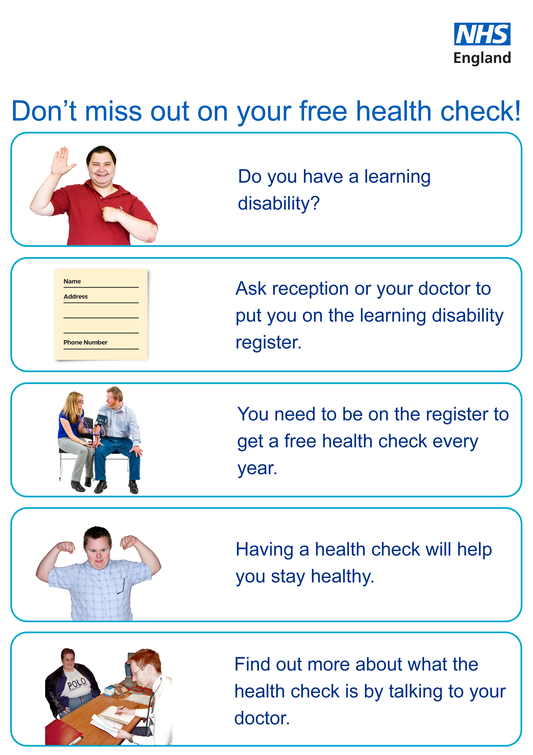

# Annex B – Learning disability health check invitation letter

Dear [insert patient name],

I note from your healthcare record that you have a learning disability.

You may be aware that the NHS offers a free annual health check for patients who have a learning disability.

Please contact the practice on [insert number] or by email on [insert email address] explaining that you have received this learning disability health check invitation letter and one of our team will gladly book an appointment for you.

Please see the information below regarding this free health check.

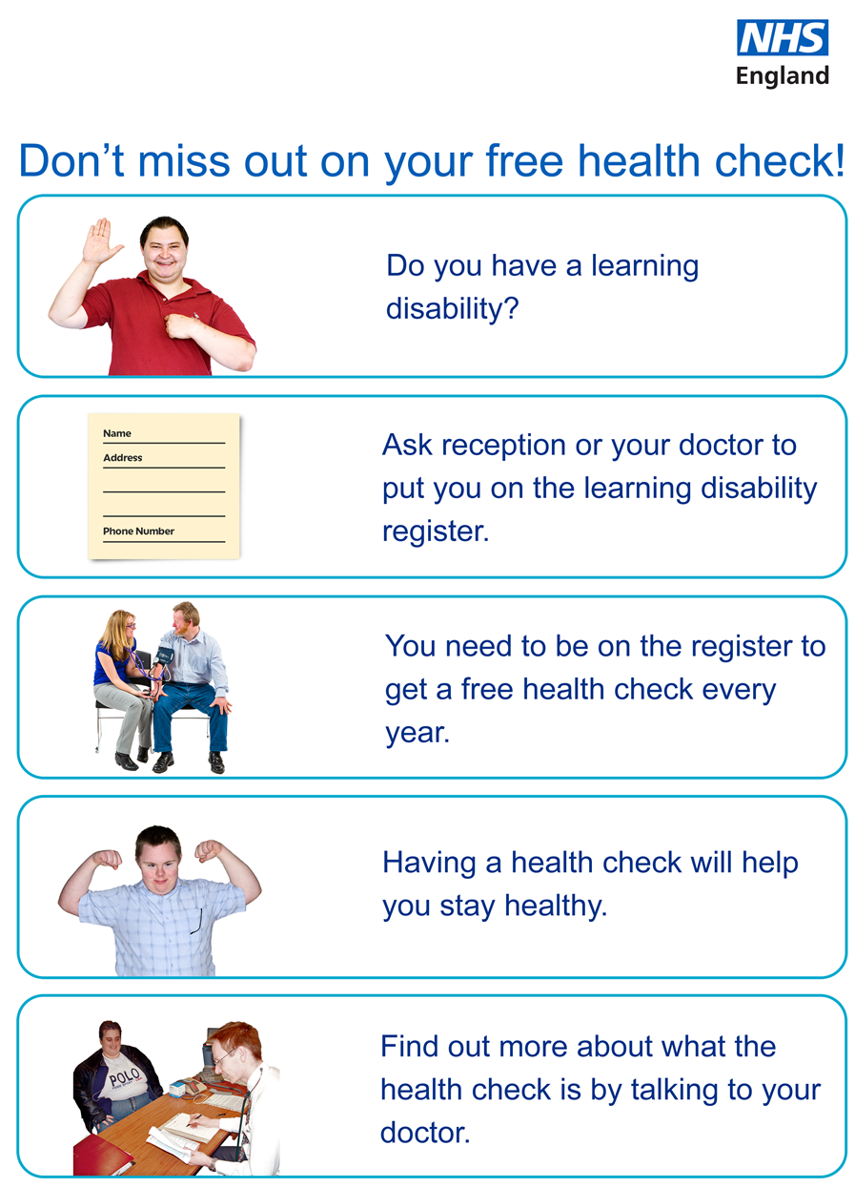

Yours sincerely,

[Signature]

[Name]