Clinical Guidance Document
Patient Immunisation

Version: | Review date: | Edited by: | Approved by: | Comments:
v1 | 01/03/2021 | Sultan Mohamed | Nine Swift  Wendy Mayne
v1.11 | 24/11/2022 | Sultan Mohamed | Nine Swift  Wendy Mayne | New annex – refusal of childhood immunisation
 | December 2024 |  |  | Next review

Table of contents
1 Introduction 3
1.1 Policy statement 3
1.2 Status 3
2 Policy 3
2.1 Contractual obligations 3
2.2 Vaccination schedule 4
2.3 Training 4
2.4 Provision of appointments 5
2.5 Call/recall process 5
2.6 Consent 5
2.7 Disagreement between parents 6
2.8 Administering vaccines 6
2.9 Patient self-administration 6
2.10 Patient Group Directions (PGDs) 7
2.11 Patient Specific Directions (PSDs) 7
2.12 Prescribed medication administration 8
2.13 Opportunistic vaccination 8
2.14 Catch-up campaigns 8
2.15 Vaccination failure 9
2.16 Free travel vaccinations 9
2.17 Private travel vaccinations 9
2.18 Determining travel vaccination requirements 10
2.19 Vaccination and pregnancy 10
2.20 PPV for high-risk conditions 10
2.21 COVID-19 10
2.22 Reporting adverse reactions 10
2.23 Patient Did Not Attend (DNA) 11
2.24 Patient Was Not Brought (WNB) 11
2.25 Refusal of childhood immunisation 11
2.26 Personalised care adjustment 12
2.27 Stock control 12
2.28 Funding for vaccinations 12
3 Information and improving uptake 13
3.1 Patient information 13
3.2 Displays, website and social media communication 13
3.3 Monitoring uptake 13
3.4 Vaccine updates 13
3.5 Further reading 14
4 Summary 14
Annex A – Vaccination schedule 15
Annex B – Recall letter for adults 16
Annex C – Recall letter for children 17
Annex D – Self-administration vaccine protocol 18
Annex E – Childhood immunisation disclaimer form 21

Introduction

Policy statement

The purpose of this document is to outline the vaccinations that are to be offered to registered patients at Sheerwater Health Centre and the timescale for such vaccinations. Vaccines are the most effective way to prevent infectious diseases and the principle aim of vaccination is to protect the recipient from infection whilst reducing the risk to others.

Vaccinations are to be given free of charge to patients unless stated otherwise. This document provides detailed guidance on vaccination schedules for all patient groups. It is to be read in conjunction with the referenced material and local publications.

Status

This organisation aims to design and implement policies and procedures that meet the diverse needs of our service and workforce, ensuring that none are placed at a disadvantage over others, in accordance with the Equality Act 2010. Consideration has been given to the impact this policy might have regarding the individual protected characteristics of those to whom it applies.

This document and any procedures contained within it are non-contractual and may be modified or withdrawn at any time. For the avoidance of doubt, it does not form part of your contract of employment.

Policy

Contractual obligations

Vaccinations are an essential service, available to the entire patient population. Sheerwater Health Centre is expected to offer all routine, pre- and post-exposure vaccinations and NHS travel vaccinations to all patients.

The following core contractual standards underpin the delivery of immunisation services and include:

Core Standard
1 | There is a named lead for vaccination services
2 | There are sufficient trained staff and convenient, timely appointments available to the entire patient population
3 | The call/recall process and opportunistic offers are in line with national standards
4 | Participation in agreed national catch-up campaigns
5 | Record keeping meets the defined standards

Important notes:

- For COVID-19 vaccinations, all additional voluntary support will be trained, managed and overseen by Surrey Heartlands and not any individual organisation

- All vaccinations will be overseen by the lead clinician within the vaccination clinic

- Where some of the provisions of the core standards are delegated, Sheerwater Health Centre will ensure that these standards are being met by that delegated person or organisation

The organisation’s named lead for vaccination and immunisations is [insert name and role].

At Sheerwater Health Centre, the named lead for vaccination services is Wendy Mayne.

Vaccination schedule

The vaccination schedule is detailed in The Green Book at Chapter 11 (illustrated at Annex A). For national advice on the COVID-19 vaccination programme, refer to the current NHS E guidance here. Furthermore, advice can be sought from The Green Book Chapter 14a.

Training

The organisation will ensure that vaccinating staff are appropriately trained, and assessed as competent, in the administration of vaccinations:

- Registered Healthcare Practitioners (RGPs) will receive comprehensive training in line with the National Minimum Standards and Core Curriculum for Immunisation Training for RGPs. Vaccines will be administered under a Patient Group Direction.

- Non-registered healthcare assistants (HCAs) will receive comprehensive training in line with Public Health England’s Guidance on Minimum Training Standards for HCAs administering vaccinations. HCAs are only permitted to vaccinate under a Patient Specific Direction.

e-learning training modules are available to staff via Blue Stream Academy.

Provision of appointments

Sheerwater Health Centre will offer appointments to vaccinate the eligible population; this offer may be made in conjunction with other practices within the Primary Care Network (PCN).

Where triage is not indicated, and to support the changes to the 2022/23 GP contract, appointments will be made available for online booking via the NHS App.

Call/recall process

Patients at Sheerwater Health Centre are called/recalled for vaccinations using the letter templates at Annex B (for adults) and Annex C (for children). Patients are identified for routine recall using searches on EMIS web clinical system. This is the responsibility of Wendy Mayne (Practice Nurse) and Nine Taylor (Practice Manager). Searches are conducted on a regular basis. Patients are also identified opportunistically during contacts with the practice and requested to book an appointment for any required immunisations.

All staff have a responsibility to ensure that, during any type of patient contact, they identify any outstanding immunisation/vaccination requirements and arrange an appointment accordingly.

Consent

For consent to immunisation to be valid, it must be given freely, voluntarily and without coercion. Consent is a process rather than a one-off event. Consent may be withdrawn at any time and consent obtained for one immunisation does not necessarily remain in place for all future doses of a course of immunisation.

Detailed reading on consent in relation to immunisations can be sought from The Green Book Chapter 2.

Staff must ensure that they give the patient all the available information about the process including the benefits and risks of the vaccination(s) that is about to be administered. This is to include:

- Ensuring that the patient fully understands which immunisation(s) is to be administered
- The disease(s) which it will offer protection against
- The risks of not having the immunisation
- Any potential side effects and how these should be managed
- Any follow-up action that is required

Consent is to be recorded in the individual’s healthcare record. Consent forms may be used but are not a legal requirement. It should be noted that a signature on a consent form does not prove that the consent is valid but rather acts as a record that the decision was reached and the person administering the vaccine had discussed consent with the patient.

The Green Book advises that for immunisation of younger children who lack the competency to give or withhold consent, it is acceptable for consent to be given by a person with parental responsibility providing that individual can give consent. If an individual who is aged 16 or 17, or a younger child who is deemed ‘Gillick competent’ (that is, a child who fully understands the process/procedure), consents to treatment, a parent is unable to override that consent.

Clinicians must ensure that if consent is either refused or withdrawn by a patient, or a person giving consent on behalf another person, this decision is documented in the individual’s healthcare record.

Consent will be obtained in conjunction with the organisation’s Consent Guidance.

Disagreement between parents

The Green Book Chapter 2 advises that whilst the consent of one person with parental responsibility is usually sufficient, if one parent agrees to immunisation but the other disagrees, the immunisation should not be carried out unless both parents can agree to immunisation or there is a specific court approval that the immunisation is in the best interests of the child.

If there is any evidence that the person with parental responsibility may not have agreed to the immunisation (for example the notes indicate that the parent(s) have negative views on immunisation) or may not have agreed that the person bringing the child could give
the consent (for example, suggestion of disagreements between the parents on medical matters) then the person with parental responsibility should be contacted for their consent. If there is disagreement between the people with parental responsibility for the child, then immunisation should not be conducted until their dispute is resolved.
A person giving consent on behalf of an infant or child may change their mind and withdraw consent at any time. Where consent is either refused or withdrawn, it is the duty of each healthcare professional to communicate effectively and share such knowledge and information with other members of the primary healthcare team.

Administering vaccines

The Green Book Chapter 4 details the recommendations for immunisation procedures. All staff at Sheerwater Health Centre are to adhere to this guidance. Clinicians are professionally accountable for their actions, as defined by their professional bodies, and all healthcare staff advising on immunisation or administering vaccines must have received specific training in immunisation, including the recognition and treatment of anaphylaxis.

The Green Book Chapter 4 dictates that clinical staff are to maintain and update their professional knowledge and skills through appropriate training.

Patient self-administration

Patients may self-administer a vaccination at home without the inconvenience of regular practice visits. Ordinarily, this would be for a regular vaccination such as vitamin B12 although patients who have other regular vaccine requirements may equally request to complete these at home.
Should any patient request to self-administer, then an initial appointment with the practice nurse will be arranged where training, advice and guidance on the process will be provided.

The administration protocol at Annex D is also to be provided to the patient as this will support the process. Whilst there are several YouTube clips that show how to self-administer a vitamin B12 injection, this useful one here created by Eastwood Primary Care Centre in Ripley can support the process.

It should be noted that the process is similar for another intramuscular injection and, as above, specific training will be given to support any request.

The Green Book Chapter 4 provides detailed guidance.

Patient Group Directions (PGDs)

The Green Book Chapter 5 advises that Patient Group Directions (PGDs) are written instructions that provide a legal framework for the supply and/or administration of medicines by a range of qualified healthcare professionals. At Sheerwater Health Centre, all relevant staff have received the necessary training to ensure that they are competent and trained in the use of PGDs.

A record of all the health professionals authorised to practise under the PGD must be kept. PGDs for Sheerwater Health Centre have been signed by those staff who will use them in the course of their duties. For further information, refer to the Patient Group Directions Policy and also GP Mythbuster 19: Patient Group Directions (PGDs).

Patient Specific Directions (PSDs)

PSDs are written instructions from an independent prescriber to another healthcare professional to supply and/or administer a medicine directly to a named patient or to several named patients.

Specialist Pharmacy Service advise that all immunisations administered by an HCA will require a PSD whereas the prescriber is responsible for the assessment of the patient and the decision to authorise the supply/administration of the medicine(s).

Importantly, it should be noted that whilst the CQCs GP Mythbuster 57: Health Care Assistants in General Practice states that the RCN only supports HCAs to administer specific vaccines to adults and children; it should be noted that this is simply a viewpoint of the RCN and that this statement does not have any legal basis.

To clarify this point, Practice Index have spoken to senior CQC management and they have confirmed that HCAs can work under a PSD to administer a much wider range of vaccinations, provided they are working in accordance with CQCs GP Mythbuster 19: Patient Group Directions (PGDs)/Patient Specific Directions (PSDs) and:

- Are assessed as competent
- Have the necessary knowledge and skills, and
- Have been delegated the task to follow a PSD

The prescriber must individually assess each patient. The prescriber must have knowledge of the patient’s health and be satisfied the medicine meets the individual needs of each patient. For example, for an HCA to run a flu clinic, the prescriber must review the patients attending the clinic and sign a list of those who they authorise to be immunised.

A PSD is not:

- A Patient Group Direction (PGD) template renamed a PSD and used to instruct healthcare staff

- A generic instruction to be applied to any patient who may be seen by a healthcare professional or who has an appointment on any particular day, e.g., an instruction to administer a flu vaccine to any patient who fits the criteria attending clinics on a specific day

- A verbal instruction

Further reading can be sought within the Patient Specific Directions (PSDs) document.

Prescribed medication administration

The organisation may issue a prescription to a patient to have the medicine dispensed at a pharmacy or dispensary for administration at the practice, e.g., the patient may obtain an injection such as vitamin B12 or Zoladex from a community pharmacy.

Should this be required, then the patient will return to the practice for it to be administered by a member of the nursing team. In these circumstances, the responsibilities of the prescriber and the delegated member of staff administering the medicine are the same as for a PSD.

Opportunistic vaccination

During a consultation, staff have a responsibility to ensure that any outstanding vaccination requirements are identified. Should any be outstanding, then the patient should have an appointment arranged.

Catch-up campaigns

Often catch-up campaigns are commissioned for those who have not been previously vaccinated, or who have missed a scheduled vaccine dose, or who have not completed a vaccine series.

Upon commissioning, Sheerwater Health Centre will follow the nationally provided protocol for that vaccination campaign.

Vaccination failure

It is imperative that patients are informed that no vaccine offers 100% protection and, on occasion, vaccinations may fail and individuals may become infected. There are two main types of failure:

- Primary failure occurs when the recipient fails to make an immunological response to the vaccine

- Secondary failure occurs when the recipient responds initially but protection diminishes over a period

Free travel vaccinations

Since 2021, NHS travel vaccination is now deemed to be an essential service, with the following vaccinations available free of charge to patients:

- Polio (given as a combined diphtheria/tetanus/polio jab)
- Typhoid
- Hepatitis A
- Cholera

Further information can be sought from the NHS webpage on travel vaccinations.

Private travel vaccinations

The following vaccinations are available for a fee:

- Hepatitis B (when not combined with Hepatitis A)
- Japanese encephalitis
- Meningitis vaccines
- Rabies
- Tick-borne encephalitis
- Tuberculosis (TB)
- Yellow fever

The cost per vaccine at Sheerwater Health Centre is £[xx]. Payments can be added to the Money coming-in toolkit. Further information can be sought from the NHS webpage on travel vaccinations.

To provide the above as an NHS service, the organisation would need to:

- Prescribe the immunisation on an FP10 (or national equivalent) or
- Provide the vaccine from purchased stock and claim reimbursement through the normal channels
- Not charge the patient for the administration of the vaccine

Further reading on travel vaccines can be sought here.

Determining travel vaccination requirements

When determining vaccination requirements for those patients travelling abroad and giving travel advice, staff at Sheerwater Health Centre will refer to the information provided by the National Travel Health Network and Centre (NaTHNaC).

Vaccination and pregnancy

Live vaccinations are not recommended in pregnancy. Pregnant women are advised to have the following vaccinations to protect their health and the health of the unborn child:

- Inactivated influenza vaccine – available from September until January/February

- Pertussis vaccine – from 16 weeks of pregnancy (this is administered using the Diphtheria, Tetanus, Pertussis and Polio (DTaP/IPV or dTaP/IPV) vaccine)

- COVID-19 vaccine

Pregnant women are advised to avoid travelling to countries where travel vaccination is required or seek the advice of their GP or midwife.

PPV for high-risk conditions

Sheerwater Health Centre has a responsibility to ensure that all patients in clinical risk groups are offered the pneumococcal polysaccharide vaccine (PPV23) as outlined in Chapter 25 of the Green Book.

Sheerwater Health Centre will identify patients in the above risk groups upon diagnosis, through robust correspondence management procedures and by conducting regular searches on EMIS web clinical system.

Correspondence which references any of the conditions outlined in the table above must be referred to a clinician for review and consideration as to whether the patient requires the PPV23 vaccine. [This paragraph should be adapted to suit individual practice preferences].
Furthermore, it is the responsibility of [insert name and role] at [insert organisation name] to conduct [insert frequency] searches on [insert clinical system name] to identify any patients who are eligible for the PPV23 and to arrange for them to have the vaccine at the earliest opportunity.

COVID-19

Specific information pertaining to COVID-19 can be found in The Green Book, Chapter 14a.

Reporting adverse reactions

All adverse reactions are to be reported using the Yellow Card scheme which is managed by the MHRA and can be accessed using this link. The manager is to be informed of all adverse reactions.

Sheerwater Health Centre will ensure that the following is documented within a patient’s record using SNOMED CT codes:

- Any refusal of immunisation
- The name of the person who gave consent to the immunisation and, where indicated, that person’s relationship to the patient
- The batch number and expiry date of the vaccine
- The date of administration
- In the case where two vaccines are administered by injections in close succession, the route of administration and the injection site of each vaccine
- Any contraindications to the vaccine
- Confirmation of consent
- Any adverse reactions to the vaccine

Patient Did Not Attend (DNA)

Where an adult fails to attend an appointment for immunisation, the appropriate SNOMED code will be applied to the record. This also applies to those patients over the age of 11 deemed to be Gillick Competent.

The Did Not Attend (DNA) Policy is to be followed including contacting the patient to advise of their failure to attend. Sample template letters can be found in the annexes to this policy.

Patient Was Not Brought (WNB)

Where the patient is under 16 years and not deemed to be Gillick competent, as the child is not able to attend themselves the attendance will not be classified as a ‘Was Not Brought’.

This failure to attend is to be coded as SNOMED CT code 901441000000108 (Child not brought to appointment) and the parent/guardian will be contacted to ascertain the reasons for non-attendance. A further appointment will be scheduled, and a note entered into the child’s medical record.

Where there is no response from the parent/guardian or in the event of a second missed appointment, the parent/guardian will again be contacted, the benefits of immunisation reiterated and a further appointment scheduled, as above. Dr S Kakati, the safeguarding lead, will be notified and the child’s record reviewed. Should there be any significant concerns, a child protection referral is to be initiated as detailed within the Safeguarding Policy.

Full guidance on Was Not Brought including sample letters can be sought in the Did Not Attend (DNA) Policy.

Refusal of childhood immunisation

In certain circumstances, parents/guardians may feel that it is not in the best interest of their child to have a childhood vaccination.

Following discussions with the clinician, should a parent/guardian advise that they still will not be bringing their child for a routine vaccine, then they are to complete the disclaimer form at Annex E.

Further reading relating to both consent and should there be a disagreement between those with parental responsibility can be sought at Section 2.6 and Section 2.7 respectively.

Personalised care adjustment

It is not permitted to use an ‘exception code’ or, to use the current terminology, to use a personalised care adjustment within the Quality and Outcomes Framework (QOF) should any parent, guardian or patient refuse a vaccination, even after a third refusal.

The only suitable personalised care adjustment for childhood vaccinations is when vaccination is clinically contraindicated.

Further reading can be sought within the Personalised Care Adjustment Policy.

Stock control

Accurate monitoring of vaccine stock reduces waste, ensuring vaccine profit is maximised.

Sheerwater Health Centre utilises the Vaccines Toolkit to manage stock control of the contents of vaccine fridges. When items are removed from the fridge, the toolkit should be updated with the new stock level detailed. As the spreadsheet details a minimum stock level, upon reaching this level, the practice manager is to be informed to enable a re-supply.

Further reading can be sought from the CQC GP Mythbuster 17: Vaccine storage and fridges in GP practices, the Cold Chain Policy and the Medicines and Medical Gases Storage Protocol.

Funding for vaccinations

Sheerwater Health Centre will make strenuous efforts to ensure maximum uptake of childhood immunisations. It is noted that from April 2021, major changes have been made regarding payment for childhood immunisation work, specifically the retirement of the Childhood Immunisation DES target, replaced with a vaccination and immunisation domain in the QoF.

This organisation has visibility of the current prices for reimbursement coupled with drug costs.

Information and improving uptake

Patient information

At Sheerwater Health Centre, clinicians will have access to the most current guidance to enable them to fully inform those patients, particularly those reluctant to accept the offer of vaccination.

Displays, website and social media communication

The organisation will promote the benefits of vaccination via as many routes as possible. Where there is misinformation shared, the organisation will do its best to share content to counter the spread. The following sites have patient-friendly information for sharing:

- WHO: How do vaccines work?
- NHS E Why vaccination is safe and important
- Public Health England – COVID-19 vaccination resources
- GOV.UK – Do not share the beast
- WHO: Vaccines and immunisation, myths and misconceptions
- WHO: If you choose not to vaccinate your child, understand the risks and responsibilities

Monitoring uptake

At Sheerwater Health Centre, Nine Taylor (the Practice Manager) will be responsible for monitoring vaccine uptake, using searches available in EMIS web clinical system. These searches will indicate actual uptake figures, as opposed to the sites named below, that will be subject to a delay in reporting.

Additionally, children’s vaccinations uptake and comparison data can be found on the following sites:

- PHE - Fingertips
- NHS Digital – Childhood Vaccination Coverage Statistics

Due to there being very limited opportunities for personalised care adjustments within the childhood vaccination indicators (eight months, 18 months and five years of age), the practice manager will scrutinise the birth dates of the target cohorts for all vaccination and immunisation indicators. Failure to do so may result in missing the target for the year.

Vaccine updates

This organisation has subscribed to the UK Health Security Agency (UKHSA) Vaccine update that is a vaccination newsletter for health professionals. Updates provide information including, but not limited to, revised guidance, policy, programme implementation and managing stock shortages.

At Sheerwater Health Centre, the practice manager is responsible for ensuring that all pertinent information is shared with the clinical team via email in a timely manner.
Further reading

- World Health Organization – Information for healthcare professionals
- GOV.UK – COVID-19: Information for healthcare practitioners
- WHO: Children, Improving Survival and Well-being

Summary

All staff at Sheerwater Health Centre have a responsibility to ensure that patients are fully advised regarding those immunisation services that can be provided free of charge and those that command a fee.

Clinical staff have a duty of care to ensure that the patient is fully advised regarding their vaccinations and that consent is obtained. Where any doubt exists, additional advice and guidance must be sought.

Annex A – Vaccination schedule

The schedule below is an extract from the Green Book, Chapter 11

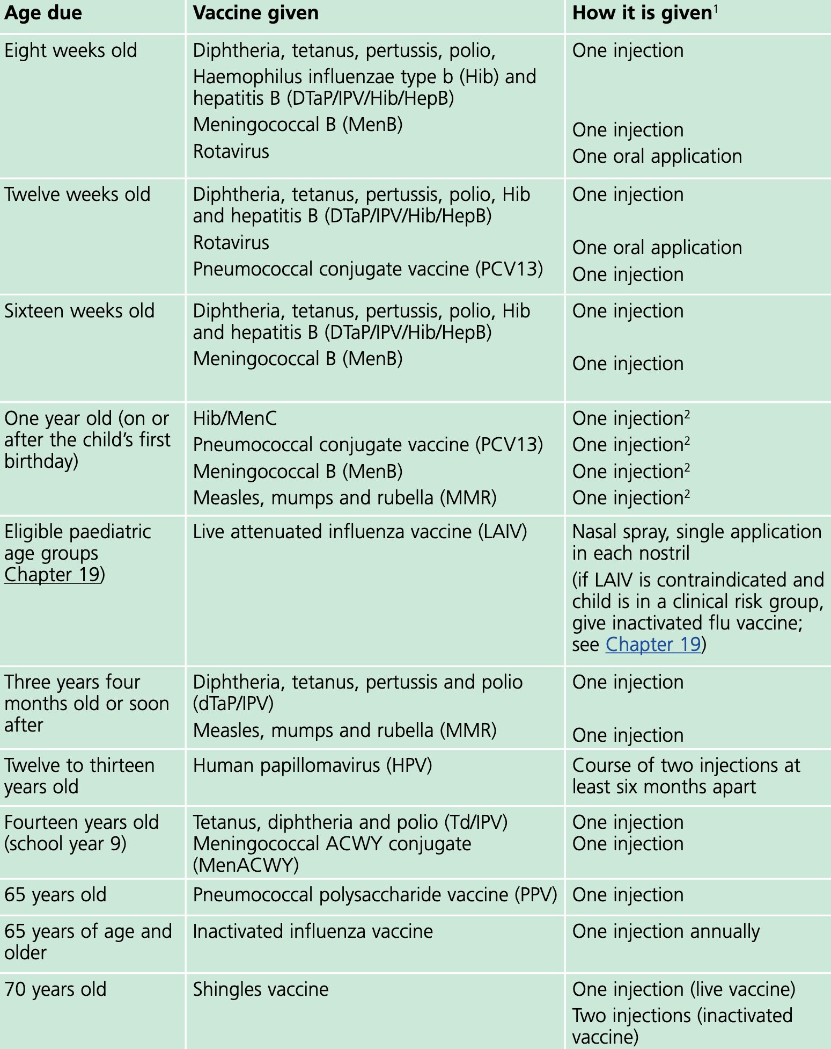

Annex B – Recall letter for adults

Dear [insert patient name],

I am writing to invite you to come for [insert immunisation] as it is now due. It is important for you to continue with this vaccination to guard against disease in the future.

Please call [insert number] to arrange a convenient date and time for an appointment with the practice nurse. If you have recently made an appointment, or have already had your vaccination, then please ignore this letter.

If you would like further information, please contact the organisation and ask to speak to a member of the nursing team. Alternatively, visit our website [insert web address] where information about immunisations is available.

Yours sincerely,

[Signature]

[Name]

[Role]

Annex C – Recall letter for children

To the parent or guardian of [insert child’s name]

I am writing to invite you to bring your child for the following [insert immunisation/s] as they are now due. It is important for your child to continue with this immunisation programme to guard against disease in the future.

Please call [insert number] to arrange a convenient date and time for an appointment with the practice nurse. If you have recently made an appointment, then please ignore this letter.

If you would like further information, please contact the organisation and ask to speak to a member of the nursing team. Alternatively, visit our website [insert web address] where information about immunisations is available.

Yours sincerely,

[Signature]

[Name]

[Role]

Annex D – Self-administration vaccine protocol

An informative video showing how to self-administer a vitamin B12 injection is available on YouTube. Should the vaccine not be vitamin B12, the organisation will discuss the process as whilst this may be the same as for all intramuscular vaccinations, there may be specific requirements that need to be discussed.

Preparing to give a vitamin B12 injection

Unlike most other vaccines, vitamin B12 vaccines are not to be stored in the fridge but should be stored at room temperature (between 15- and 30-degrees Celsius). The ampules should be protected from direct sunlight and both children and pets.

To administer the vaccine, the following will be needed

- 3 ml syringe
- Green needle and blue needle
- Vitamin B12 ampoule
- Cotton wool
- Sharps box

To prevent the risk of infection under the skin during an injection it is important that hands are washed and touching the sterile parts of the needle and syringe during the injection is avoided.
Current guidance within The Green Book Chapter 4 states that if the skin is clean, no further cleaning is necessary. Only visibly dirty skin needs to be washed with soap and water and then dry the area.
- Attach the green needle to the syringe (usually 3 ml syringe)

- Shake all the red fluid into the bottom part of the ampoule

- Using a tissue to hold the ampoule, snap the top off backwards where the red spot faces forwards. Put the top into the sharps box

- Remove the cap from the green needle and draw all the red vitamin B12 fluid from the ampoule into the syringe by pulling the plunger out from the syringe. Avoid touching the needle on the glass bottom of the vial, because it might dull its sharpness

- Put the empty ampoule into the sharps box

- Hold the syringe upside down (green needle at the top) so all the red fluid is at the bottom and check for trapped air. If you see an air bubble, flick the side of the syringe. You may need to flick it several times until all air has risen to the top. Then push the plunger a little, just enough to push out the air

- Remove the green needle and put it into the sharps box

- Attach the blue needle to the syringe without the tip of the syringe or the connection of the blue syringe touch anything else

- Hold the syringe upside down (blue needle at the top) and make sure there are no further air bubbles

- The injection is ready to administer

How to give yourself a vitamin B12 injection

When you give yourself a vitamin B12 injection, either the upper arm or thigh are the preferred sites.

Be careful to keep injection sites 1″ (2.5cm) apart from each other and do not inject to any swollen or burnt spot.

- You will need to expose the top of the arm or the outer part of the thigh where the injection will be given

Upper arm

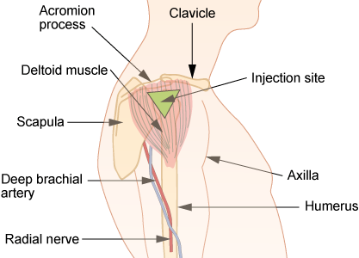

  - You can use the upper arm muscle if you can feel the muscle there. If you are very thin or the muscle is very small, do not use this site

  - The muscle forms an upside-down triangle that starts at the bone going across the upper arm

  - The point of the triangle is at the level of the armpit

  - Put the injection in the centre of the triangle of the muscle. This should be 1-2 inches (2.5 to 5 cm) below that bone

Thigh

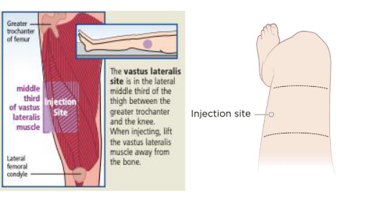

  - Look at the thigh and imagine it in 3 equal parts
  - Put the injection in the middle of the thigh

- Remove the cover from the blue needle
- Push the needle into the skin at a 90º angle until it cannot go any further
- Push the plunger down slowly until the syringe is empty
- Pull the needle out the skin and discard immediately into the sharps bin
- Dab with cotton wool or cover if appropriate
- Ensure all packaging from the needles and syringe are disposed of into a household waste bin

Possible complications of intramuscular B12 injections

- At times, the needle can hit a small blood vessel causing a small amount of bleeding under the skin. This causes a bruise to appear which resolves over a few days. Applying moderate pressure to the injection site with cotton wool or gauze for a few minutes after the injection may help to avoid larger bruises,

- Injecting in the wrong area can cause an abscess to form under the skin. To avoid this, only inject in the area recommended by your nurse or doctor. Do not inject into a painful or inflamed area. Seek medical advice if this happens,

[Insert organisation name] cannot accept responsibility if the instructions given by your clinician are not followed and result in injury.

If you are unsure what to do or have any questions, please do not hesitate to contact [insert contact name].

Annex E – Childhood immunisation disclaimer form
To: Sheerwater Health Centre
*Delete as appropriate
I/We* acknowledge that all children can be exposed to disease that can have serious, if not fatal consequences, for example, measles, mumps, meningitis and polio. The only way to protect children is by immunisation; this will also help to protect other people with whom the child may come into contact, such as those with weakened immune systems, newborn babies or the elderly.
I/We* also acknowledge that immunisation is the safest and best defence against epidemics that can kill or disable both adults and children. I/We* understand that vaccines work by making the body produce antibodies which are used to fight diseases without infecting the person with the disease.
Considering the above, I/we* would like to advise Sheerwater Health Centre that I/we* do not wish for my/our child to participate in the NHS childhood immunisation schedule.
I/We* assume full responsibility for my/our* decision and confirm that I/we* have read and understand the above statement about the associated risks and benefits and the importance of childhood immunisations in reducing the risk of my/our child contracting serious, potentially fatal diseases.
Furthermore, please do not send me/us* any further invitations for childhood immunisations.
I/We* understand that my/our* child can be restored to the vaccination schedule at any time by contacting the practice.
The Green Book Chapter 2: Consent states that the consent of one person with parental responsibility is usually sufficient. However, if one parent agrees to immunisation but the other disagrees, the immunisation should not be conducted unless both parents can agree to immunisation or there is a specific court approval that the immunisation is in the best interests of the child.
I confirm I have sole parental responsibility for my child, and this is my decision
We confirm we have joint parental responsibility and are both agreed about this decision
Child’s surname |  | Child’s forename(s)
Date of birth |  | NHS number

Continued overleaf:

Adult with parental responsibility 1:

Name

Address
Postcode

Signature

Date

Adult with parental responsibility 2:
Name

Address
Postcode

Signature

Date

Please return this form to the practice as soon as possible.

Immunity and how vaccines work: The Green Book, Chapter 1

