Dementia Guidance Document

Version: | Review date: | Edited by: | Approved by: | Comments:
v1.4 | 11/10/2024 | Sultan Mohamed | Munira Mohamed
 | October 2026 |  |  | Next review

Table of contents
1 Introduction 2
1.1 Policy statement 2
1.2 Status 2
2 Understanding dementia 2
2.1 Dementia 2
2.2 Early-onset (or young-onset) dementia 2
2.3 Diagnosing dementia 3
3 Care pathway 3
3.1 The Well Pathway for Dementia 3
3.2 Prevention 5
3.3 Initial assessment 5
3.4 Pharmacological intervention 5
3.5 Looking after someone with dementia 5
3.6 Care planning 6
3.7 Practice friendly considerations 6
4 Capacity 6
5 Training 7
5.1 Requirement 7
6 Summary 7

Introduction

Policy statement

NHS England advises that dementia is a growing challenge and the number of people with dementia in the UK is estimated to be 850,000. It is imperative that staff at this organisation fully understand the care pathway for dementia to ensure that dementia sufferers receive an optimal level of care at all times. Dementia is a key priority for NHS England and the Government.

All staff at this organisation have a responsibility to make sure they adhere to the guidance detailed within this document which will ensure that the highest standard of care is offered to those patients with dementia and the appropriate level of support is afforded to carers.

Status

The organisation aims to design and implement policies and procedures that meet the diverse needs of our service and workforce, ensuring that none are placed at a disadvantage over others, in accordance with the Equality Act 2010. Consideration has been given to the impact this policy might have regarding the individual protected characteristics of those to whom it applies.

This document and any procedures contained within it are non-contractual and may be modified or withdrawn at any time. For the avoidance of doubt, it does not form part of your contract of employment. Furthermore, this document applies to all employees of the organisation and other individuals performing functions in relation to the organisation such as agency workers, locums and contractors.

Understanding dementia

Dementia

NICE defines dementia as a progressive, irreversible clinical syndrome with a range of cognitive and behavioural symptoms including memory loss, problems with reasoning and communication, change in personality and a reduction in the person’s ability to carry out daily activities.

Early-onset (or young-onset) dementia

Early-onset dementia is defined by NICE as dementia that develops before the age of 65 years.

Diagnosing dementia

NICE states that for a diagnosis of dementia to be made, the patient must have impairment in at least two cognitive domains – memory, language, behaviour, visuospatial or executive function which:

- Causes significant functional decline in work or usual activities
- Cannot be explained by either psychiatric disorders or delirium

Mild cognitive impairment (MCI) is defined as cognitive impairment that does not meet the diagnostic criteria for dementia, for example, as only one cognitive domain is affected, or deficits do not significantly affect daily activities.

Care pathway

The Well Pathway for Dementia

The Well Pathway for Dementia illustrates the appropriate care pathway for patients, including reducing the risk and end of life care, ensuring that patients with dementia die with dignity.

The NHS England pathway is shown on page 4.

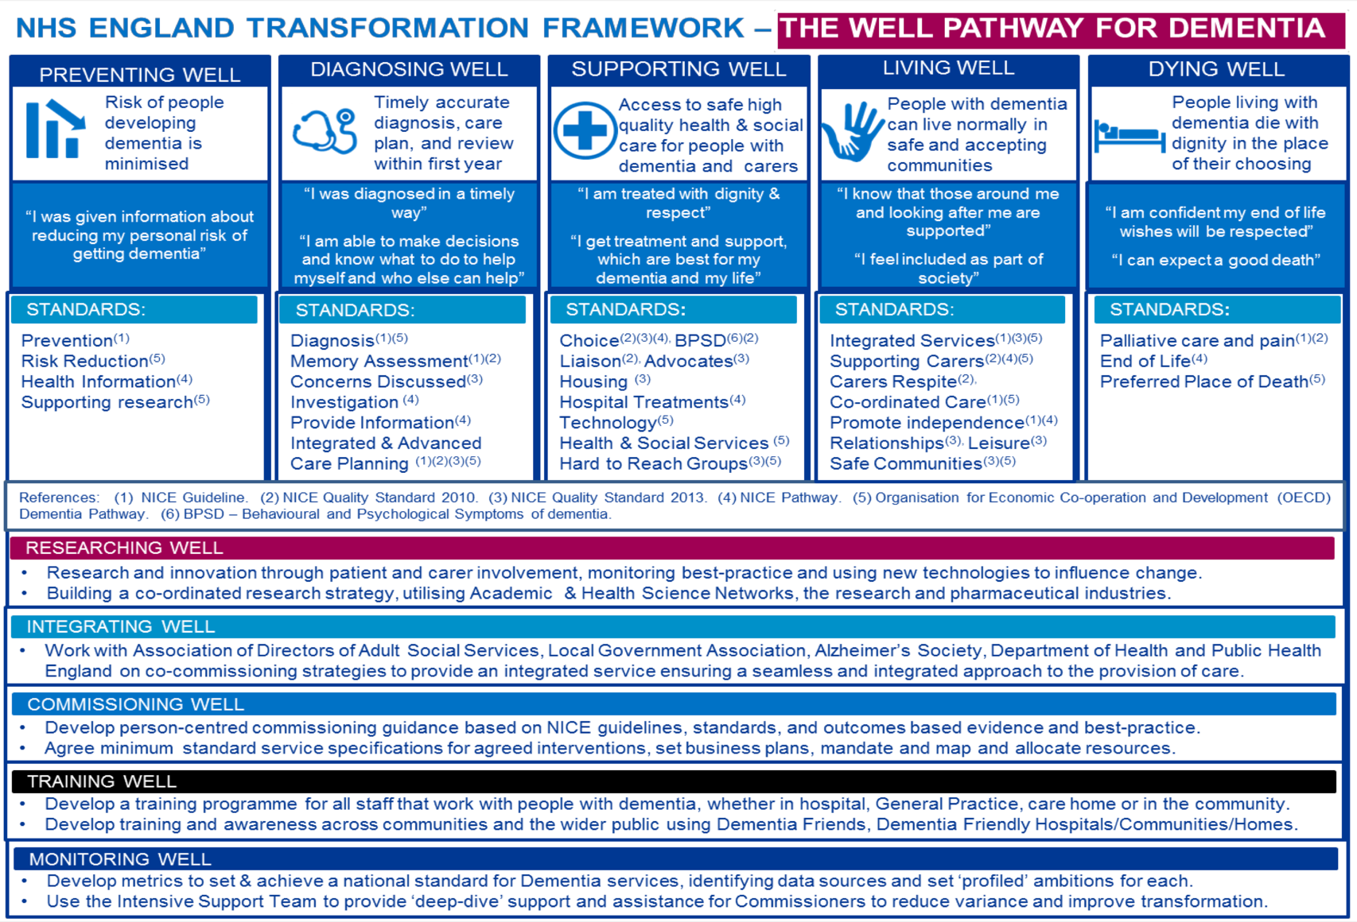

Prevention

NICE Guideline NG16 provides recommendations on promoting healthy lifestyles and encouraging healthy behaviours, including but not limited to:

- Smoking cessation
- Becoming more physically active
- Reducing alcohol consumption
- Adopting a healthy diet
- Achieving and maintaining a healthy weight

At this organisation we actively promote healthy living and have patient information readily available to support and encourage a healthy lifestyle.

Initial assessment

Initial assessment should be undertaken in accordance with NICE guideline NG97 which also includes guidance regarding management and support for people living with dementia and their carers.

Clinicians can use the baseline assessment tool to assess whether clinical practice conforms to NICE guidance and should be used in conjunction with NG97.

In addition to the NICE guidance, clinicians can also use the Dementia diagnosis and management guidance issued by NHS England.

The Dementia Roadmap is a resource that has been produced to support primary care staff in diagnosing, supporting and signposting people with dementia. It provides high-quality information about the dementia journey alongside local information about services, support groups and care pathways to assist primary care staff to more effectively support people with dementia and cognitive impairment, their families and carers.

Pharmacological intervention

Recommended medication can be found at paragraph 1.5 – Pharmacological intervention for dementia within NG97.

Looking after someone with dementia

NHS England provides detailed guidance on looking after someone with dementia. This guidance is primarily for family members and carers. Additionally, there are a number of charities and voluntary organisations that can provide valuable support:
- Alzheimer's Society's Dementia Connect support line on 0333 150 3456
- Age UK Advice Line on 0800 678 1602 (free)
- Independent Age Helpline on 0800 319 6789 (free)
- Dementia UK's Admiral Nurse Dementia Helpline on 0800 888 6678 (free)
- Carers Direct helpline on 0300 123 1053 (free)
- Carers UK Helpline on 0800 808 7777 (free)
- Dementia Carers Count has a virtual carers centre that provides a range of online support and resources

Care planning

Effective care planning is essential; each care plan must be bespoke and meet the needs of each patient with dementia.

Staff at this organisation will use Dementia: Good Care Planning, the aim of which is to enhance the provision of care offered by GPs, incorporating a standardised approach to dementia care planning.

Practice friendly considerations

At this organisation, we have considered how our environment may affect a person living with dementia. Following the recommendations in CQC GP Mythbuster No 42: Caring for people with dementia, this organisation has implemented the following:

- Contrasting colours for walls and floors
- Handrails in corridors
- Effective signage
- A quiet area where it is ‘safe’ for people to wait without feeling anxious
- Offering longer appointments and at quieter times of day.

Additional considerations can be sought from the Alzheimer’s Society.

Capacity

Sometimes a person living with dementia may lack capacity and consideration must be given to best interest decisions about health and social care.

In some instances, a GP or other member of the team may be asked to become involved in certifying Powers of Attorney and this can be for both health and social needs as well as financial decisions.

Additional information can be found within the Mental Capacity Act Policy.

Training

Requirement

All health and social care staff who may be involved in the care of people with dementia should have the appropriate skills and knowledge to provide effective care, commensurate with their roles and responsibilities.

The Dementia Awareness course is available in Blue Stream Academy (e-platform) to enable staff to develop their skills and knowledge, ultimately delivering an excellent level of care to dementia patients.

Summary

It is essential that those patients suffering from dementia, their families and carers are offered the appropriate level of support from the outset and consistency is key to successful outcomes.

All staff at this organisation will adhere to the referenced material within this policy to ensure that the highest level of care is delivered to patients at all times.

