Duty of Candour Policy

Version: | Review date: | Edited by: | Approved by: | Comments:
v1.5 | 16/10/2023 | Sultan Mohamed | Munira Mohamed
 | October 2025 |  |  | Next review

Table of contents

1 Introduction 2
1.1 Policy statement 2
1.2 Status 2

2 Overview 2
2.1 Duty of candour 2
2.2 Degrees of harm 3
2.3 Notifiable safety incidents 3

3 Procedure 5
3.1 Responding to a notifiable safety incident 5
3.2 A ‘sincere apology’ 6
3.3 Reporting an incident to the authorities 6

Annex A – Sample letter 7

Introduction

Policy statement

CQC GP Mythbuster 32: Duty of Candour and General Practice (Regulation 20) explains that Sheerwater Health Centre must promote a culture that encourages candour, openness and honesty at all levels. This should be an integral part of a culture of safety that supports organisational and personal learning.

Regulation 20 sets out some specific requirements that this organisation must follow when things go wrong with care and treatment, including informing people about the incident, providing reasonable support and truthful information and providing an apology when things go wrong.

A culture of ‘being open’ is fundamental to the organisation’s relationships with (and between) patients, the public, organisation staff and other healthcare organisations.

Status

The organisation aims to design and implement policies and procedures that meet the diverse needs of our service and workforce, ensuring that none are placed at a disadvantage over others, in accordance with the Equality Act 2010. Consideration has been given to the impact this policy might have regarding the individual protected characteristics of those to whom it applies.

This document and any procedures contained within it are non-contractual and may be modified or withdrawn at any time. For the avoidance of doubt, it does not form part of your contract of employment. Furthermore, this document applies to all employees of the organisation and other individuals performing functions in relation to the practice such as agency workers, locums and contractors.

Overview

Duty of candour

The duty of candour is a general duty to be open and transparent with people receiving care from this organisation. Regulation 20 explains that both the statutory duty of candour and the professional duty of candour have similar aims, to make sure that those providing care are open and transparent with the people using their services whether or not something has gone wrong.

The organisation will use the following definitions in relation to the duty of candour:

- Openness – enabling concerns and complaints to be raised freely without fear and questions asked to be answered
- Transparency – allowing information about the truth about performance and outcomes to be shared with staff, patients, the public and regulators
- Candour – any patient harmed by the provision of a healthcare service is informed of the fact and an appropriate remedy offered, regardless of whether a complaint has been made or a question asked about it

Degrees of harm

The organisation will use the following CQC definitions when defining degrees of harm:

Moderate harm | Harm that requires a moderate increase in treatment and significant but not permanent harm
Severe harm | A permanent lessening of bodily, sensory, motor, physiologic or intellectual functions, including removal of the wrong limb or organ or brain damage, that is related directly to the incident and not related to the natural course of the service user's illness or underlying condition
Moderate increase in treatment | An unplanned return to surgery, an unplanned re-admission, a prolonged episode of care, extra time in hospital or as an outpatient, cancelling of treatment or transfer to another treatment area (such as intensive care)
Prolonged pain | Pain which a service user has experienced, or is likely to experience, for a continuous period of at least 28 days
Prolonged psychological harm | Psychological harm that a service user has experienced, or is likely to experience, for a continuous period of at least 28 days

Notifiable safety incidents

Notifiable safety incident is a specific term defined in the duty of candour regulation. It should not be confused with other types of safety incidents or notifications. A notifiable safety incident must meet all three of the following criteria:

- It must have been unintended or unexpected
- It must have occurred during the provision of regulated activity
- In the reasonable opinion of a healthcare professional, it already has, or might, result in death or severe or moderate harm to the person receiving care

If any of these criteria are not met, it is not a notifiable safety incident (but remember that the overarching duty of candour, to be open and transparent, always applies).
The flow diagram below illustrates how to identify a notifiable safety incident.

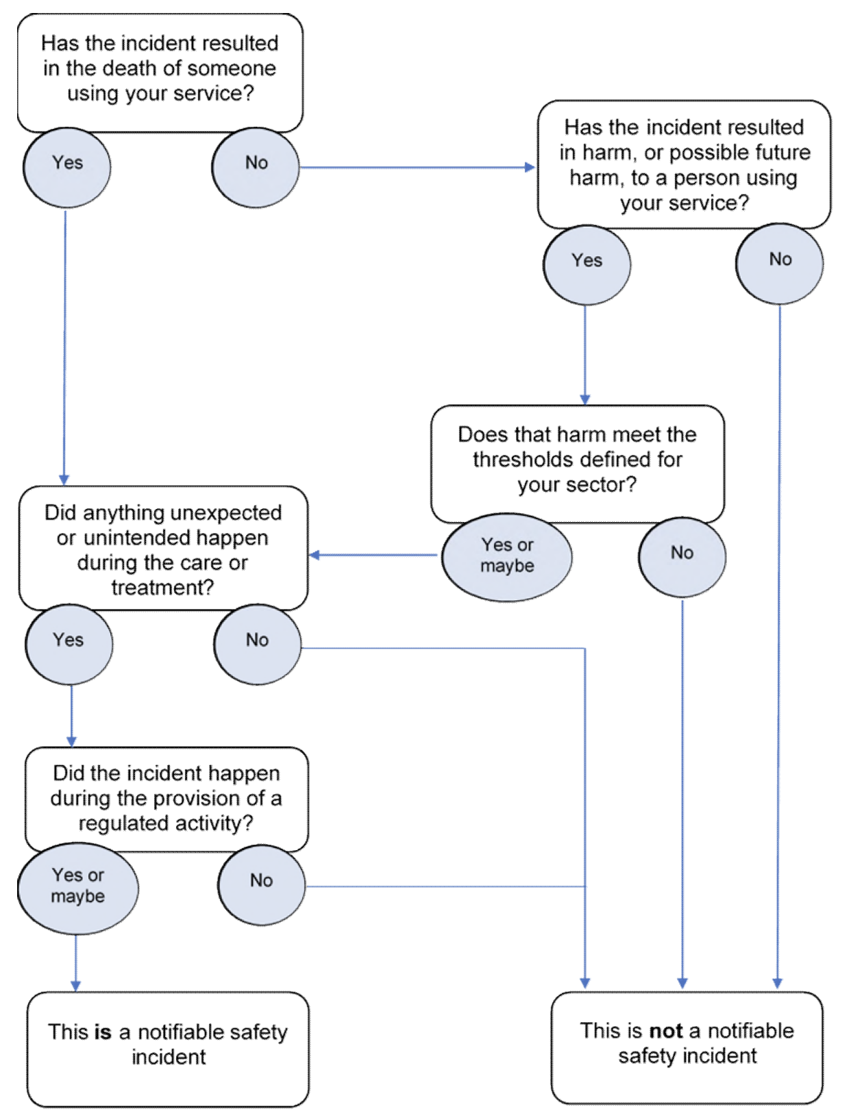

Image source: CQC

Procedure

Responding to a notifiable safety incident

The diagram below illustrates the process to be followed when a notifiable safety incident has been identified. CQC guidance states that the following procedure must be started as soon as reasonably practicable:

It is essential that this organisation keeps a written record of all communication with the service user, as stated in Regulation 20.

A letter template is available at Annex A.

A ‘sincere apology’

NHS Resolution states that saying sorry is always the right thing to do, is not an admission of liability, acknowledges that something could have gone better and is the first step to learning from what happened to prevent it recurring.

Saying sorry meaningfully when things go wrong is vital for everyone involved in an incident including the patient, their family, carers and the staff who care for them. Detailed information is available in the NHS Resolution Saying sorry guidance document.

Reporting an incident to the authorities

Depending on the degree of harm, the organisation must consider reporting the incident to the following:

- Integrated Care Board

- Care Quality Commission

- Learning from Patient Safety Events Service

Annex A – Sample letter

[Insert patient’s or carer’s name and address together with the date and reference number of the letter as per the organisation’s house style].

Dear (patient/relative)

Following our initial meeting which took place on [insert date] to inform you of a notifiable safety incident under the statutory duty of candour, I am writing to provide you/your [identify relationship, e.g., husband, wife, etc.] with all the relevant information that was provided at that initial face-to-face meeting.

As discussed at the initial meeting, we investigated this event and explained our findings to you as follows [insert details of findings].

*Delete if not applicable

[As discussed at the initial meeting, we stated that we are undertaking further enquiries and when these have been completed, we will inform you of the outcome.]

OR

[As discussed at the initial meeting, we stated that we were undertaking further enquiries. These have been completed and the outcome is as follows.]

Please find enclosed a leaflet detailing the duty of candour. This has been created by an organisation called AvMA and has been endorsed by the Care Quality Commission.

We would like to express our sincere apologies that this event occurred as the organisation aims to provide the good, high-quality services that our patients expect.

Yours sincerely,

For and on behalf of the organisation

