


Title | Sheerwater Health Centre  Incident and Business Continuity Plan
Version | 2.0 | Dated | June 2023
Owner | Dr Munira Mohamed | Author | Practice Manager
Approved by | Signed off by partners at practice meeting | Next review | One year from date plan last approved

SHEERWATER HEALTH CENTRE
Business Continuity and Incident Management Plan
OFFICIAL SENSITIVE not for wider sharing / publication

Purpose
This document contains contacts details for use by the Sheerwater Health Centre staff and partners when responding to incidents and emergencies.
Distribution and Accessibility
Partners management meetings
Staff meetings
Access via Teletrek Intranet
Hardcopy and computer access held of site by Senior Partner and Practice Manager
Version | Changes
001 | Implementation of this policy personalised to Sheerwater Health Centre

Invocation of this plan
This plan will be implemented by discussion with all members of staff at Practice Meetings which are minuted.

Contents
1. Overview 3
2. Aim 3
3. Objectives 3
4. Scope 4
5. Types of Incidents 4
6. Notification, Escalation and Invocation 5
7. Incident Co-ordination 6
8. Decision making and recording 6
9. Data Sharing 7
10. Communications / Media 7
11. Recovery 8
12. Debriefs 9
13. Training and Exercising 9
14. Business Continuity 8
15. Action Plan 16
16. Appendices 16

1. Overview
  - This business continuity and incident management plan [the plan] has been developed in collaboration with NHS Surrey Heartlands and other health & social care partners across the Surrey Heartlands Integrated Care System.
  - The aim of this plan is to ensure that all GP practices across the Surrey Heartlands ICS have a robust framework from which they can respond to incidents affecting their services and their local communities, in conjunction with multi-agency partners.
  - This plan relates to the single-agency actions to be undertaken by GP practices. Multi-agency actions and response actions can be found in Local Resilience Forum (LRF) and Local Health Resilience Partnership (LHRP) plans. (Please contact the NHS Surrey Heartlands EPRR team via syheartlandsicb.shoc@nhs.netfor more information).
  - All NHS funded providers, including primary care, are required to comply with the NHS England Emergency Preparedness, Resilience and Response (EPRR) Framework 2022 and align to the NHS England EPRR Core Standards issued each year. EPRR arrangements are also covered under section 30 of the standard NHS contract and the Care Quality Commission (CQC) undertake a review of the arrangements in place to respond to emergencies and major incidents, including business continuity planning.
  - This plan is designed to evidence the compliance of GP practices in the Surrey Heartlands ICS with EPRR requirements set out above. It also represents a statement of intent for the Practice as it commits resources and funding to EPRR activities as part of an annual work plan that includes planning, reviewing, training and exercising. It should be developed in collaboration with other practices and healthcare providers to ensure the whole patient pathway is considered.
  - The Practice Manager is responsible for ensuring suitable and sufficient EPRR arrangements are in place for the Practice, with support from the Partners and the Assistant Practice Manager. The Practice Manager should report progress on the work plan to senior partners at least annually.

Aim
  - To provide a framework that supports Sheerwater Health Centre to respond to incidents and emergencies in an effective and coordinated way.

Objectives
  - This plan is specifically designed to:
    - Guide the actions of staff in response to an incident or emergency.
    - Assess threats and risks that could potentially impact on the delivery of primary care services.
    - Identify and prioritise critical activities, personnel, data, assets and supply chains required to deliver primary care services.
    - Identify emergency communications and escalation arrangements.
    - Identify back-up locations and resources.
    - Outline the training and exercising arrangements for staff to ensure effective emergency preparedness.
    - Identify weaknesses and other single points of failure in order to develop mitigating actions thus improving the resilience of the GP practice.

Scope
  - This plan covers all the services and activities provided by Sheerwater Health Centre, which are based at the following locations:
Location | Address | Telephone
Sheerwater Health Centre | Devonshire Avenue, Sheerwater, Woking, Surrey. GU1 5QJ | 01932 343524

Types of Incidents
  - As defined in the NHS England EPRR Framework 2022, there are three types of incidents which are:
    - A business continuity incident(BCI) is an event or occurrence that disrupts, or might disrupt, an organisation’s normal service delivery, below acceptable predefined levels, where special arrangements are required to be implemented until services can return to an acceptable level.
    - There are a wide range of scenarios that could lead to a BCI, such as flooding, ICT outage, surge in demand, high levels of staff absence, etc. The business continuity aspects of the incident affecting the GP practice will be managed by the GP practice with support from NHS Surrey Heartlands. Note: A GP practice may need to declare a BCI as a result of a wider critical or major incident.
    - A critical incident is any localised incident where the level of disruption results in the organisation temporarily or permanently losing its ability to deliver critical services, patients may have been harmed or the environment is not safe requiring special measures and support from other agencies, to restore normal operating functions.
    - For example, a major fire or a legionella outbreak affecting the practice, etc.Critical incidents will be managed jointly by the GP practice and NHS Surrey Heartlands.
    - A major incident is any occurrence that presents serious threat to the health of the community or causes such numbers or types of casualties, as to require special arrangements to be implemented.
    - For example, a plane / train crash, terrorist attack or chemical incident resulting in multiple patients requiring urgent treatment. Major incidents will be managed by NHS Surrey Heartlands in conjunction with multi-agency partners and GP practices should provide with support as appropriate. Note: GP Practices are unlikely to need to declare a major incident.

Notification, Escalation and Invocation
  - Staff members identifying an incident or emergency should assess the situation and call emergency services if required by dialling 999. Immediate life safety actions should be implemented, such as evacuation of the premises.
  - The Practice Manager or duty manager should be informed in order to decide if this plan should be invoked and whether the situation needs to be escalated, for example to NHS Surrey Heartlands, the CQC, etc.
  - The NHS Surrey Heartlands Tactical on-call manager (available 24 hours a day, 7 days a week) is the first point of escalation and can be contacted by calling 0208 242 6511. The Tactical on-call can access additional support across the ICS and will alert NHS England as required.
  - In accordance with Joint Emergency Services Interoperability Principles (JESIP), the following information should be included as part of the escalation where possible:
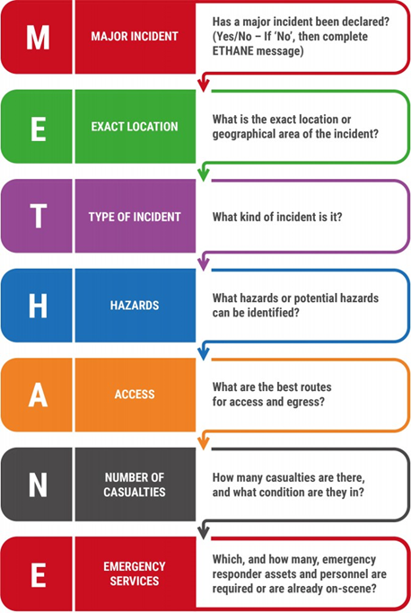
  - Note: Practice activity data is uploaded into the Primary Care OPEL system each day. Any change to Practice OPEL status because of the incident or emergency occurring should be updated on the system and shared with the M/ETHANE message.

Incident Co-ordination
  - In the event of an incident the GP practice will manage the response from Sheerwater Health Centre. If this location is unavailable, the back-up location(s) will be Maybury Surgery, Alpha Road, Woking, Surrey GU22 8HF.
  - An incident response group should be established and include the following members:
    - Practice Partner(s)
    - Practice Manager
    - Loggist / note taker
    - NHS Surrey Heartlands Primary Care Commissioning Team representative if available or Surrey Heartlands Tactical on-call

  - If the nature and/or scale of the incident warrants, NHS Surrey Heartlands may establish an Incident Coordination Centre (ICC) to support or manage the incident – this will be at the discretion of the Surrey Heartlands Strategic on-call manager.

Decision making and recording
  - It is essential that decision making is effective, timely and recorded appropriately. The JESIP Joint Decision Making Model (JDM) is seen as best practice within the NHS for emergency response and can be used through the JESIP App (https://www.jesip.org.uk/jesip-app).
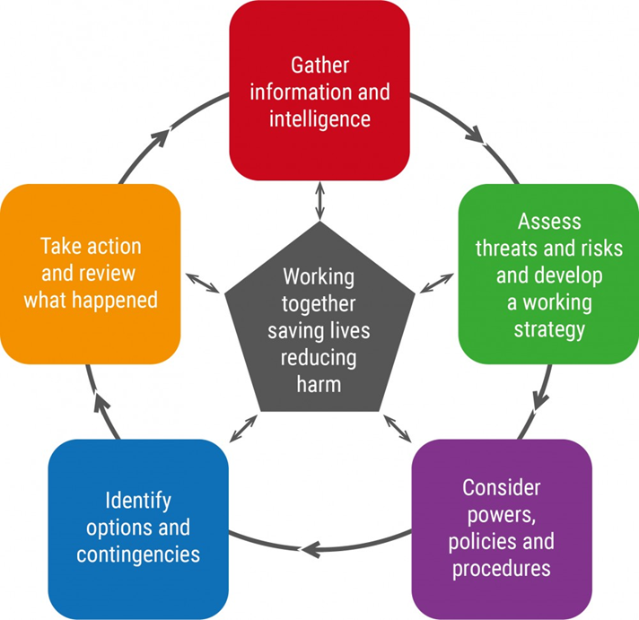
  - Information and decisions should be recorded, and an audit trail maintained, in order to provide an accurate record of events. Where appropriate, a designated loggist or note taker should be used to ensure all information is captured including details of decisions made and actions taken by the GP practice. All other records, emails, call logs, minutes, notes, post it notes, other papers or audiotapes should be kept for analysis after the event.

Data Sharing
  - It may be necessary to share patient information during an emergency or business disruption. Health and care professionals have a legal duty to share relevant information to support individual care and the law and the Caldicott Principles support you to do this. The duty to share information for individual care is as important as the duty to protect confidentiality. You should therefore feel confident to share information where this is considered to be in the best interests of the patient, is undertaken in a secure manner to safeguard confidentiality and where possible is supported by the patient’s consent.
  - Where you intend to share information in support of a patient’s direct care, you are confident this would be within the reasonable expectations of the patient, and you have no reason to believe the patient has objected to the sharing, you can safely imply a patient’s consent and share their information. If you are unsure or have concerns about the expectations of a patient and are able to do so, you should seek their explicit consent.
  - When sharing data, the following points should be considered:
    - Make sure that the person you are sharing information with has a legitimate and appropriate reason to be involved in the care of the patient or service user.
    - Check for patient or service user objections. If someone has objected but you are concerned that his might impact upon providing safe care, you should talk to your DPO, information governance support and/or Caldicott Guardian.
    - Share only relevant and necessary information.
    - Ensure information is transferred securely when it is shared with others, for example, via NHSmail or other secure and approved communication tools.
  - The Caldicott Principles help to ensure that health and care information is used and shared appropriately to support care. Please follow the guidance set out in the principles when sharing information for care and other purposes.
  - The Primary Care Data Protection Officer (DPO) or NHS Surrey Heartlands Information Governance Team can provide further advice and support to individual GP practices.

Communications / Media
  - It is essential that communication is maintained with key stakeholders, including staff and patients, throughout an emergency or business disruption.
  - Surrey Heartlands operates a 24/7 communications on call service and can be contacted to provide advice and support in the event of an incident. The team can be contacted via the JAM Media service on 020 8389 1475(please note this is not a public facing number so is not to be shared externally).
  - In the event of an incident practices will want to make use of their existing communications channels as appropriate to keep patients, staff and key stakeholders updated.
  - Communications channels include:
Stakeholder | Communication channels
Staff | e.g. website, SMS cascade, social media, phone list
Patients | e.g. website, AccuRx messaging, social media, phone list
Community | e.g. social media channels and website
Key stakeholders including the media | e.g. Web statements, email updates and telephone calls as required
Other | Face to Face

  - When communicating during an incident it is important to consider the messages that are being given publicly – making sure these provide helpful, up-to-date information and that messages support the reputation of the practice, NHS and wider partners. The Surrey Heartlands communications on call team can advise on messaging and the most appropriate channels.
  - If the practice receives enquiries or requests from the media, the practice will probably want to respond by providing an update, which will include messages that are already being shared with the public and other partners. This can be published as an update on the practice website and journalists can be referred to the practice website to ensure consistency of messaging. This also helps to manage with multiple requests.
  - If a media outlet requests an interview, this will need to be carefully considered by the practice and the Surrey Heartlands communications team can advise on this. Any spokespeople put forward should be senior, well versed on the incident and media trained. If it is not possible to put forward a spokesperson, or there is no-one suitable available, journalists can be referred to updates on the practice website or written statements (which ideally would come from a named partner).
  - Regular updates should be provided throughout the duration of the incident. This will ensure patients, staff and wider stakeholders receive timely information and it will also give confidence in the practice and the local NHS and its ability to effectively manage an incident to ensure resolution as quickly as possible.

Recovery
  - As soon as practicable,consideration should be made about recovering the services affected by the incident. This may initially be done as part of the incident response group (see 7.0)but separate resources should be assigned to manage this when practicable.
  - There are four overarching categories of impact that need to be considered, which are:
    - Humanitarian (including Health): Physical impacts (including individuals’ health, housing, financial needs and personal possessions); Psychosocial impacts, death, etc.
    - Economic: business recovery, cost of services, impact on supply chain, etc.
    - Infrastructure: building reconstruction, site clearance, security of empty properties, disruption to utilities and essential services, etc.
    - Environmental: pollution and decontamination, waste management, etc.

Debriefs
  - It is good practice to conduct debriefing after in order to support the welfare of staff as well as to identify learning opportunities to improve processes. Hot debriefs should be held at the end of the incident (or period of duty if the incident is protected) to capture initial thoughts and urgent issues.
  - A more structured debrief should be held within two weeks that can be based on the NHS After Action Review (AAR) process. A report, with action plan as appropriate, should then be compiled to ensure that lessons are implemented and can be shared. Further debriefing support is available through syheartlandsicb.shoc@nhs.net.

Training and Exercising
  - The GP practice will ensure that staff receive training appropriate to their role, which should be recorded against each individual for audit purposes. In addition, the provider will ensure that this plan is tested at least every twelve months.
Date | Exercise | Outcomes / actions
18.10.2023 | Management of critical incidents | Staff training  Recorded in minutes of staff meetings

Business Continuity
  - In the event of a business continuity incident, the GP practice will identify the nature of the incident and work to protect / recover the priority activities identified by their business impact analysis (see 13.4 below), within the predetermined recovery time objective. The GP practice will aim to minimise the impact that any incident may have on their patients and local communities. This plan should be reviewed annually, following an incident or after any significant organisational changes. Further guidance on completing a business impact analysis is available from the NHS England website: https://www.england.nhs.uk/ourwork/eprr/bc/ .
  - Risk assessment
    - The GP practice will consider the hazards and threats they face, the risk posed by these hazards and threats, and the mitigations they can put in place to minimise the impact on business if these risks are realised. The hazards and threats should reflect the National Risk Register, the Surrey Community Risk Register and any local / organisational risk identified by the provider and recorded in the table below. These risks should be regularly reviewed (at least annually) and recorded in the Practice risk register.
    - The following risks have been identified by Sheerwater Health Centre as potentially affecting the provision of their services (further guidance on risk assessment is available in appendix 15.15):
Risk Description | Likelihood | Impact | Risk Rating | Owner | Mitigation
Flooding | 2 | 2 | 4 | Dr Munira Mohamed
Fire | 2 | 3 | 6 | Dr Munira Mohamed
Significant Staff Absence | 3 | 2 | 6 | Dr Munira Mohamed
IT Failure | 2 | 2 | 4 | Dr Munira Mohamed
Significant Structural Damage to the Building | 1 | 4 | 4 | Dr Munira Mohamed
Severe Weather Conditions | 3 | 3 | 9 | Dr Munira Mohamed
Loss of utilities e.g power and water | 2 | 2 | 4 | Dr Munira Mohamed

  - High level considerations / capability planning
    - There are a range of generic scenarios (from national business resilience planning assumptions) that should be considered when undertaking business continuity planning arrangements, these are recorded as follows:
Scenario | Mitigating actions(the GP practice to amend / add to the suggestions below to fit their local circumstances)
Denial of access to site for up to 14 days. | - Working from a practice satellite site / branch surgery.  - Working from a buddy practice.  - Remote working for GPs providing telephone triage and online appointments.  - Working from other NHS sites supported by the Commissioning Support Unit (CSU).
Loss of premises for up to 6 months. | - Working from a practice satellite site / branch surgery.  - Working from a buddy practice.  - Remote working for GPs providing telephone triage and online appointments.  - Working from other NHS sites supported by the CSU.  - Contact NHS Surrey Heartlands / NHS Property Services to discuss current void space that could be utilised with some remedial work.  - Liaise with insurers to determine whether temporary working space can be provided.
Disruption to retail banking services / payment systems lasting for several days. | - Consider support to staff who may struggle to get into work due to inability to access funds – maximise remote working opportunities.  - Negotiate arrangements with any essential suppliers to ensure deliveries can continue.  - Seek alternative arrangements to pay staff, contractors and suppliers.  - Take cash payments only for chargeable services.
Significant disruption to trade, as well as disruption to financial transactions and the movement of goods. | - Consider what items are essential and get reassurance from suppliers that these will be delivered.  - Negotiate pooling resources through PCN or other NHS organisations.  - Consider stockpiling to mitigate on-going disruption to the supply chain, unless directed otherwise.  - Seek support from NHSE/I and / or DHSC via NHS Surrey Heartlands.
Up to 30% staff absence. | - Prioritise workloads. Suspend non-critical activities and redeploy staff to support critical activities.  - Consider use of agency staff.  - Request support from other GP practices and NHS organisations.
Disruption to fixed and mobile telecoms lasting for up to 3 days affecting a single wide geographic area. | - Determine what forms of communication are affected and then agree a work around.  - Utilise mobile phones, MS Teams, VOIP and fixed landlines as appropriate.  - Consider remote working if the server location is unaffected.  - Consider working from other sites that are less affected.  - Working from other NHS sites supported by the CSU.
Travel delays for up to 5 days. | - Minimise business travel to essential journeys – consider using rail, walk, cycle, etc.  - Maximise remote working opportunities for staffto reduce travel requirement.  - Consider working from other sites that are less affected by the transport disruption.  - Consider delays to deliveries and varying hours that they can be accepted.
Localised loss of water to non-industrial customers for up to 2 weeks. | - Consider provision of alternative potable water supplies where possible.  - Register with the water supplier as a priority user.  - Relocate to another site or buddy practice.  - Seek advice on infection prevention and control.
Loss of the national grid; some urban areas without power for up to 5 days and likely longer depending on the cause and degree of network damage. | - Consider working from other sites that are less affected.  - Register with the electricity supplier as a priority user.  - Working from other NHS sites supported by the CSU.  - Consider use of generators.
Disruption to fuel supply (petrol and diesel). | - Minimise business travel to essential journeys – consider using rail, walk, cycle, car share, etc.  - Maximise remote working opportunities for staff to minimise commuting fuel usage.  - Refer to the Local Resilience Forum fuel plan via NHS Surrey Heartlands.
Cyber issue affecting the ability to deliver digital GP services (spam, malware, ransomware, phishing, etc.). | - Maintain regular back up of all data and configurations.  - Follow CSU guidance to reduce the potential for cyber issues (anti-virus, firewalls, etc.), including not inserting unauthorised devices into laptops, etc.  - Refer to the latest guidance from the National Cyber Security Centre  - Turn off technology if cyber issues suspected and report to NHS Surrey Heartlands and CSU immediately  - Consider use of alternative technology or sites that are unaffected but supported by the CSU.  - Consider use of alternative processes, such as temporary paper records, to maintain essential activities.
Severe Weather - Heat | - Monitor temperatures within workspaces (above 25C)  - Use window blinds to reduce heat build-up in buildings  - Provide shade for staff working outdoors  - Plan activity to avoid the hottest part of the day (11am – 3pm)  - Ensure the availability of drinking water / encourage staff to stay hydrated  - Encourage the use of sun cream, use of hats, etc.  - Ensure all windows are secured properly at the end of the working day
Severe Weather – Cold/Frost | - Consider if it is safe to operate the site  - Encourage staff to work remotely where possible but are suitably prepared for any journeys they need to make (fuel, water, shovel, warm clothes, etc.)  - Monitor temperatures within workspaces (should remain above 16oc)  - Check heating systems working effectively  - Ensure any portable heaters are authorised and being used safely  - Define an area for the storage / drying of coats, boots, etc.  - Consider gritting exposed areas where temperatures fall below 0C  - Seek support from SCC to grit routes to sites  - Consider how to notify stakeholders including staff, patients/clients and suppliers if it is necessary to close the site.
Severe Weather - Wind | - Check windows and doors are closed and secured.  - Review the outside of the premises for items that maybe affected by high wind, such as waste storage, scaffolding, banners, temporary structures etc.
Other local scenario.

  - Priority activities (based on a generic business impact analysis
Activity | MTPD  (hours) | RTO  (hours) | MBCO | SPoF? | Resources required
Booking patient appointments. | 24 | 24 | Patients being able to call in to make appointments using a temporary booking system. | Yes | Telephony, IT – HSCN connection, EMIS/System1, Staff, Premises.
Patient contact. | 2 | 2 | Some method of contact re-established (email, phone, AccuRx messaging, radio, social media, etc.). | Yes | Telephony, IT – HSCNconnection, EMIS/System1, Staff, Premises.
Prescriptions. | 48 | 24 | Access to e-prescription system. | No | Telephony, IT – HSCNconnection, EMIS/System1, Staff, Premises, Prescription paper, practice stamp, GP.
Referrals – Two-week rules. | 24 | 24 | Telephone call to referral support service. | Yes | Telephony, IT – HSCNconnection, EMIS/System1, Staff, Premises, eRS/RSS.
Clinics – Urgent. | 6 | 6 | Telephone triage service. Clinician in a room to see patients. | No | Telephony, IT – HSCNconnection, EMIS/System1, Staff, Premises, GP or NP, clinical equipment and consumables.
Clinics – Routine. | 48 | 48 | Clinician in a room to see patients. | No | Telephony, IT – HSCNconnection, EMIS/System1, Staff, Premises, GP or NP clinical equipment and consumables.
Payroll. | 72+ | 24 | Staff paid as last month. | Yes | Medic Accountants  Sultan Mohamed
Banking. | 72+ | 24 | Access to online banking services. | No | Barclays Bank  Sultan Mohamed
Correspondence management. | 120 | 72 | Incoming correspondence prioritised and managed. | Yes | Telephony, IT – HSCNconnection, EMIS/System1, Staff, Premises.
Patient registrations. | 72+ | 72+ | As normal. | No | Telephony, IT – HSCNconnection, EMIS/System1, Staff, Premises.
Ordering supplies and stock control. | 24 | 24 | Have sufficient stock of key supplies. | Yes | Telephony, IT – HSCNconnection, EMIS/System1, Staff, Premises, Supplier business continuity arrangements.
General administration. | 72+ | 72+ | Reception and Admin staff briefed to continue essential services | Yes | Telephony, IT – HSCNconnection, EMIS/System1, Staff, Premises.
Receipt and management of test results –Urgent. | 2 | 2 | Lab to contact NHS111 to contact patient. | No | Telephony.

  - Resource contacts including mutual aid arrangements
Resource | Responsible person / organisation | Telephone | Comments / detail
Telephony | Surgery Connect X-on  Practice Manager  Sheerwater Health Centre | 0333 332 6633
IT – HSCNconnection | SCW South, Central and West Commissioning Support Unit  Sheerwater Health Centre | 0300 123 0880
EMIS | Practice Manager  Sheerwater Health Centre | 0330 094 7701 | Organisation Code: 2555
Staff | Dr Munira Mohamed  Practice Manager  Sheerwater Health Centre | 07894 388911  07730 360691 | Mutual aid arrangements with Maybury Surgery, Alpha Road Woking  01483 728757
Premises | Dr Munira Mohamed  Practice Manager  Sheerwater Health Centre | 07894 388911 | As above
GP/Practice Manger | Dr Munira Mohamed  Practice Manager  Sheerwater Health Centre | 07894 388911  07730 360691
Clinical equipment / consumables | Practice Manager  Sheerwater Health Centre | 07730 360691
Non-clinical equipment / consumables | Practice Manager  Sheerwater Health Centre | 07730 360691
eRS / RSS | Practice Manager  Sheerwater Health Centre | 07730 360691
Other?

  - Commissioned suppliers
Products / services supplied | Provider details (name / address / email) | Telephone | Comments (including account reference number, etc.)
Clinical Consumables | Williams Medical Supplies | 01395 270 530 | Account No: CW 028755
Vaccines & Injectables | AAH | 0344 561 8899 | Account No: 703M21003494N  GSK & MSK Vaccines & Denosumab
Vaccines & Injectables | Alliance Health Care | 0300 1000 448 | Account No: 738930  Depo-Provera & Depo-Medrone & Lidocaine B12 Hep A
Vaccines | Sanofi | 0800 854 430 | Account No: 10177179  Flu vaccine & Hep A & Typhoid Revaxis
SMS Services | AccuRx | 0207 099 2279  support@accurx.com
Pharmacy | May & Thomson | 01932 346186

  - Review
    - In accordance with ISO 22301, business continuity arrangements should be reviewed at least annually, following activation of the plan or significant organisational change.

Action Plan
  - An action plan should be developed to improve organisational resilience identified through the planning process as well as learning identified as a result of implementation of the plan, either through exercise or emergency / incident.
Ref | Action (plus owner) | Target date | Comments
1 |  |  | Nil to report
2

Appendices
  - Sheerwater Health Centre staff contact details in the event of an emergency (including out of hours).
Name | Role (plus additional incident role) | Telephone
Sultan Mohamed | Business Manager  Practice Partner  Media Spokesperson | 07949 965 774
Dr Munira Mohamed | Senior Partner | 07894 388 911
Nine Taylor | Practice Manager | 07730 360 691
Louise Gray | Assistant Practice Manger | 07809 373 606

  - Heatwave
    - GP practices should monitor heat health alerts circulated by the Met Office or cascaded by the NHS Surrey Heartlands. GP practices should sign up to receive weather alerts directly from the Met Office.
    - The table below outlines actions that should be completed by GP practices as the heat health alert levels escalate. Up to date guidance on these levels can be found in the NHS England Heatwave Plan - Heatwave Plan for England - GOV.UK (www.gov.uk).

Level 0 | Long-term planning - This is all year standing heatwave level.
- Develop systems to identify and improve the resilience of high-risk individuals*.
- Encourage cycling/walking where possible to reduce heat levels and poor air quality in urban areas.
- Work with commissioners to develop longer term plans to prepare for heatwaves.
- Make environmental improvements to provide a safe environment for patients in the event of a heatwave.
- Prepare business continuity plans to cover the event of a heatwave (e.g. storage of medicines, computer resilience, etc.).
- Work with partners and staff to raise awareness of the impact of severe heat and on risk reduction awareness.
Level 1 | Heatwave and summer preparedness programme - Actions should be completed from 1st June to 15 September every year.
- Identify high-risk individuals and raise awareness of heat illnesses and their prevention among patients and carers.
- Include risk in care records and consider whether changes might be necessary to care plans in the event of a heatwave.
- Ensure business continuity plans are in place and implement them as required.
- Ensure appropriate contact details are provided to the NHS Surrey HeartlandsPrimary Care team to facilitate the transfer of emergency information.
- Identify or create cool rooms/areas (able to be maintained below 26ºC).
- Install thermometers where vulnerable individuals spend substantial time.
Level 2 | Heatwave is forecast – alert and readiness - Actions should be completed when there is a 60% risk of heatwave in the next 2/3 days.
- Check high-risk* people have visitor/phone call arrangements in place.
- Reconfirm key public health messages to patients and carers.
- Check room temperatures if visiting patients.
- Check indoor temperatures are recorded regularly during the hottest period for all patient areas.
- Ensure cool areas are below 26ºC.
- Review and prioritise high-risk people.
- Ensure sufficient cold water and ice is available.
- Consider weighing patients regularly to identify dehydration and rescheduling any physio to cooler hours.
- Communicate alerts to staff and make sure that they are aware of heatwave plans.
- Ensure sufficient staffing.
- Implement business continuity plans.
Level 3 | Heatwave action - Actions should be completed when heatwave threshold temperatures are reached in one or more Met Office regions.
- Visit/phone high-risk* people.
- Reconfirm key public health messages to patients and carers.
- Advise carers to contact the GP if they have any concerns about a patient’s health.
- Activate plans to maintain business continuity – including a possible surge in demand.
- Check indoor temperatures are recorded regularly during the hottest period for all patient areas.
- Ensure staff can help and advise patients and carers, including providing access to cool rooms, close monitoring of vulnerable individuals, reducing internal temperatures through shading, turning off unnecessary lights/equipment, cooling the building at night, and ensuring discharge planning takes into account home temperature and support.
Level 4 | Major incident – emergency response - Government will declare a Level 4 alert in the event of severe or prolonged heatwave affecting sectors other than health.
- Continue actions as per Level 3 unless advised to the contrary.
- Central government will declare a Level4 alert in the event of severe or prolonged heatwave affecting sectors other than health and if a coordinated multiagency response is required.
*High-risk individuals in the community:
Over 75; female; living alone and isolated; severe physical or mental illness; living in urban areas; living in a south-facing top floor flat; alcohol and/or drug dependency; homeless; babies and young children; multiple medications; over-exertion.

  - Cold Weather
    - GP practices should monitor cold weather alerts circulated by the Met Office or cascaded by NHS Surrey Heartlands. GP practices should sign up to receive weather alerts directly from the Met Office.
    - The table below outlines actions that should be completed by GP practices as the cold weather alert levels escalate. Up to date guidance on these levels can be found in the NHS England Cold Weather Plan - Cold weather plan for England - GOV.UK (www.gov.uk).
Level 0 | Long-term planning - This is all year standing winter preparedness level.
- Be aware of emergency planning measures relevant to general practice.
- Promote flu immunisation to both staff and patients.
- Ensure staff are aware of local services to improve warmth in the home including the identification of vulnerable individuals.
- Signpost appropriate patients to other services then they present for other reasons.
Level 1 | Winter preparedness and action- Actions should be completed from 1st November to 31stMarch each year.
- Staff training to include cold weather plan and consider using a cold weather scenario as a tabletop exercise to test business continuity arrangements.
- Be aware of systems to refer patients to appropriate services from other agencies and promote key public health messages about cold weather and cold homes.
- Encourage staff and relevant patients to access flu / Covid immunisation.
- When making home visits, be aware of the room temperature.
Level 2 | Cold weather is forecast – alert and readiness - Actions should be completed when there is a 60% risk of mean temperatures below 2ºC and/or widespread ice and heavy snow within 48 hours.
- Take advantage of clinical contacts to reinforce key public health messages about cold weather and the impact of cold homes on health.
- When prioritising visits, consider vulnerability to cold as a factor in decision making.
Level 3 | Severe weather action - Actions should be completed when mean temperatures are below 2ºC and/or widespread ice and heavy snow.
- Expect surge in demand in near future.
- Ensure staff are aware of cold weather risks and take appropriate action, such as whilst travelling.
- Ensure staff can advise patients appropriately about relevant cold weather risks.
Level 4 | Major incident – emergency response
- Central government declare Level 4 alert in the event of severe or prolonged cold weather affecting sectors other than health.
- All level 3 actions to be maintained unless advised to the contrary.

  - Pandemic
    - NHS Surrey Heartlands will take the lead in coordinating the primary care response to a pandemic, in line with national guidance.
    - During a pandemic general practice are likely to be expected to continue business as usual. The aim of planning is to respond in a practical and proportionate way, and to use usual processes as far as possible. If a symptomatic patient comes into a practice, they should separate that patient if it is possible to do so. Usual cleaning and infection control procedures should apply unless updated by new guidance.
    - The National Pandemic Flu Service, which enables the public to use a phone or web algorithm to determine whether their symptoms warrant antiviral treatment, will be activated nationally when pressures on primary care indicate it is needed.
    - All practices should have business continuity plans in place and a local decision would have to be taken about practices sharing space or personnel (‘buddying’).
    - Communications to practices would go through the usual routes – Central Alerting System (CAS) alerts, plus primary care commissioning. All practices should ensure they are signed up to receive CAS alerts if they haven’t done so already.
    - GP practices should maintain a stock of appropriate personal protective equipment (PPE) for their staff.
  - Infectious Disease Outbreak
    - GP practices may be asked to increase their working hours and administer prophylaxis to any patients affected by an infectious disease. Arrangements for the management of an infectious disease outbreak are detailed in the Surrey Local Health Resilience Partnership (LHRP) Memorandum of Understanding. A copy of this MoU can be obtained from the NHS Surrey Heartlands EPRR team on syheartlandsicb.shoc@nhs.net. The Outbreak Management Operational Guidance outlines the standards for managing an outbreak.
  - Mass Casualty (surge)
    - In the event of a mass casualty incident, GP practices should expect to see an increase in phone calls, appointment requests and patients self-presenting at the practice location(s). GP practices should make every attempt to support those affected by a mass casualty incident whilst also continuing to deliver their normal day-to-day services. Some of those who have been affected by the incident may require ongoing monitoring and support. GP practices should be cognisant of this need and ensure that appropriate mechanisms are in place.
    - Notification of a mass casualty incident may reach the provider via NHS Surrey Heartlands, NHS England, local/national news media or by word of mouth when patients call / self-present. Once the notification has been received, the provider must consider its response and take any action necessary.
Situation | Action(s)
Increase in calls to the provider | Increase number of staff to man the telephones.
Increase in demand for appointments | Manage appointment system to facilitate the additional capacity
Patients self-presenting at the provider location(s) | Triage by GP/Nurse

  - Shelter and evacuation
    - Depending on the nature of the incident it may be necessary for the GP practice to either evacuate their working location(s) or to instruct their staff and visitors to take shelter within the location(s).
    - Staff should manage the evacuation of the building(s) should be undertaken in a calm, orderly fashion to the assembly point. If a silent evacuation is needed, do not sound the fire alarm but follow the same principles of the fire action plan. A copy of the fire action plan can be found in all rooms.
Action(s) – Do not use mobile phones
- Stay calm, try to ask where, what & when questions.
- Call the Police via 999.
- Inform the most Senior Manager on duty.
- Write down the information that was given to you by the suspect and what you said to the police.
- If the threat is made in person, try and remember what the person looks like and any identifying features and write this down.
- If safe to do so check information given.
- If a suspect device / package is located, do not touch and move people away from the area.
    - Alternative assembly points should be considered in the event of a suspect device or bomb threat, which should be at least 200m from the building. Actions to be taken on receipt of a threat are as follows:

    - If it is necessary to take shelter within the provider location(s), staff and visitors should be directed to the main corridor away from windows and external doors, which should be secured where possible.
  - Lockdown
    - In line with current guidance and legislation, the organisation has effective arrangements in place to safely manage site access and egress for patients, staff and visitors to and from the organisation's facilities. This should include the restriction of access / egress in an emergency which may focus on the progressive protection of critical areas.
    - Lockdown is the process in which the provider temporarily adopts increased control and restrictions over access to, and egress from its buildings, or movement of people on its site. Lockdown can be used to prevent the escalation of certain types of incidents and to reduce risk of harm to visitors and staff. In order to be effective, a lockdown will need to be declared and implemented quickly and may require the support both of provider staff and the police.
    - The decision to lockdown a provider location will be considered when extraordinary circumstances exist, including but not limited to:
  - The need to contain or isolate a communicable disease or hazard within the location.
  - The presence of hazardous materials within the location, which would pose a threat to the community if spread more widely.
  - A threat to visitors or staff within the provider location from terrorist or other potentially relevant activity outside.
  - A requirement to reinforce the safety of a visitor or member of staff from serious criminal activity.
    - While NHS staff can give direction within their premises (for example, stating which exit someone can use), it is unlawful to forcibly prevent someone from leaving. NHS staff can only appeal to individuals to stay in the building that is in lockdown.
Who can declare a lockdown? | Sultan Mohamed  Dr Munira Mohamed  Practice Manager  Assistant Practice Manager  Duty GP
How will the provider location be locked down? | - Don’t activate fire alarm system  - Secure all entrances / exits  - Keep away from glass / windows  - Switch off air conditioning systems, etc.  - Other
Who can stand-down a lockdown? | Sultan Mohamed  Dr Munira Mohamed  Practice Manager  Assistant Practice Manager  Duty GP
How will the lockdown be stood down? | Communication with all staff on duty

    - The GP practice will also encourage all staff to familiarise themselves with the Run, Hide, Tell principles by watching this video: Stay Safe Film - GOV.UK (www.gov.uk).
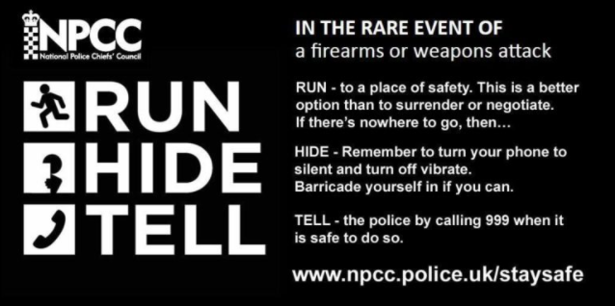
  - Protected individuals
    - In line with current guidance and legislation, the organisation has effective arrangements in place to respond and manage ‘protected individuals'; Very Important Persons (VIPs), high profile patients and visitors to the site.
    - GP practices will be aware if any protected individuals that are registered as a patient at their practice. The provider will work with the relevant security service / police to ensure the protected individual can safely access care. Specific plans may be in place where applicable.

  - Excess deaths planning
    - Surrey County Council are responsible for coronial services and take the lead on excess death planning.
    - In the event of excess deaths, during a heatwave or pandemic for example, GP practices may see an increase in workload. The GP practice should consider how they would manage an increase in demand for GPs to provide a declaration of life extinct in the community and immediate death certification/cause of death. Additional information can be found in the Surrey LRF Managing Excess Deaths Plan, which can be accessed by contacting the NHS Surrey Heartlands EPRR team via syheartlandsicb.shoc@nhs.net.

  - Hazardous Materials / CBRN
    - Hazardous material or Chemical, Biological, Radiological, Nuclear (CBRN) incidents that result in individuals being exposed to hazardous substances are medical emergencies. If a GP practice is made aware of a patient who may have been exposed to a hazardous substance, the provider should immediately call 999 and ask for the ambulance service.
    - The ambulance service, with the support of other emergency responders, will be able to safely decontaminate and manage the individuals who have been exposed. The ambulance service has staff specially trained in managing hazardous materials and will be able to access specialist advice from UK Health Security Agency.
    - The GP practice must notify NHS Surrey Heartlands Tactical on-callmanager as soon as reasonably practicable 0208 242 6511.
    - Until the ambulance service arrives the GP practice should where possible follow the Remove, Remove, Remove principles (see poster below). 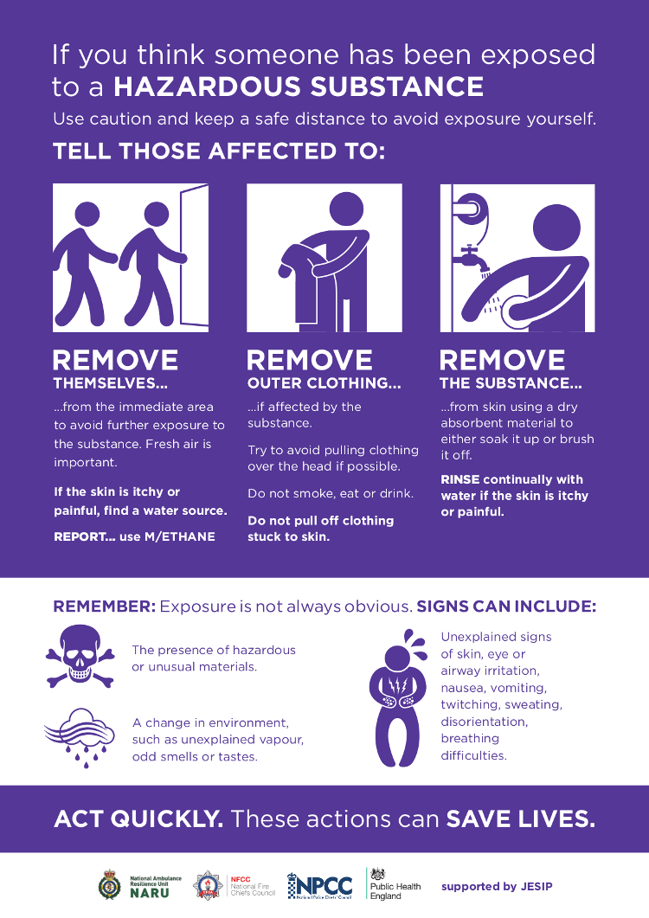
    - The GP practice should also encourage all patient facing staff to familiarise themselves with Initial Operational Response (IOR) procedures by watching this video: https://naru.org.uk/videos/ior-nhs/

  - Risk Assessment
    - This involves assessing the likelihood and impact or severity of a particular hazard or threat. Further information on risk assessment is available at Risk assessment: Steps needed to manage risk - HSE.
    - The Likelihood should be assessed taking account of the controls in place and their adequacy in accordance with the following scale:
Score | Descriptor | Description
1 | Rare | May occur only in exceptional circumstances.
2 | Unlikely | Could occur at some time.
3 | Possible | Might occur at some time.
4 | Likely | Will probably occur in most circumstances.
5 | Almost Certain | If the activity continues it is almost certain that an incident will occur.

    - The impact or severity should be assessed taking account of the controls in place and their adequacy in accordance with the following scale:
Score | Descriptor | Description
1 | Insignificant | No risk of harm, damage or financial loss
2 | Minor | Injury recovery within 1 month, limited damage and financial losses
3 | Moderate | Injury recovery within 12 months, moderate damage and financial losses
4 | Major | Permanent injury, major damage and financial losses
5 | Catastrophic | Death, totalloss/damage and significant financial losses

    - Risk Matrix
Likelihood | Impact / severity |  |  |  |  | Action
 | Insignificant | Minor | Moderate | Major | Catastrophic
Rare | 1 | 2 | 3 | 4 | 5 | No Immediate action
Unlikely | 2 | 4 | 6 | 8 | 10 | Action within 12 months
Possible | 3 | 6 | 9 | 12 | 15 | Urgent Action
Likely | 4 | 8 | 12 | 16 | 20
Almost Certain | 5 | 10 | 15 | 20 | 25

MTPD – maximum tolerable period of disruption – when not having this capability becomes unacceptable.
RTO – recovery time objective – prioritised time for when the MBCO is in place.
MBCO – minimum business continuity objective – an acceptable level of service for this activity.
SPoF – single point of failure – if this activity stops, does it prevent other activities from happening?
Resources required (how many people, premises, technology, information, supplies) to continue or recover this activity. See 13.5 below.

