HCA Blood Pressure Monitoring
Guidance Document

Version: | Review date: | Edited by: | Approved by: | Comments:
v1.3 | 08/12/2022 | Sultan Mohamed | Munira Mohamed | Version notation follows that used by PI
v1.4 | 14/01/2025 | Sultan Mohamed | Munira Mohamed
 | December 2026 |  |  | Next review

Table of contents
1 Introduction 2
1.1 Policy statement 2
1.2 Status 2
2 Understanding blood pressure 2
2.1 Terminology 2
2.2 Parameters 3
2.3 Readings 3
3 Stages of hypertension 4
3.1 Stage 1 4
3.2 Stage 2 4
3.3 Stage 3 or severe hypertension 4
4 Measuring BP 4
4.1 Manual BP measurement 4
4.2 BP measurement using an automatic monitor 4
5 Effective management 4
5.1 ABPM and HBPM 4
5.2 Diagnosing hypertension 5
5.3 Recommendations to the patient 5

Introduction

Policy statement

At Sheerwater Health Centre, blood pressure (BP) readings are taken by clinical staff including healthcare assistants (HCAs). This policy specifically focuses on the role of the HCA when undertaking a BP measurement. This is considered to be within their scope of responsibilities and they have been trained and assessed as competent to undertake this task.

Additionally, BP readings are also passed to the reception team following the return of either an ambulatory blood pressure monitor (ABPM) or home blood pressure monitoring (HBPM). The policy also refers to the actions needing to be taken by this group within the team.

This document has been produced to provide all staff at this organisation with the necessary information to understand the role of the HCA with regards to BP measurements, detailing how this task is to be undertaken while incorporating NICE guidance (NG136).

Status

The organisation aims to design and implement policies and procedures that meet the diverse needs of our service and workforce, ensuring that none are placed at a disadvantage over others, in accordance with the Equality Act 2010. Consideration has been given to the impact this policy might have regarding the individual protected characteristics of those to whom it applies.

This document and any procedures contained within it are non-contractual and may be modified or withdrawn at any time. For the avoidance of doubt, it does not form part of your contract of employment. Furthermore, this document applies to all employees of the organisation and other individuals performing functions in relation to the organisation such as agency workers, locums and contractors.

Understanding blood pressure

Terminology

BP is measured in millimeters of mercury (mmHg) which generates two readings:

- Systolic, which relates to the phase of the heartbeat when the heart muscle contracts and pumps blood from the chambers into the arteries

- Diastolic, which relates to the phase of the heartbeat when the heart muscle relaxes and allows the chambers to fill with blood

For example, a BP reading is expressed as 120/80mmHg or, when spoken, 120 over 80.

Parameters

This organisation uses NICE guidance (NG136) for the classification of BP levels as illustrated below:

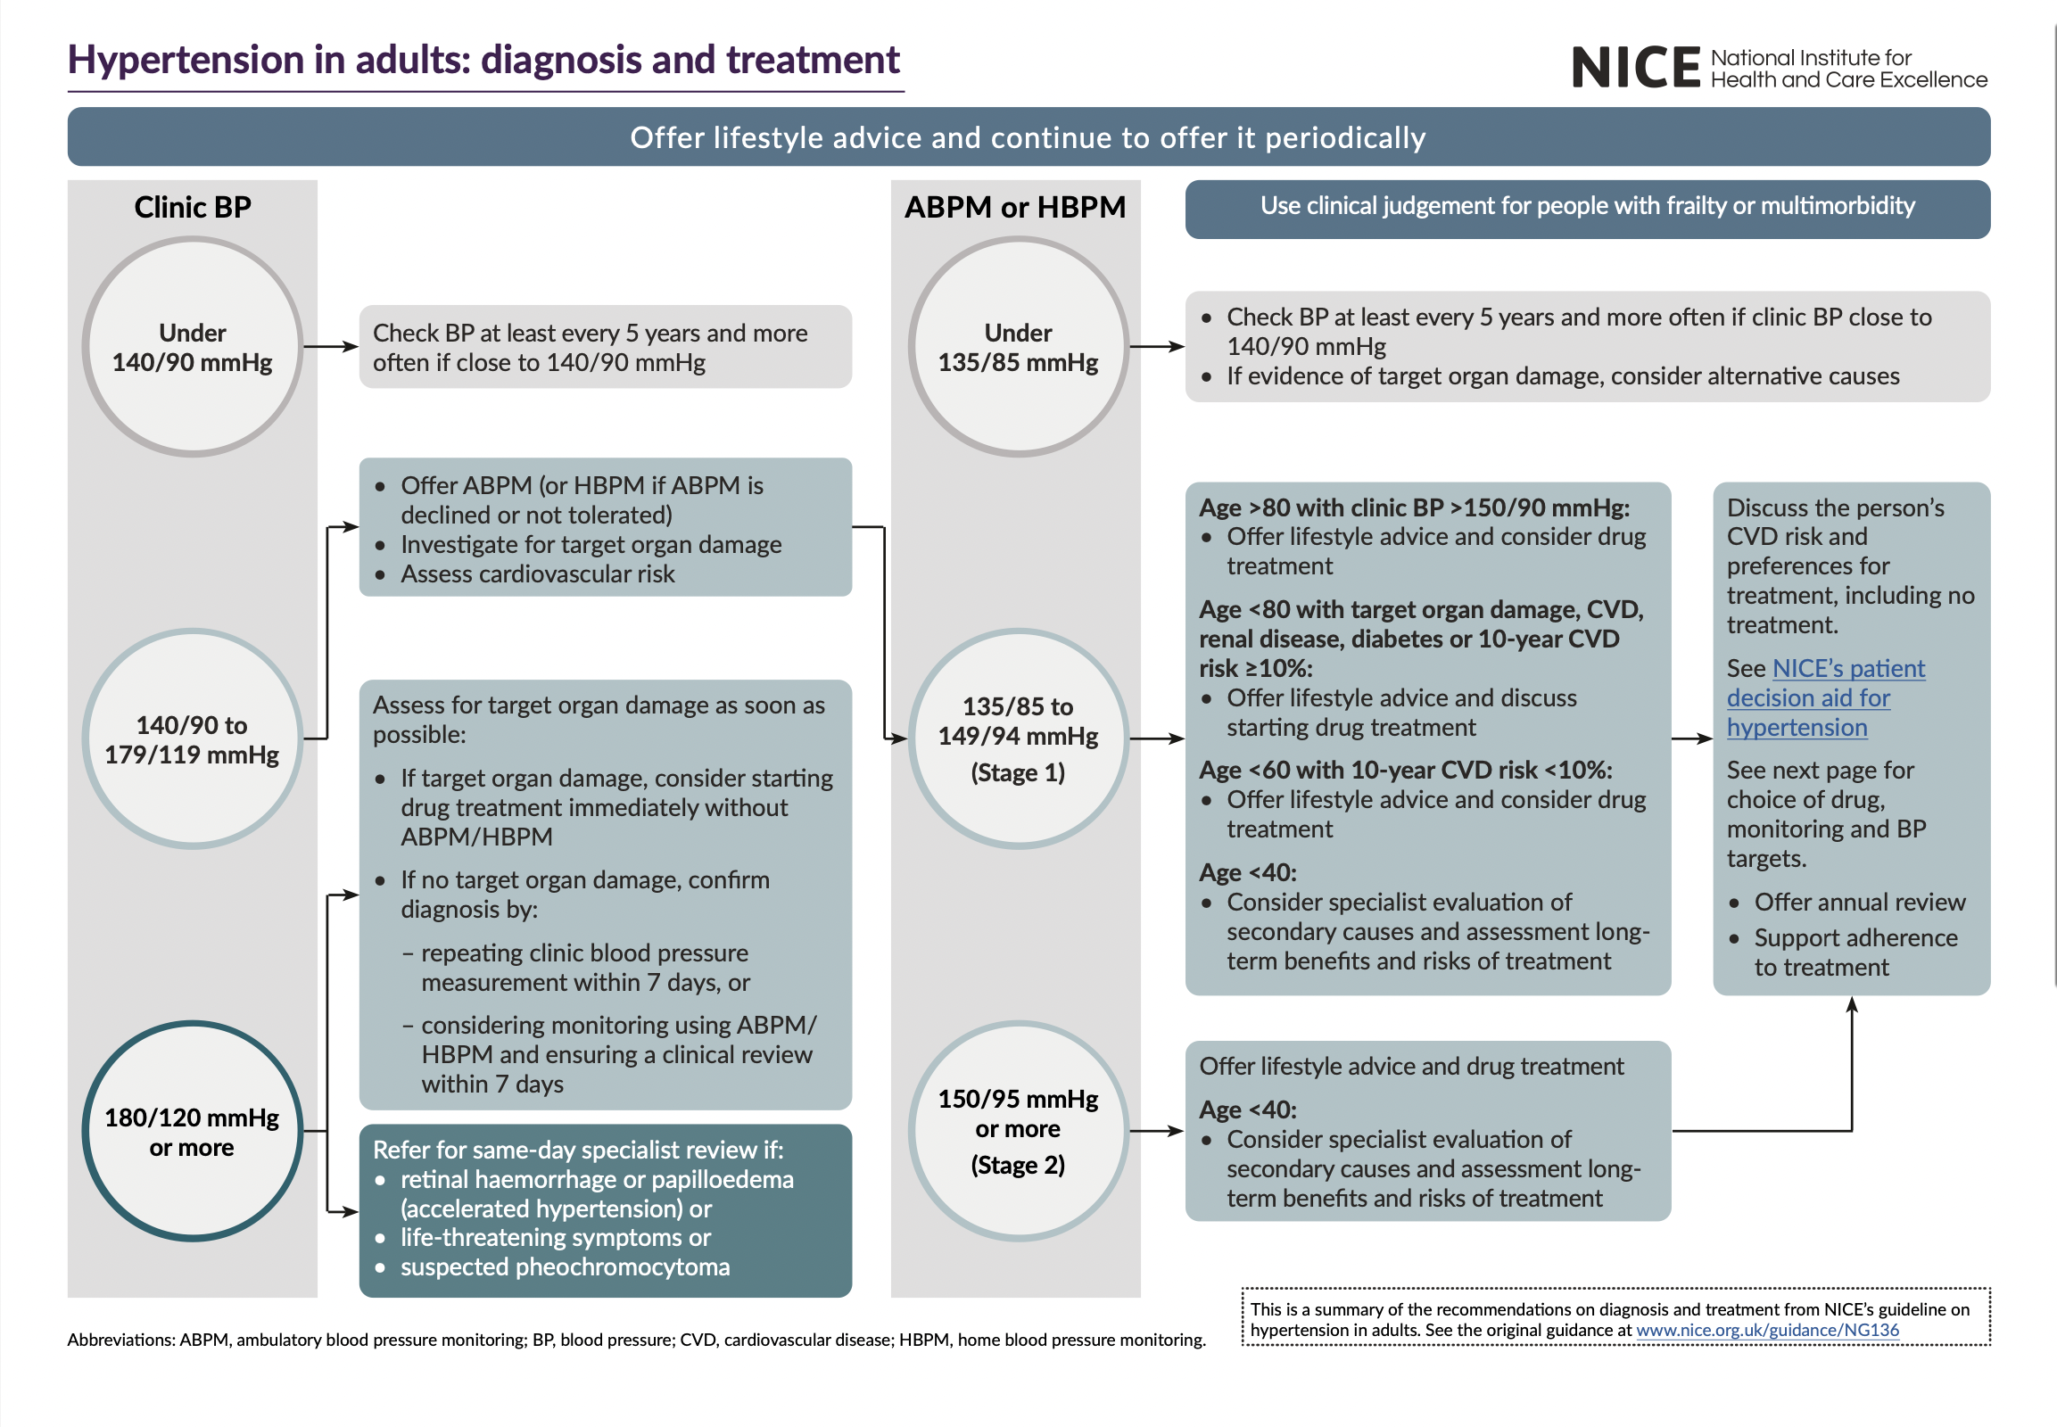
Image source: NG136

Readings

HCAs and non-clinical staff receiving information with regard to a patient’s BP, such as a return of either ABPM or HBPM, must adhere to the following guidance which is aligned to that given by NICE.

- If a patient’s BP is 140/90mmHg or higher, a second measurement is to be taken by the HCA
- If the second measurement differs considerably from the first, a third measurement is to be taken
- The lower of the second and third measurements is to be recorded as the clinic BP

If the BP measurement is 140mmHg or higher, the HCA is to either inform a practice nurse or the HCA is to follow management guidance at paragraph 5.1.

If not severe hypertension, HCAs should advise the Practice Nurse of their findings to ensure the appropriate management of hypertension.

Stages of hypertension

Stage 1

NICE explains that Stage 1 hypertension is when the clinic BP is 140/90mmHg to 159/99 mmHg and there is a subsequent ABPM daytime average or HBPM average BP is 135/85mmHG to 149/94mmHg.

Stage 2

NICE explains that Stage 2 hypertension is when the clinic BP is 160/100 mmHg or higher but less than 180/120 mmHg and there is a subsequent ABPM daytime average or HBPM average BP of 150/95 mmHg or higher.

Stage 3 or severe hypertension

NICE explains that Stage 3 or severe hypertension is where the clinic systolic BP is 180mmHg or higher or clinic diastolic BP is 120mmHg or higher.

Measuring BP

Manual blood pressure measurement

The University of South Wales has produced a short video that demonstrates how to perform a manual BP measurement using a sphygmomanometer.

BP measurement using an automatic monitor

NHS England has produced a short video that demonstrates how to measure an individual’s blood pressure using an automatic monitor.

Effective management

ABPM and HBPM

NICE guidance recommends that, if the clinic BP is 140/90mmHg to 180/120, ABPM is to be offered to the patient by the HCA or Practice Nurse in order to confirm a diagnosis of hypertension. If, however, this is not practical or tolerable for the patient, HBPM is to be used and is deemed an appropriate alternative to confirm the diagnosis of hypertension.

If a diagnosis of hypertension is not reached, the patient’s BP is to be measured at least every five years. This can be more frequently if the clinic BP pressure reading was close to 140/90mmHg.

Clinic reading | Management
Below 140/90 | Review BP every 5 years
140/90 to 179/119 | - Offer home BP monitoring (ask patient to see reception who will arrange)  - Request blood test (hypertension link on ICE). Dip urine for protein
180/120 or more | Discuss with the duty doctor immediately

Diagnosing hypertension

When using ABPM to confirm a diagnosis of hypertension, ensure that at least TWO measurements per hour are taken during the person's usual waking hours (for example, between 08:00 and 22:00).

NICE advises that the average value of at least 14 measurements taken during the person's usual waking hours is required to confirm a diagnosis of hypertension.

When using HBPM to confirm a diagnosis of hypertension, ensure that:

- For each BP recording, two consecutive measurements are taken, at least one minute apart, and with the person seated
- BP is recorded twice daily, ideally in the morning and evening
- BP recording continues for at least four days, ideally for seven days

Discard the measurements taken on the first day and use the average value of all the remaining measurements to confirm a diagnosis of hypertension.

Recommendations to the patient

HCAs at this organisation are permitted to offer the following advice to patients whose BP is classified as high-normal:

- Reduce salt intake
- Eat more fruit and vegetables
- Maintain a healthy weight
- Reduce alcohol intake
- Increase exercise/become more active
- Reduce excessive coffee and other high caffeine products
- Smoking cessation advice
- Signpost to any local initiatives to support healthy living

Additional guidance relating to the above recommendations can be found on the Blood Pressure UK website.

