Moving and Handling Policy

Version: | Review date: | Edited by: | Approved by: | Comments:
v1.2 | 02/01/2024 | Sultan Mohamed | Nine Taylor
 | January 2026 |  |  | Next review

Table of contents
1 Introduction 2
1.1 Policy statement 2
1.2 Status 2
2 Policy 2
2.1 Employer’s responsibilities 2
2.2 Employees’ responsibilities 3
2.3 Avoiding hazardous moving and handling 3
2.4 Assessing risks 3
2.5 Task Individual Load Environment (TILE) assessment 4
2.6 Reducing risk and the use of control measures 4
2.7 Teamwork 5
2.8 Training 5
Annex A – Lifting and lowering risk filter 6
Annex B – Pushing and pulling risk filter 7
Annex C – Handling while seated 8
Annex D – General risk assessment and control form – moving and handling 9

Introduction

Policy statement

Moving and handling injuries are part of a wider group of musculoskeletal disorders and Sheerwater Health Centre is committed to taking the action described within this policy to help to prevent such injuries and ill health.

This policy is to be read in conjunction with the following legislation and guidance:

- Health & Safety at Work, etc. Act 1974
- Management of Health and Safety at Work Regulations 1999
- Provision of Use of Work Equipment Regulations 1998 (PUWER)
- Manual Handling Operations Regulations 1992
- HSE – Manual handling at work – Musculoskeletal disorders
- HSE – Manual handling: Health and Safety
- HSE – Manual Handling Operations Regulations 1992 – Guidance on regulations
- HSE – Manual handling at work – A brief guide

This document and supporting training will ensure that all personnel at this organisation are fully aware of their individual responsibilities regarding moving and handling tasks within the workplace.

Status

The organisation aims to design and implement policies and procedures that meet the diverse needs of our service and workforce, ensuring that none are placed at a disadvantage over others, in accordance with the Equality Act 2010. Consideration has been given to the impact this policy might have regarding the individual protected characteristics of those to whom it applies.

This document and any procedures contained within it are non-contractual and may be modified or withdrawn at any time. For the avoidance of doubt, it does not form part of your contract of employment. Furthermore, this document applies to all employees of the organisation and other individuals performing functions in relation to the organisation such as agency workers, locums and contractors.

Policy

Employer’s responsibilities

The Health and Safety at Work Act 1974 (HASAWA) makes clear the employer’s duty to ensure the health, safety and welfare of all employees, as far as is reasonably practicable.

The Management of Health and Safety at Work Regulations specifically require that employers risk assess and reduce the risk of injury from moving and handling loads.

Employers must deal with any risks by:

- Avoiding moving and handling activities if there is a risk of injury
- Assessing moving and handling activities if they cannot be avoided
- Reducing the risk of injury to employees as far as reasonably practicable
- Reviewing risk assessments regularly

Employees’ responsibilities

This organisation will consult and involve the workforce when identifying managing risks relating to moving and handling.

The HASAWA places a duty on an employee to “take reasonable care for the health and safety of himself and other persons who may be affected by his acts or omissions at work” and to cooperate with the employer to enable compliance with that duty.

It is the responsibility of the employee to:

- Follow prescribed safe systems of work
- Be aware of and understand the organisation’s Moving and Handling Policy
- Use the equipment provided properly
- Not misuse or interfere with the equipment provided
- Co-operate with the organisation on moving and handling matters
- Inform the management should any hazardous handling activities or defects with equipment be identified
- Ensure their activities do not put themselves or another member of staff at risk

Avoiding hazardous moving and handling

Where possible, hazards relating to moving and handling should be eliminated. When a hazard cannot be eliminated, control measures to avoid the hazard should be considered:

- Redesign of the task e.g., can the activity be performed in situ to reduce the need for movement of the load?
- Are more resources required to move the load?
- Automating the process e.g., the use of hoists or other mechanical lifting device

Assessing risks

When risks from hazardous moving and handling in the workplace cannot be eliminated or avoided, the nominated health and safety lead will conduct a moving and handling risk assessment.

Not every risk will be subject to a full moving and handling risk assessment. The health and safety lead will refer to the HSE’s simple moving and handling risk filters to identify when a full risk assessment is appropriate:

- Lifting and lowering risk filter as at Annex A
- Pushing and pulling filter as at Annex B
- Handling while seated as at Annex C

Employees will be fully involved in the risk assessment process and an example of a general risk assessment can be found at Annex D. Where a risk assessment is indicated, the use of ‘task specific’ tools for assessing the risk, available from the HSE, will be considered such as:

- RAPP tool (risk assessment of pushing and pulling)
- MAC tool (moving and handling assessment charts)

Task Individual Load Environment (TILE) assessment

In fully assessing any risk, the moving and handling task itself will be considered with the aim to reduce any hazards associated with the task.

The acronym TILE offers prompts for considering the essential aspects of moving a load as detailed:

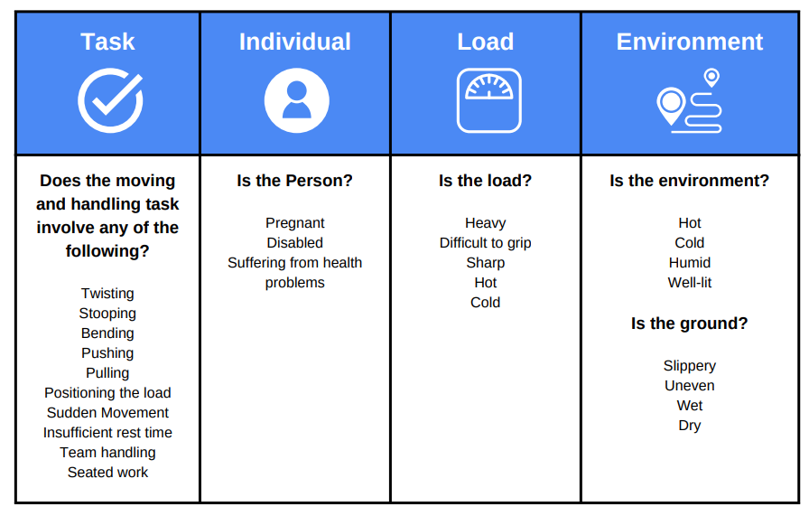

Reducing risk and the use of control measures

This organisation will aim to control any hazards relating to moving and handling when reasonably practicable. The HSE’s brief guide to manual handling makes suggestions for control measures; these measures may help to reduce the risks associated with moving and handling in the workplace.

Teamwork

Lifting as a team does not mean a lot more weight can be lifted. Handling by two or more people may make possible an operation that is beyond the capability of one person or reduce the risk of injury to a single handler.

Considerations when lifting as a team are:

- Ensure there is enough space for the handlers to manoeuvre
- There should be adequate access to the load
- One person should plan and then take charge of the operation, ensuring that the movements are co-ordinated
- Good communication between team members is important
- Consider the dignity and safety of everyone
- Teams of more than four members are unlikely to work successfully

Training

Providing information and training alone will not eliminate the risks associated with moving and handling but acts as a further control measure to reduce the risk of injury in the workplace.

The information covered by moving and handling training should be role-specific and should include:

- Moving and handling risk factors and how injuries can happen
- Appropriate systems of work for the individual’s tasks and environment
- Use of mechanical aids
- How to carry out safe moving and handling, including good handling techniques
- Practical work relevant to the job to allow the trainer to identify and put right anything the trainee is not doing safely
- How to report symptoms and injuries

Annex A – Lifting and lowering risk filter

The law does not specify weight limits for lifting and lowering weights. This filter looks at the differences between men and women when lifting or lowering loads.

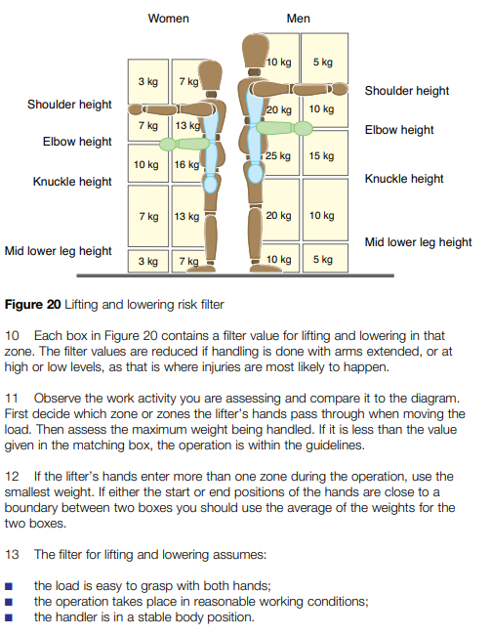
Moving and handling. Moving and handling Operations Regulations 1992. Guidance on Regulations L23 (hse.gov.uk)

When the filter weight lifted exceeds the filter weight or the assumptions are not met, a more detailed assessment (either MAC or a full risk assessment) should be conducted.

Annex B – Pushing and pulling risk filter

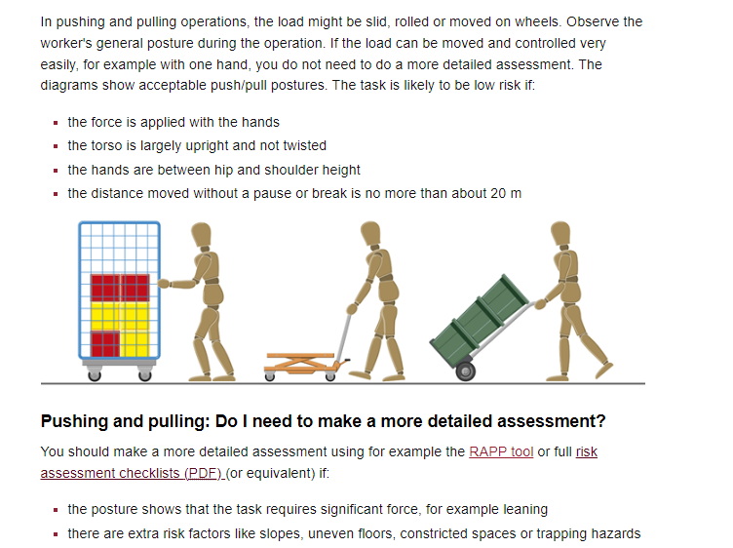

Moving and handling. Moving and handling Operations Regulations 1992. Guidance on Regulations L23 (hse.gov.uk)

Annex C – Handling while seated
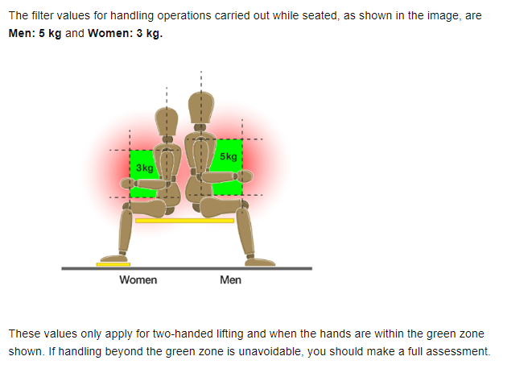

Annex D – General risk assessment and control form – moving and handling

Risk assessment and control form

Brief task description: [Lifting and handling of office supplies]

Practice name: Sheerwater Health Centre Risk assessment reference: [Insert local reference number]

Date completed: [Insert date completed] Relevant documents reference: [Insert supporting document name/reference numbers]

General risk description  (hazard consequence) | Hazard rating | Likelihood  (including relevant people, environmental and data factors as well as existing control measures) | Likelihood rating | Risk rating | Additional control measures required | To be implemented  By who?  By when? | Residual risk  (risk - after all additional controls are implemented)
When lifting and handling office supplies such as A4 paper reams/boxes, were a person to adopt poor posture, this may result in a minor or moderate musculoskeletal injury. | 3 | Supplies are typically less than 5 kg per item, although boxes of paper may be heavier (10 - 15 kg). Stock is usually delivered by supplier then stored by staff  Moving and Handling Policy and training provided during induction for staff; however, refresher training is now overdue  Moving and handling activities of this nature are frequent but observations indicate that good practice is generally followed  There are currently four staff members who have known musculoskeletal conditions, with one resulting from a recent non-work-related injury | 3 | 9 | To undertake a review of existing training content and provision to ensure that moving and handling information and techniques taught reflect the activities undertaken  Review the activities (risk assessments) performed by colleagues with musculoskeletal conditions to identify any limitations  To identify if further improvements can be made by use of moving and handling equipment such as trolleys | Practice Manager by end August 2023  Practice Manager by end Sept 2023  Practice Manager by end Oct 2023

Risk assessor’s name: | Contribution to risk assessment by: | Manager approval:
[Insert name of risk assessor] | [Insert name of any contributors] | [Insert name of manager]
Risk assessor’s job role: | Contributor’s job role: | Date of approval:
[Insert job role] | [Insert job role] | [Insert date]

This document was reviewed/updated by: | Job role: | On date: | Next planned review due:
[Insert name of assessor] | [Insert job role] | [Insert date] | [Insert date]

Risk review profile | Recommended risk assessment and risk controls review periodicity  Guidance note: The principle of review is that the more significant the risk level, the more often it must be reviewed.  Always review if an incident has occurred:
 | If the risk is 15 - 25 (Very high) Review at least every 1 - 3 months
 | If the risk is 8 - 12 (High) Review at least every 6 - 12 months
 | If the risk is 4 - 6 (Moderate) Review at least every 12 - 18 months

