Newborn and Infant Physical Examination
Guidance Document

Version: | Review date: | Edited by: | Approved by: | Comments:
v1.0 | 29/11/2022 | Sultan Mohamed | Munira Mohamed
v1.1 | 15/12/2024 | Sultan Mohamed | Munira Mohamed
 | November 2026 |  |  | Next review

Table of contents
1 Introduction 2
1.1 Guidance statement 2
1.2 Status 2
2 Policy 2
2.1 Programme overview 2
2.2 Screening pathways 3
2.3 Examination criteria 3
2.4 Training and maintenance of competency 3
2.5 Quality assurance 4
2.6 Record keeping 4
2.7 Management of results 4
2.8 Missed appointments 4
Annex A – Newborn screening pathway 5
Annex B – Infant screening pathway 6

Introduction

Guidance statement

This guidance document explains the processes to be followed for clinicians at Sheerwater Health Centre for newborn and infant physical examinations (NIPE) and the subsequent six-to-eight-week examination. Ideally, during the six-to-eight-week examination the infants first immunisations will be given.

This guidance is to be read in conjunction with the following:

- NHS England Newborn and infant physical examination (NIPE) screening: programme overview
- Newborn and infant physical examination: clinical guidance
- Newborn and infant physical examination: programme handbook

Status

The organisation aims to design and implement policies and procedures that meet the diverse needs of our service and workforce, ensuring that none are placed at a disadvantage over others, in accordance with the Equality Act 2010. Consideration has been given to the impact this policy might have regarding the individual protected characteristics of those to whom it applies.

This document and any procedures contained within it are non-contractual and may be modified or withdrawn at any time. For the avoidance of doubt, it does not form part of your contract of employment. Furthermore, this document applies to all employees of the organisation and other individuals performing functions in relation to the organisation such as agency workers, locums and contractors.

Policy

Programme overview

The NIPE programme recommends the offer of screening to all babies born in England for conditions relating to the:

- Eyes
- Heart
- Hips
- Testes (if applicable)

The examination should be completed before, or at, 72 hours of age. This examination should be conducted before the newborn baby is discharged from the care of any maternity, neonatal or paediatric inpatient service.

The NIPE newborn screening examination in England forms part of the wider systemic examination of the newborn, usually undertaken at the same time.

The three main aims of the NIPE programme are:

- Identify and refer all children born with congenital abnormalities of the eyes, heart, hips and (in males) testes, where these are detectable, within 72 hours of birth
- Further identify those abnormalities that may become detectable by six to eight weeks of age at the NIPE infant screening examination
- Reduce morbidity and mortality

The programme handbook explains that these ages are based on best practice and current evidence and should facilitate a prompt referral for early clinical assessment. The infant screening examination (at six to eight weeks of age) will usually be conducted in primary care or at this organisation.

Screening pathways

The screening pathway for newborns can be found at Annex A while the screening pathway for the infant examination can be found at Annex B.

Examination criteria

Clinicians at this organisation are to adhere to the clinical guidance when conducting the newborn screening examination. Detailed guidance is accessible in the links below:

- Screening examination of the eyes
- Screening examination of the heart
- Screening examination of the hips
- Screening examination of the testes

The above examination criteria are also used at the 6-to-8-week examination as some conditions can develop or become evident after the initial newborn screening examination.

Training and maintenance of competency

Section 16 of the programme handbook details the training and competency requirements for those conducting screening examinations.

The following eLearning modules are available to support GPs and other health professionals in maintaining their competencies and to improve their knowledge and understanding of their responsibilities in the delivery of the NIPE screening programme.

- NIPE e-LfH
- NIPE BMJ

Records of training are to be retained by the individual and this organisation and can be used as demonstrable evidence at revalidation.

Quality assurance

Section 17 of the programme handbook focuses on quality assurance and explains how the NIPE screening programme defined set of standards is monitored and enhanced where necessary.

Record keeping

The programme handbook explains that clinicians conducting examinations should ensure that verbal consent for screening is obtained from the infant’s parent(s) and documented together with the screening result and any referrals following screen positive results. Such information is to be recorded in:

- SMaRT4NIPE (S4N) IT system or GP clinical system using the appropriate SNOMED CT ID
- Personal Child Health Record (PCHR) (commonly referred to as the red book)

Management of results

Those babies with screen negative results return to the care pathway of the Healthy child programme. Those babies with screen positive results require appropriate and timely referrals which should be made in line with NIPE screening standards and guidance.
As a minimum, NIPE states there should be:
- Local arrangements to ensure all babies with screen positive results are referred and seen in line with national standards
- Regular feedback of attendance at appointment or specialist review after screen positive referrals to enable recording of outcomes in S4N
- A local process to follow up all non-attendance of appointments after a screen positive referral
- A process to record all screening results and outcomes (including post referral outcomes on S4N)

Missed appointments

Section 11 of the programme handbook explains the process for managing babies who have missed screening. If the missed screen is due to a screening pathway failure, then actions are to be taken in line with national screening incident guidance.

Annex A – Newborn screening pathway
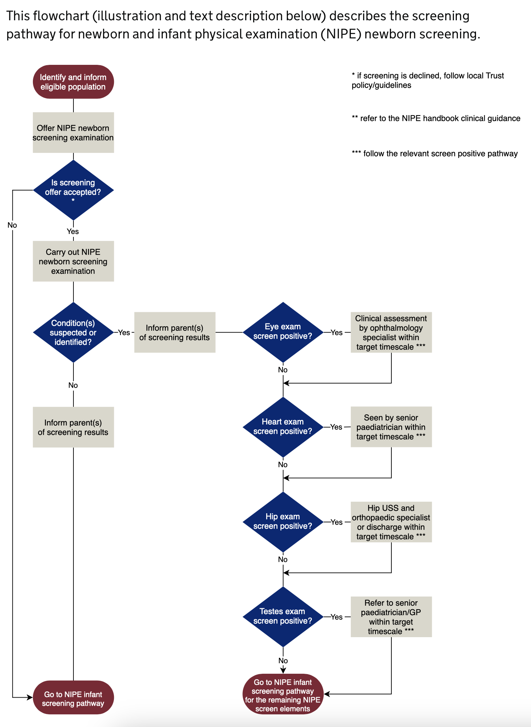
Image source www.gov.uk

Annex B – Infant screening pathway
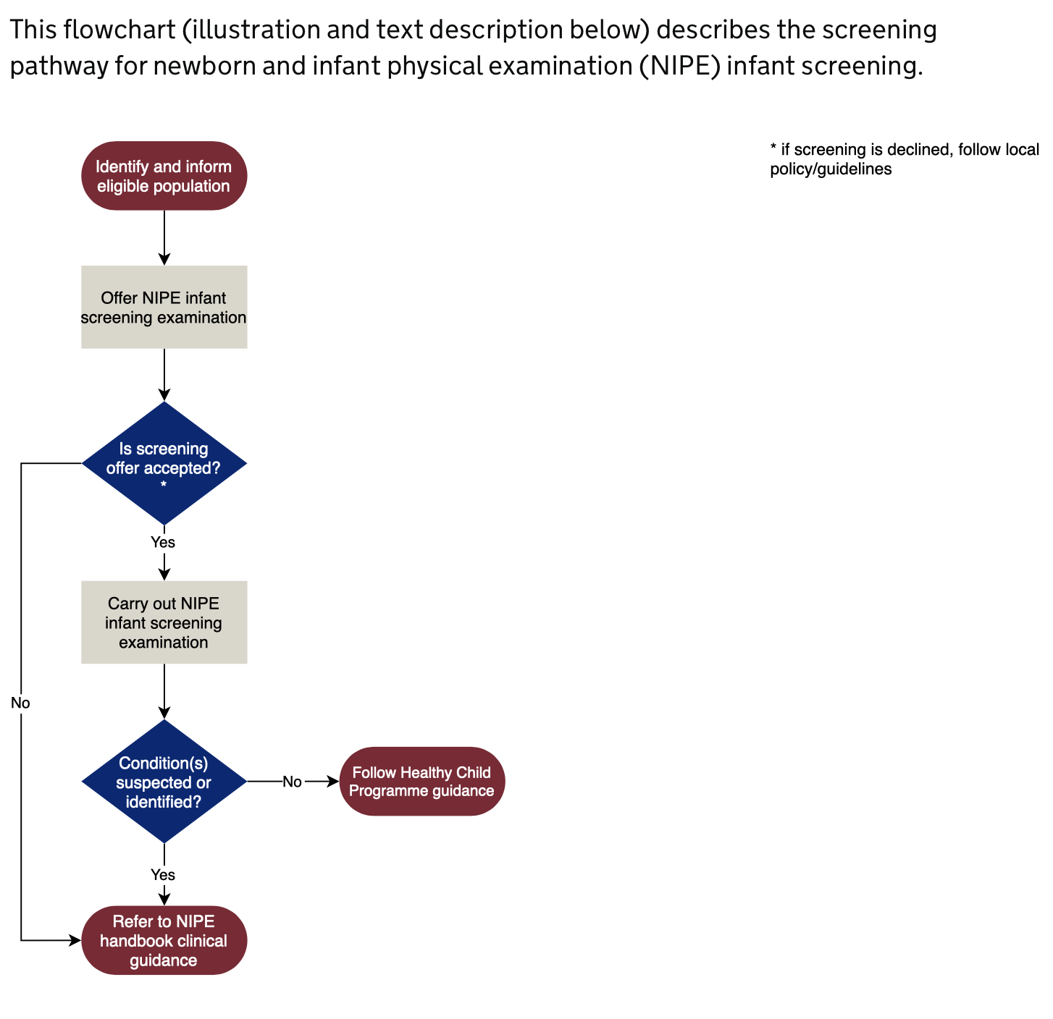
Image source www.gov.uk

