Patient Group Directions

Version: | Review date: | Edited by: | Approved by: | Comments:
v1.2 | 21/02/2024 | Sultan Mohamed | Elisabeth Hawkey
 | June 2026 |  |  | Next review

Table of contents
1 Introduction 3
1.1 Policy statement 3
1.2 Status 3
2 Developing, issuing and using PGDs 3
2.1 Developing a PGD 3
2.2 Information legally required in a PGD 4
2.3 Approval and authorisation 4
2.4 Medicines that can be supplied under a PGD 4
2.5 Medicines that cannot be supplied under a PGD 5
3 Staffing and PGDs 5
3.1 Healthcare professionals who can use a PGD 5
3.2 Healthcare professionals who cannot use a PGD 5
3.3 Bank or agency staff 6
4 PGD use within the organisation 6
4.1 When to use a PGD 6
4.2 PGD use in end-of-life care 6
4.3 Situations when a PGD should not be used 6
4.4 Cautionary usage 6
5 Governance 7
5.1 Responsibility 7
5.2 Clinical governance 7
5.3 Change of responsible person 7
5.4 Retention of documentation 7
6 Summary 8
Annex A – Audit of staff compliance to work under a PGD 9
Annex B – Audit of completion of patient records for PGD 10

Introduction

Policy statement

Patient Group Directions (PGDs) are governed by the Human Medicines Regulations 2012. They allow specified health professionals to supply and/or administer medicine without a prescription or an instruction from a prescriber.

PGDs are not a form of prescribing. PGDs allow the healthcare professionals specified within the legislation to supply and/or administer a medicine directly to a patient with an identified clinical condition without the need for a prescription or an instruction from a prescriber. The healthcare professional working within the PGD is responsible for assessing that the patient fits the criteria set out in the PGD.

Status

Sheerwater Health Centre aims to design and implement policies and procedures that meet the diverse needs of our service and workforce, ensuring that none are placed at a disadvantage over others, in accordance with the Equality Act 2010. Consideration has been given to the impact this policy might have regarding the individual protected characteristics of those to whom it applies.

This document and any procedures contained within it are non-contractual and may be modified or withdrawn at any time. For the avoidance of doubt, it does not form part of your contract of employment.

Developing, issuing and using PGDs

Developing a PGD
Sheerwater Health Centre will follow the cyclical PGD process when developing a PGD. PGD development requires a multi-disciplinary approach, knowledge about PGD legislation and governance as well as clinical expertise, and knowledge about the service where the PGD is being considered. Cross organisation working may be required.
The image overleaf shows the cyclical process. For detailed information see the Specialist Pharmacy Service’s How to develop a Patient Group Direction guidance.
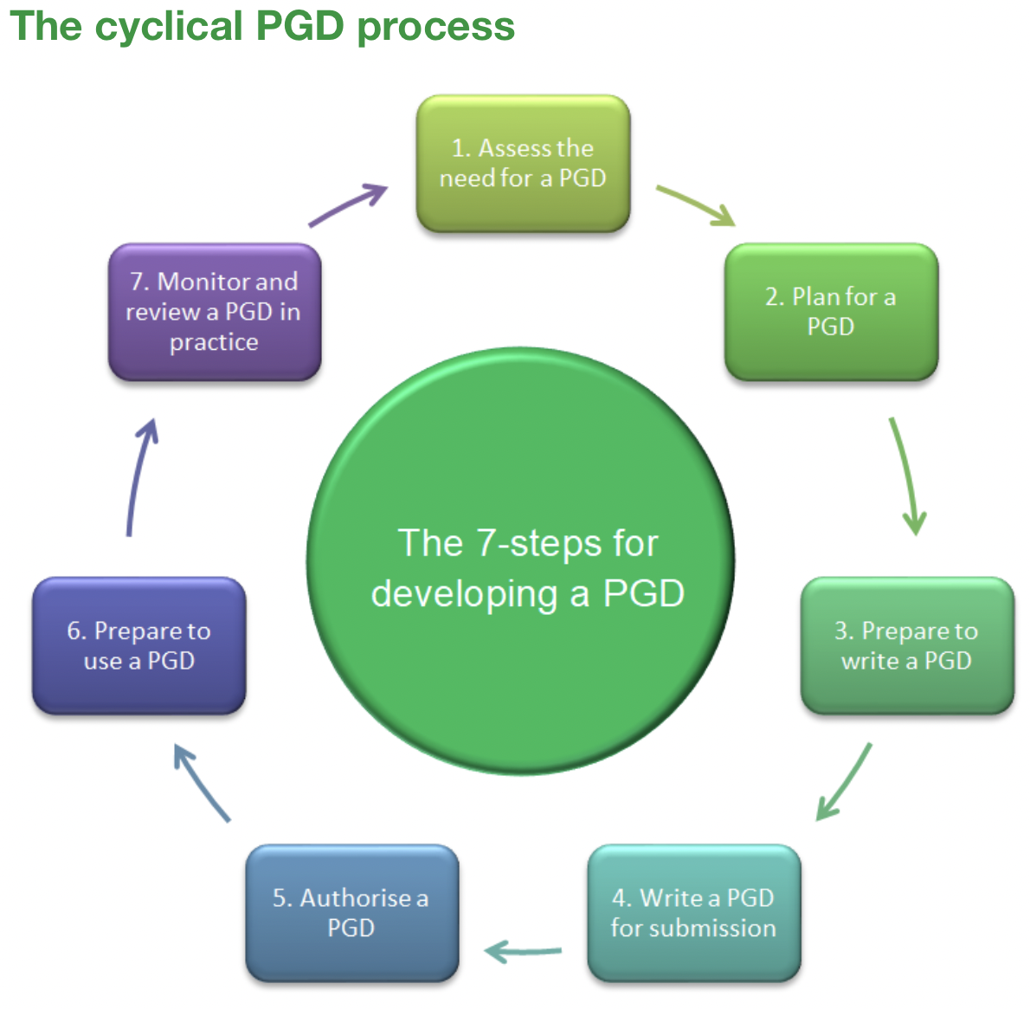
Image source: SPS

Information legally required in a PGD
Sheerwater Health Centre will ensure that all PGDs include the legally required information as detailed by the Medicines and Healthcare products Regulatory Agency (MHRA) and as stipulated in the Human Medicines Regulations 2012, Schedule 16, Part 1

Approval and authorisation

Sheerwater Health Centre can develop its own PGDs. However, there must be a formal agreement in place between the commissioner (the Integrated Care Board or NHS England) and Sheerwater Health Centre.¹

Sheerwater Health Centre will follow the guidance available in NICE MPG2 Patient group directions regarding the regulatory requirements, authorisation and use of PGDs.

Medicines that can be supplied under a PGD

The MHRA advises that all medicines are classified according to three legal categories which are:
- Prescription only (POM)
- Pharmacy (P)
- General sale list (GSL)

Medicines that cannot be supplied under a PGD
Under a PGD you cannot supply:
- Unlicensed medicines
- Dressings, appliances and devices
- Radiopharmaceuticals
- Abortifacients such as Mifepristone

Staffing and PGDs

Healthcare professionals who can use a PGD
Currently, the following healthcare professionals can only supply or administer under a PGD:
Chiropodists and podiatrists | Orthoptists
Dental hygienists | Orthotists and prosthetists
Dental therapists | Paramedics
Dieticians | Pharmacists
Midwives | Physiotherapists
Nurses | Radiographers
Occupational therapists | Speech and language therapists
Optometrists

Each healthcare professional must be named and must sign each PGD they use.

Further reading can be sought from the Human Medicines Regulations 2012.

Healthcare professionals who cannot use a PGD

All other clinical personnel including those commonly used in primary care such as healthcare assistants are covered by the organisation’s patient specific directions (PSD) procedure.

The SPS advises that neither nursing associates nor physician associates are included within the legislation so cannot operated under a PGD.

Bank or agency staff

At Sheerwater Health Centre, should bank or agency staff be considered, then these staff members can operate under PGDs to maintain the service provision provided. However, prior to allowing any PGD to be used, the same training and governance requirements would need to be satisfied.

Further reading on bank or agency staff and PGD use can be sought here.

PGD use within the organisation

When to use a PGD

PGDs must only be used where there is no other suitable mechanism for the administration or supply of the medicine within legislation. Careful consideration should be given to opportunities within the care pathway to use a prescription or written PSD and also consider the use of exemptions.

PGD use in end-of-life care

For PGD use in end-of-life care, see this SPS guidance.

Situations when a PGD should not be used

The SPS advises that a PGD should not be used in the following circumstances:

- Where there is an opportunity for the medicines to be prescribed
- Where there is an exemption under the Human Medicines Regulations 2012
- Where the medicines to be supplied or administered are GSL medicines
- Where the medicines to be administered are P medicines
- Where a medical gas is to be administered

Cautionary usage
There are certain categories of medicines for which a PGD should only be used with caution. Examples are antibiotics, off licence drugs (for example, when amitriptyline, licenced for the treatment of depression, is used for neuropathic pain), controlled drugs or those subject to black triangles.
Black Triangle medicines (▼) are licenced medicines that are intensively monitored and subject to special reporting arrangements for adverse events.

Governance

Responsibility
Failure of Sheerwater Health Centre to agree and document clear lines of accountability and responsibilities could result in a significant risk to the organisation and to the delivery of patient care.
A person who supplies or administers a medicine is accountable for their own practice and must be trained and competent to undertake such tasks. They must act according to their level of competence and in accordance with the directions of the prescriber.
Prescribers and anyone administering or supplying medicines must ensure that they adhere to clinical governance policies and procedures and associated arrangements.

Clinical governance

Sheerwater Health Centre has a duty of care to both the patient and to the staff and is responsible for ensuring that staff are properly trained and undertake only those responsibilities specified in agreed job descriptions.

Dr Munira Mohamed is the responsible person for PGDs and has overall organisational responsibility for these. This role is to establish and manage a structured work programme for reviewing, updating and reauthorising PGDs whilst ensuring that a lead auditor is nominated to review and update the PGDs.

To support clinical governance processes, there are two questionnaires at both Annex A and Annex B.

Change of responsible person

Should the responsible person be changed, it would be best practice for the PGDs to be reissued and signed to reflect the new responsible person.

Retention of documentation

The organisation will publish final signed versions within the PGD log which is held at Teletrek website to allow named, authorised health professionals using the PGD to be able to access the most up-to-date version.

The same rules apply to PGD records as to all other patient records:

PGD group | Comment
Adults | All PGD documentation in a patient’s clinical record must be kept for eight years
Children | All PGD documentation in a patient’s clinical record must be kept until the child is 25 years old or for eight years after a child’s death
Implant | Any PGD for an implant in adult documentation in a patient’s clinical record must be kept for 10 years  An example would apply to contraceptive and sexual health PGDs for contraceptive implants
Final authorised copy | This documentation should be kept for eight years after the expiry date of the PGD if the PGD relates to adults only (10 years if relates to an implant) and for 25 years after the expiry date of the PGD if the PGD relates to children
Staff authorisation records | To be kept for eight years after the expiry date of the PGD if the PGD relates to adults only (10 years if relates to an implant) and for 25 years after the expiry date of the PGD if the PGD relates to children
An unauthorised final copy | The main content of a PGD which contains no patient identifiable information or staff authorisation records may be retained by an organisation for up to 20 years for purposes of business planning/continuity if there is reason to do so.  Note GDPR rulings

Summary

PGDs should not be used routinely.

At Sheerwater Health Centre, appropriate staff may operate under PGDs if locally assessed and competent to do so and have undertaken the appropriate training.

A PGD should be reviewed every two years and at review, clinical governance arrangements and an assessment of whether the PGD remains the most effective way of providing the relevant services should be considered.

Annex A – Audit of staff compliance to work under a PGD
Name of PGD________________________________________

Staff initials
Does the member of staff know where the latest version of the PGD can be found?
Is their name on the master list of staff authorised to work under the PGD?
Is the most recent and in-date final signed version of the PGD being used?
Has this staff member completed training and been assessed as competent and authorised?
Comments

Annex B – Audit of completion of patient records for PGD
Ten patient records should be checked using this form
Patient number (anonymous) | 1 | 2 | 3 | 4 | 5 | 6 | 7 | 8 | 9 | 10
Was the date of supply/administration recorded?

Were the patient’s name, DOB, allergy status and hospital number recorded?

Was the medicine given in accordance with the inclusion criteria?

Have the details of the administration of the medicine (name, strength, dose, frequency, quantity, route and site (injection) been recorded?
Have the name and signature of the health professional supplying or administering the medicine been recorded?
Was relevant information provided to the patient, i.e., up-to-date patient information leaflet?
Was patient consent obtained?

Auditor name | Signed | Date

CQC GP Mythbuster 19: Patient Group Directions/Patient Specific Directions
SPS An introduction to PGDs
SPS How to develop a Patient Group Direction
www.gov.uk
Patient specific directions
SPS When to use a PGD
black-triangle-medicines
Specialist Pharmacy Service advice on PGD Record keeping

