Location | Action Number | Risk identified | Who might be harmed & how? | Action description | Action by who? | Action by when? | Progress | Notes | Status
 | RA-01  Replacing & disposing clinical waste sacks | When replacing and then disposing of clinical waste sacks, were a used sharp to have been placed in error in the yellow sack during the disposal process, a person may inadvertently sustain a sharp’s injury, potentially resulting in a BBV. | Replacement of yellow sacks and removal from pedal bin frame for disposal is a frequent activity performed by practice staff including final disposal to external waste bins, and staff must follow the Clinical Waste Management Protocol & Infection Control Policy and Guidelines. | To identify/ provide suitable refresher training for all staff members in clinical waste management and safe sharps disposal.  To undertake a review of PPE type, provision usage, availability and general precautions for this task.  Regular infection prevention control audit | Practice Manager  Practice Manager  IPC lead  (Wendy Mayne) |  |  | Risk rating is high at 12 (4x3) | RA to be repeated in February 2025
 | Waste management audit by Anenta Ltd  (Appointed Waste Management agent for NHS England) | -Waste management induction training for new staff  -Ensure all clinical containers are clearly labelled  -Importance of waste segregation handling |  | -Ensure training provided to all new staff | Practice Manager | Action completed (?) but ongoing vigilance is important |  | Risk assessment carried out in March 2024 | Repeat RA in March 2025
 | RA-02  Interacting with violent or aggressive patients | Interacting with members of the public/patients, were a person to be aggressive, it may result in an assault, causing moderate level of injury, e.g. broken nose. | There have been no reported physical assaults on staff, in the last 12 months.  The practice has a Violence and Aggression Policy. It also has a zero-tolerance policy  Patients and public are periodically rude, but rarely aggressive.  Staff are professional when dealing with the public/patients.  Waiting times are occasionally exceeded, and can result in increased levels of complaints being made. | To ensure that adequate information is provided to staff on de-escalation techniques**.  To provide relevant information to public-facing staff on duty.  Inform patients/public via posters on reasonable expectations and the potential outcomes that may result from abusive or aggressive behaviours. | Practice Manager  Practice Manager – ongoing  Practice Manager - ongoing | Ongoing  Ongoing  Ongoing |  | Risk factor estimated as 9 (3x3) in August 2024. | RA to be repeated in August 2025
 | RA-03  Asbestos management survey report  31.03.2020 | Woking Borough Council (landlord) instructed Lucion Environmental Ltd to carry out asbestos management survey at SHC in March 2020  Survey identified low level risk from asbestos-containing bituminous product in roof-sarking in treatment room corridor.  The product was re-examined in June2023 & again in June 2024 | Low risk level to staff, patients and visitors | Reinspect periodically as required by law | Woking Borough Council  -Practice Manager to ensure report received when action completed periodically | Ongoing – Practice Manager to liaise with WBC | Last inspection carried out by WBC appointed inspector in June 2024 | The practice hope to use building area recently vacated by a dental practice. WBC will need to survey the whole building for safety | RA to be repeated by WBC at specified intervals to comply with regulations  Next scheduled inspection in June 2025 or earlier depending on the progress of adding more rooms to the practice accommodation
 | RA-04  Prescription security | Prescription forms are assets with financial value, were a staff member to leave forms unsecured, theft may occur and the forms fraudulently misused |  | To carry out spot checks to ensure all staff store prescriptions in locked drawers when leaving their room unattended  Nominate a designated deputy to support the nominated individual  Provide new members of staff with an induction to ensure that they are aware of the Prescribing Policy and existing control measures | Practice Manager  Louise Gray  Practice Manager | Ongoing  Ongoing  Ongoing | How many spot checks carried out? | Risk factor estimated as 8 (4x2). Last RA carried out in August 2024. | RA to be repeated in August 2025
 | RA-05  Legionella management & control Risk Assessment report by Guardian Water Treatment Ltd | Woking Borough Council (landlord) instructed Guardian Water Treatment Ltd to carry out Legionella risk assessment & recommendation report Feb/May 2018 | Potential risk to staff, patients and visitors | Reinspect periodically  Samples from locations for TVC, Coliforms & E Coli for independent analysis  Samples for LP for independent analysis | Guardian Water Treatment Ltd | Inspection report 17.01.2023  Inspection report  19.01.2024  Sheerwater tap temperatures  Monthly  Daily | Completed  Completed  Ongoing  Ongoing |  | WBC ensure Guardian monitor water safety and keep the Practice informed with copies of inspection reports  Sheerwater tap temperatures are recorded daily & monthly
 | RA-06  Oxygen risk assessment | Storage of oxygen cylinders (including full and empty cylinders of varying size)  Should the cylinders not be stored appropriately, there is a risk of injury and explosion which could be fatal.  Use of oxygen cylinders | All oxygen cylinders are stored within secure facilities, with access restricted to trained staff.  Signage denoting oxygen is stored within is clearly displayed on the door.  There is fire detection within the storage area.  Storage area is free from clutter enabling easy access and egress  The floor surface is flat, level and in sound condition.  Signage is displayed showing actions to be taken in the event of an incident/emergency.  There is a fire extinguisher within close proximity to the storage area.  There is a fire call point nearby.  Staff wear suitable clothing and footwear to ensure reasonable purchase/footing and to achieve balance.  Only trained staff will use oxygen cylinders.  All cylinders are clearly labelled and cylinders will not be used if the label is unclear.  Only in date regulators will be used. After connecting a regulator, the user will check for leaks.  Staff will follow manufacturers’ guidance when using oxygen and associated ancillaries.  Regular checks are made to ensure all equipment is in date and there are no leaks.  Any defects will be reported to the nominated individual and the equipment quarantined until the defects are rectified. | Implement a routine monitoring process for this area to ensure compliance at all times  Provide refresher training to staff on the safe storage of medical gases  Record all staff refresher training on Blue Stream Academy | Practice manager  Practice manager  Practice manager | End of May 2024  End of June 2024 |  | Risk factor estimated as 6. Last RA in April 2024 | RA to be repeated in May 2025
 | RA-07  Assistance Dogs within the practice Risk Assessment | Hygiene  Disabled service users | Employees and patients  Patients | Clinical staff are to limit physical contact.  Limit areas within the organisation where assistance dogs can go and where infection control may be compromised.  Assistance dogs are well trained and this would include not going to the toilet in doors  Clean any mess created by the dog. Should the owner not be able to do this, for example if they are visually impaired and are unaware that the dog has made a mess, then the staff member is to assist.  PPE is required.  Liaise with cleaning staff for a greater level of cleaning as required.  Refer to the Infection Prevention Control Policy. | Clinical staff  Staff to assist any patients in an emergency | Ongoing  Ongoing |  | Risk factor is estimated to be high at 9 (3x3).  Risk factor is high, 10 (2x5) | RA to be repeated in May 2025
 | RA-08  Locking and unlocking premises | If when locking and unlocking premises, there was an attempted theft or break-in due to lone worker vulnerability, a staff member may be assaulted, resulting in moderate injuries such as bruising. | Senior staff do undertake this activity alone on a regular basis.  There have been no reported attempted break-ins or thefts in the last 12 months. However, on one recent occasion a staff member was concerned by a large group of youths in the immediate vicinity, although no untoward event occurred.  Often undertaken during darker hours, although security lighting is provided.  The practice has a Lone Working Policy. | To ensure that adequate training is provided to staff on de-escalation techniques and lone working.  To review the security arrangements for staff who undertake lone working activities, such as locking/unlocking premises.  Review of car park lighting with Woking Borough Council. Lighting to be improved. | Practice Manager -ongoing and discussed at staff meetings  Practice Manager -ongoing and discussed at staff meetings |  |  | Risk factor estimated as 6 (3x2) in September 2023. | RA to be repeated in September 2025
 | RA-09  Assess safety of window blinds | Small children could be harmed by choking/strangulation on window blinds. | Children | Blinds/risk removed in areas where shelf access is possible i.e. treatment rooms.  •Cords do not extend below bottom of window ledge.  •In all rooms where children are treated, where possible all windows are in a position where practice staff are between patient and the window.  •No children are to be left alone in rooms with window blinds. |  |  |  | Risk estimated to be low in August 2023 | RA to be repeated in August 2024
 | RA-10  Moving and handling office stationery | When lifting and handling office supplies such as A4 paper reams/boxes, were a person to adopt poor posture, this may result in a minor or moderate musculoskeletal injury. | Supplies are typically less than 5 kg per item, although boxes of paper may be heavier (10 - 15 kg). Stock is usually delivered by supplier then stored by staff  Moving and Handling Policy and training provided during induction for staff; however, refresher training is now overdue  Moving and handling activities of this nature are frequent but observations indicate that good practice is generally followed | To undertake a review of existing training content and provision to ensure that moving and handling information and techniques taught reflect the activities undertaken  To identify if further improvements can be made by use of moving and handling equipment such as trolleys | Practice Manager  Practice Manager | End June 2024  ongoing |  | Risk factor estimated as 9 (3x3). | RA to be repeated in February 2025  Identify training June 2024
 | RA-11  Closing off and sealing a sharps box | When closing off and sealing a sharps box, if the box were overfilled and staff failed to take reasonable precautions, they may inadvertently sustain a sharps injury from a protruding contaminated sharp, potentially resulting in a BBV. | Staff are competent, diligent and thorough, following the required universal precautions when closing off sharps boxes, referring to the Infection Control Policy and Guidelines as required.  Boxes are replaced up to several times per week per location and are monitored to prevent overfilling, via the ‘fill line’ on the box.  Sharps boxes are of suitable size and positioned in each location to facilitate appropriate usage and disposal requirements.  Handwashing facilities are available and used. | To identify/provide suitable refresher training for all staff members in clinical waste management and safe sharps disposal.  To undertake a review of PPE type, provision usage, availability and general precautions for sharps-related tasks. | Practice manager by end July 2024  IPC lead by end July 2024 | End of July 2024  July May 2024 |  | Risk factor estimated as 6 (3x2) in February 2024. | RA to be repeated in February 2025
 | RA-12  Display Screen Equipment (DSE) | Ensure that display screen equipment (DSE) workstations assessed in accordance with Health & Safety (DSE) Regulations  Ensure that all DSE meets with minimum requirements  Ensure that staff are aware of the free provision of eye tests where they are necessary and keep records of eye tests and examinations  Ensure that staff have received suitable information, instruction and training when using DSE
 | RA-13  COSHH Control Of Substances Hazardous to Health | RA of various commonly used items carried out  Bleach  Duracell batteries  Evo-stik SDS  Fairey washing up liquid  Hard surface wipes  Mr Sheen  Nippon ant killer | Staff, patients and unsupervised children | Products to be stored in cupboards, out of children’s reach | Admin and clinical staff | Ongoing vigilance |  | Safety Data Sheets available for all products risk assessed | Last RA carried out in September 2023  Next RA due in August 2024
 | RA-14  Fire risk assessment  Fire drill | Life safety fire risk assessment carried out by Peninsula Business Services Ltd | Patients, staff and visitors if there is a fire | Ensure fire exits are unobstructed at all times, clearly sign-posted & emergency fire-fighting equipment is well maintained | All staff | Ongoing |  | Life safety Fire Safety Risk Assessment Certificate of Conformity issued on 01.25.2024  19.07.24 | Next review to be carried out by Peninsula Business Services Ltd in July 2025 or earlier if extra rooms are added to the practice accommodation  July 2025
 | RA-15  Lone working risk assessment | Violent or threatening persons during home visits.  Dogs or potentially dangerous pets  Manual handling  Medical fitness  Premises and its location | Employees working alone away from the premises e.g. Visiting patient in the home.  Employees at risk of bites or attack from pet owner’s animal when visiting patient’s home  Employees at risk of handling injuries especially if assisting patient in the home.  Employees at risk of becoming ill when working alone  Employees at risk of accident/injury when working alone on the premises. | Threat level identified by Practice before visiting including personal background and history checks.  Employees to attend in pairs when required eg. Initial visit.  Emergency lone working procedures in place including check-in and out arrangements.  Access to mobile phone (fully charged) and emergency numbers programmed for quick access.  Personal safety training received.  Electronic diary shared with Practice and updated.  Procedures in place to request animal to be moved to garden or separate room whilst the employee is present.  The employee to leave patient’s home if they feel at risk.  Appropriate training received.  Manual handling assessments and training in place.  Employees to utilise lifting equipment where possible.  Any medical conditions known are shared/discussed with Manager prior to agreeing lone working arrangements.  Health conditions which may place the employee at increased risk must not work alone.  Emergency lone working procedures in place including check-in and out arrangements.  Access to mobile phone and emergency numbers programmed for quick access.  Safe and secure access and egress including adequate lighting at entrances and car park and safe means of escape.  Emergency lone working procedures in place including check-in and out arrangements.  Access to mobile phone and emergency numbers programmed for quick access.  Employees are aware of emergency procedures in the event of a fire or other emergency and know how to raise the appropriate alarms.  First aid boxes provided and contents checked regularly. The employee to contact security personnel in the event of injury or illness.  Regular inspections of the Practice completed and action plan in place to help prevent the risk of slips, trips and falls.  CCTV in place and operational. |  |  |  | The risk is very low as the majority of home visits are carried out by the Paramedic Home Visiting Service  Low risk  Low risk  Low risk  Low risk | Last RA done on September 2023. Repeat RA in September 2024
 | RA- 16  Emergency drugs NOT stocked | CQC have a list of emergency drugs which a GP practice is expected to stock  - Atropine  - Opiates -Diamorphine or Morphine or Pethidine  - Naloxne  - Diclofenac  - Dexamethasone | Patients  Patients in the practice and at home  See comments above  Patients  Children | Practice does not currently fit coils  Stocked only on practice premises  See comments above  Opiates available practice premises | Review if coil fitting is an option  Keep under review  Keep under review  Keep under review  Keep under review | Ongoing  Ongoing  Ongoing  Ongoing  Ongoing |  | RA carried out in May 2024  Bradycardia / vasovagal syncope  Severe pain including myocardial infarction  For opioid overdose  Intra muscular injection  For croup | RA to be repeated in May 2025
 | RA- 17  Disability access risk assessment | Temporary malfunction of front door manual/automatic front door  Wheel-chair users in the event of fire | Patients and visitors | Ensure constant unobstructed access via a ramped entrance with handrails & automatic/manual door with portable induction loop  Staff disability awareness | Practice Manager  Suitable training & staff familiarity with emergency evacuation procedure | Ongoing |  | Review PEEP & fire evacuation in general | Building access RA carried out in June 2024, to be repeated in June 2025
 | RA- 18  New and expectant mothers |  | N/A at present
 | RA- 19  First aid needs assessment | Risk consideration – list significant hazards present within the workplace:  Hazardous substances and gases  Dangerous equipment  Working at height or in confined spaces  Use of tools and medical equipment  Slip and trip hazards  Manual handling | Employees including those with special needs/ health conditions  Inexperienced staff  Young people  New and expectant mothers  Disabled people  Visitors  Members of the public | Number of first aiders required for the organisation:  Type of first aid course required:  Other specific first aid requirements including equipment: | Practice Manager  First aid in the workplace | January 2025 |  | Risk medium | Assessment carried out on 24.06.24. Review date June 2025
 | RA -20  Grading a personal data breach | Risk assessment will identify next steps depending on the severity of the breach | Patients |  |  |  |  |  | RA to be carried out following a data breach to identify the next steps (advice from the DPO)
 | RA – 21  DBS risk assessment | Reception staff provide face-to-face and phone communication to patients. The role requires access to patient records.  The individual does not act as a chaperone nor supervise children or patients with a carer. | Risk of patients being affected by means of medical information being used and disclosed in such a manner that harms the patient. Possibility of vulnerabilities being taken advantage of to the detriment of the patient’s wellbeing, mental state and physical security. | Individual not left alone with a patient; reception desk barrier between patient and the staff member; telephone calls are routinely monitored; repeat medication requests monitored by clinical pharmacist; confidentiality agreement signed; self-declaration form signed and dated by each relevant individual.  A DBS RA is to be completed by the practice manager to assess the risk of not undertaking a DBS check on the named staff member. To be completed in conjunction with staff member’s annual self-declaration form reporting any convictions and/or conditions  Refresher training to be given in relation to declaring any convictions and/or conditions | Practice Manager  Practice Manager | Ongoing  Ongoing
 | RA – 22  FGM risk assessment | DOH generated templates to assist in evaluating risk to various patients | Child/young adult under 18 at risk of FGM | Any child under 18 who has undergone FGM must be referred to police | Health professionals | Ongoing vigilance
 | RA – 23  Slips and trips hazard risk assessment | 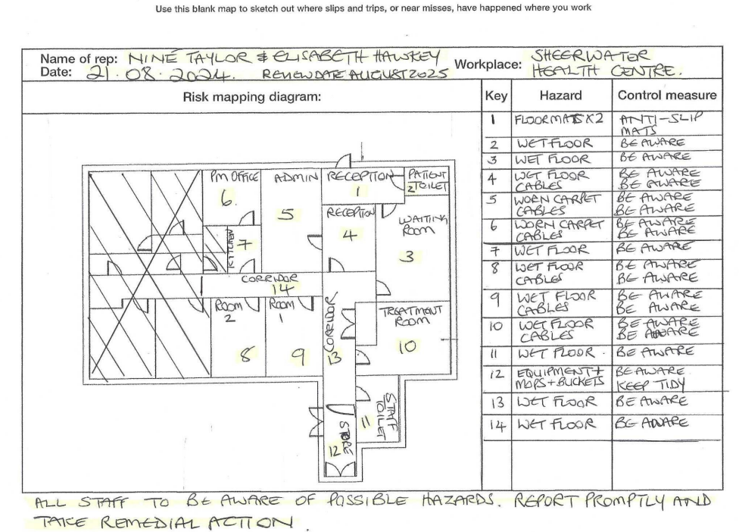  Floor map identifying wet floor/worn carpet/cable risks | Staff, patients and visitors | All staff to be aware of potential hazards. Report promptly and take remedial action | All staff | Ongoing | Discuss at practice meeting to raise awareness | RA carried out in August 2024 | Repeat RA in August 2025

Risk Review Profile | Recommended risk assessment and risk controls review periodicity  Guidance note: The principle of review is that the more significant the risk level, the more often it must be reviewed.  Always review if an incident has occurred:
 | If the risk is 15 – 25 (Very high) Review at least every 1 – 3 months
 | If the risk is 8 – 12 (High) Review at least every 6 – 12 months
 | If the risk is 4 – 6 (Moderate) Review at least every 12 – 18 months
 | If the risk is 1 – 3 (Low) Review at least every 18 – 24 months

