**Safe Water Policy**

|  |  |  |  |  |
| --- | --- | --- | --- | --- |
| **Version:** | **Review date:** | **Edited by:** | **Approved by:** | **Comments:** |
| v1.4 | 06/09/2023 | Sultan Mohamed | Nine Taylor |  |
| v1.4.1 | 16/01/2025 | Sultan Mohamed | Nine Taylor  Louise Gray | Information from Guardian added to Annex |
|  | February 2026 |  |  | Next review |
|  |  |  |  |  |

**Table of contents**

1 Introduction 3

1.1 Policy statement 3

1.2 Status 3

1.3 Training and support 3

2 Scope 3

2.1 Who it applies to 3

2.2 Why and how it applies to them 3

3 Definition of terms 4

3.1 Legionellosis 4

3.2 Legionnaires’ disease 4

3.3 Purpose-built system 4

4 Legionella 4

4.1 Background 4

4.2 Contracting legionnaires’ disease 4

4.3 Symptoms of legionnaires’ disease 5

4.4 At-risk groups 5

4.5 Treatment 5

4.6 Risk 5

5 Risk management 6

5.1 Risk reduction 6

5.2 Risk assessment 6

5.3 Responsible person 6

6 Water temperature testing 6

7 Sampling for legionella bacteria in water systems 7

7.1 Healthcare premises 7

7.2 Legionella testing kits 7

7.3 Further actions 8

8 Summary 8

Annex A – Legionella risk template 9

# Introduction

## Policy statement

The management of safe water and in particular the risk of exposure to legionella is a continued commitment of Sheerwater Health Centre. Legionnaires’ disease occurs when individuals are exposed to legionella that is growing in purpose-built systems. Legionnaires’ disease is potentially fatal and it is essential that an effective management system is in place to protect patients, staff and service users.

## Status

The organisation aims to design and implement policies and procedures that meet the diverse needs of our service and workforce, ensuring that none are placed at a disadvantage over others, in accordance with the [Equality Act 2010](https://www.legislation.gov.uk/ukpga/2010/15/contents). Consideration has been given to the impact this policy might have with regard to the individual protected characteristics of those to whom it applies.

This document and any procedures contained within it are non-contractual and may be modified or withdrawn at any time. For the avoidance of doubt, it does not form part of your contract of employment.

## Training and support

The organisation will provide guidance and support to help those to whom it applies to understand their rights and responsibilities under this policy. Additional support will be provided to managers and supervisors to enable them to deal more effectively with matters arising from this policy.

# Scope

## Who it applies to

This document applies to all employees of the organisation and other individuals performing functions in relation to the organisation such as agency workers, locums and contractors.

Furthermore, it applies to clinicians who may or may not be employed by the organisation but who are working under the Additional Roles Reimbursement Scheme (ARRS)[1]

## Why and how it applies to them

It is the responsibility of all staff to ensure that they take the necessary actions should they notice a problem with the water systems at Sheerwater Health Centre. It remains the responsibility of the organisation management team to ensure that all staff fully understand the risk of legionella and their individual responsibilities.

# Definition of terms

## Legionellosis

Legionellosis is a collective term for diseases caused by legionella bacteria.

## Legionnaires’ disease

A potentially fatal form of pneumonia

## Purpose-built system

The collective name given to hot and cold-water systems

# Legionella

## Background

The bacterium, Legionella pneumophila, and associated bacteria are commonly found in natural water sources in relatively small numbers. In addition, they are also found in purpose-built systems including cooling towers and evaporative condensers.

In optimum conditions, there is a risk of the bacteria growing thereby increasing the risk to staff, patients and other service users at Sheerwater Health Centre.

## Contracting legionnaires’ disease

Legionnaires’ disease is contracted by inhaling droplets of water (aerosols), suspended in the air, containing the bacteria. Certain conditions increase the risk from legionella, such as if:[2]

* The water temperature in all or some parts of the system may be between 20-45°C which is suitable for growth
* It is possible for breathable water droplets to be created and dispersed, e.g., aerosols created by a cooling tower or water outlets
* Water is stored and/or recirculated
* There are deposits that can support bacterial growth, providing a source of nutrients for the organism, e.g., rust sludge, scale, organic matter and biofilms

## Symptoms of legionnaires’ disease

The following are symptoms of legionnaires’ disease:

* Pyrexia
* Chills
* Cough
* Muscle pain
* Headaches
* Pneumonia
* Diarrhoea
* Delirium

## At-risk groups

Although anyone can develop legionnaires’ disease, the following groups are classed as being at higher risk:

* People aged 45 years and over
* Smokers
* Heavy drinkers

In addition to the above, patients with the following conditions are also classed as being at high risk:

* Diabetes
* Chronic respiratory or kidney disease
* Lung disease
* Heart disease
* Immunodeficiency

## Treatment

Treatment for legionnaires’ disease can include:

* Oral or IV antibiotics
* Oxygen
* IV fluids

Older adults and patients with comorbidities are likely to be admitted to hospital.

## Risk

There is a risk of legionella if the water systems at Sheerwater Health Centre:

* Have a water temperature in the range of 20-45°C
* Create and spread breathable droplets
* Store water
* Recirculate water, i.e., end of the pipeline (a dead leg)
* Are in a poor state of repair, i.e., rust, scale, etc.

At Sheerwater Health Centre, it is the responsibility of the Practice Manager to ensure that legionella risks are managed appropriately.

# Risk management

## Risk reduction

Sheerwater Health Centre acts in accordance with the Approved Code of Practice and Guidance[3] provided by the Health and Safety Executive (HSE) and will:

* Identify and assess sources of risk
* Effectively manage risks
* Take preventative measures
* Control any risks
* Maintain accurate records

## Risk assessment

Risk assessments at Sheerwater Health Centre was undertaken by Guardian Water Treatment Ltd on behalf of Skansa Facility Services (acting for Woking Borough Council, the Health Centre’s landlord) in February 2018[1]. It also included the adjacent building, Parkview Community Centre. Under contract from Skansa, Guardian Water Treatment Ltd have provided regular reports on their inspection at the Health Centre and the Community Centre [2][3][5].

Annex A shows a summary of building and water systems [1]

## Responsible person

The responsible liaison person at Sheerwater Health Centre is Nine Taylor, the practice manager. In their absence, their deputy is Louise Gray, the deputy practice manager. The responsible person is someone with sufficient authority, competence, skills, knowledge and experience.[4]

# Water temperature testing

At Sheerwater Health Centre, it is policy to regularly conduct temperature monitoring of the water outlets throughout the premises. As legionella spores can grow in temperatures between 20°c and 45°c, there is a need to ensure that both hot and cold temperatures are outside of these temperatures.

For healthcare premises, the Health and Safety Executive advises that running water temperatures from the hot tap must exceed 55°c within 60 seconds and the cold tap must not reach 20°c within 120 seconds.

Water temperatures should be monitored monthly.

The process for testing the temperature is as follows:

Hot water:

* Using a thermometer, check the water flow from a chosen hot tap
* When doing this for the first time, the tap furthest away from the water heater/boiler should be chosen
* Other representative points can then also be checked in a chosen pattern
* **Hold the thermometer, with the probe facing down, in the hot water flow for one minute, recording the temperature. It should be a minimum of 55°c after one minute**
* **If it does not reach this temperature, the temperature settings need to be adjusted.**

**Cold water:**

* As for hot water above
* Formulate a pattern for rotating through different cold taps each month
* **Hold the thermometer in the cold-water flow for two minutes, recording the temperature**
* **The reading should be 20°c or below. If not, the temperature setting needs to be adjusted.**

**All temperature recordings must be logged for action and/or evidential purposes.**

**At Sheerwater, Skansa carry out regular checks and report are filed [4]**

**The taps are run daily for around 5 minutes to allow flushing of any bacteria and a little longer in hotter months.**

# Sampling for legionella bacteria in water systems

## Healthcare premises

The HSE Publication [Legionnaire’s Disease Part 2](https://www.hse.gov.uk/pubns/priced/hsg274part2.pdf): The control of legionella bacteria in hot and cold-water systems states:

*“The circumstances when monitoring for legionella would be appropriate include high-risk areas or where there is a population with increased susceptibility, e.g., in healthcare premises including care homes*

## Legionella testing kits

Self-testing kits can either be purchased or the services of a legionella water management company may be used. Both options will require samples of tap water being sent for laboratory testing and testing will include both legionella and water quality analysis.

Further reading can be sought from the BSI British Standards publication BS 7592:2022 [Sampling for Legionella bacteria in water systems – Code of practice](https://www.thenbs.com/PublicationIndex/documents/details?Pub=BSI&DocID=335640) (updated 28 Feb 22)

## Further actions

To reduce the risk of legionella, other considerations for the water system are as follows:

* Remove dead ends/blind ends from the system and ensure regular flushing of these dead legs
* Keep pipe runs as short as possible
* Insulate water pipes in work areas where heat may be transferred from other sources, i.e., hot water pipes
* For infrequently used outlets, instigate a programme of weekly flushing to purge and drain. Note any flushing through must be at a low flow rate to avoid the release of aerosols

# Summary

Legionella is a reasonable, foreseeable risk and requires effective management to ensure that exposure to legionella bacteria is eliminated where practicable.

Everyone at Sheerwater Health Centre has a responsibility to support the responsible person by reporting any issues or concerns they have regarding the organisation’s water systems.

# References

1. Guardian: Risk assessment - Parkview Community Centre Legionella is a Legionella Management and control risk assessment March 2018
2. Guardian Report: 11 February 2021
3. Guardian Report: 19 January 2023
4. Skansa Report: Sheerwater tap temperatures – June 2023
5. Guardian Report: 20 January 2024

# Annex A – Summary of building & water systems [1]

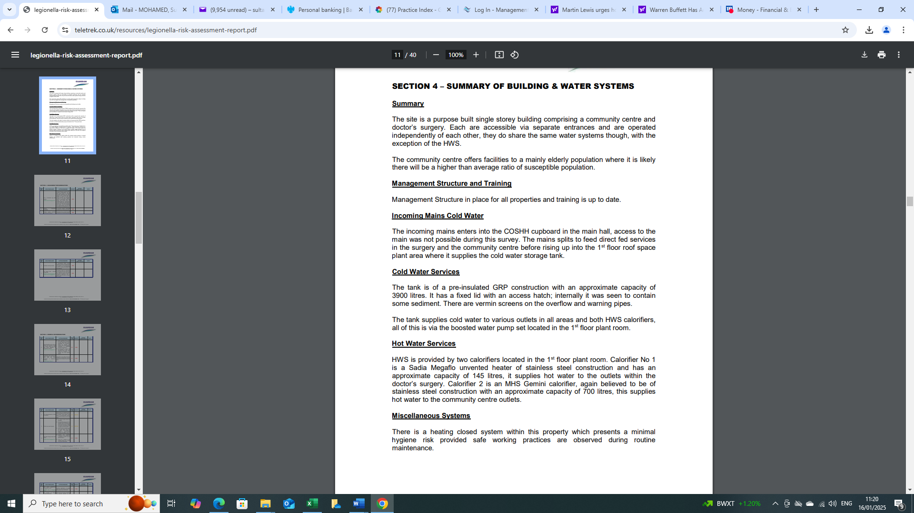

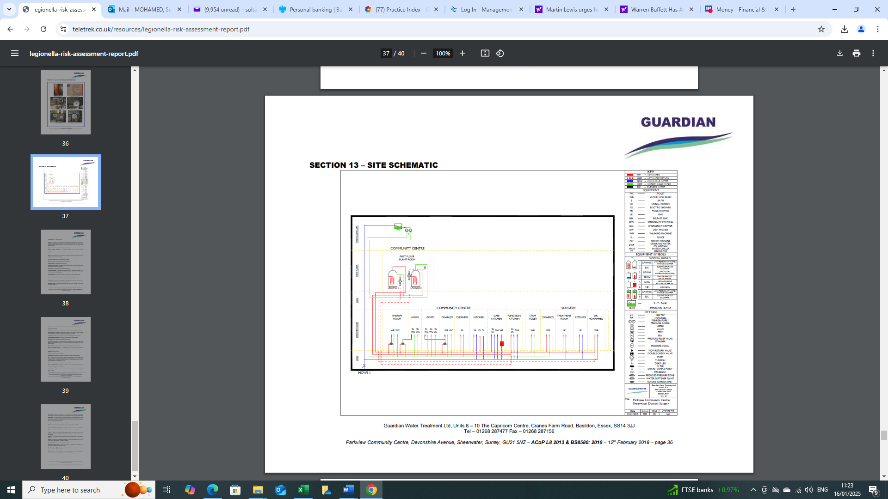

1. [Network DES specification 2022/23](https://www.england.nhs.uk/publication/network-contract-directed-enhanced-service-contract-specification-2022-23-pcn-requirements-and-entitlements/)
2. [HSE What is Legionnaires’ disease?](http://www.hse.gov.uk/legionnaires/what-is.htm)
3. [HSE Legionnaire’s Disease. The control of legionella bacteria in water systems.](https://www.hse.gov.uk/pubns/books/l8.htm)
4. [HSE What you must do](http://www.hse.gov.uk/legionnaires/what-you-must-do.htm)