**Fire Marshal/Warden Guidance**

|  |  |  |  |  |
| --- | --- | --- | --- | --- |
| **Version:** | **Review date:** | **Edited by:** | **Approved by:** | **Comments:** |
| v1 | 14/05/2021 | Sultan Mohamed | Nine Taylor |  |
| v2 | October 2022 | Sultan Mohamed | Nine Taylor | Staff changes |
| v3 | 06/12/2023 | Sultan Mohamed | Nine Taylor | Minor changes |
| v4 | 30/12/2024 | Sultan Mohamed | Nine Taylor | Reissued |
|  | December 2025 |  |  | Next review |
|  |  |  |  |  |

**Table of contents**

1 Introduction 2

1.1 Fire marshal/warden 2

1.2 Policy statement 2

1.3 Status 2

1.4 Training and support 3

2 Scope 3

2.1 Who it applies to 3

2.2 Why and how it applies to them 3

3 Definition of terms 3

3.1 Regulatory Reform (Fire Safety) Order 2005 3

3.2 Responsible person 4

3.3 Fire marshal/fire warden 4

3.4 Fire risk assessment 4

3.5 Personal emergency evacuation plan (PEEP) 4

3.6 Fire alarm system 5

3.7 Smoke alarm 5

3.8 Fire extinguishing equipment 5

3.9 Fire muster point and drills 6

3.10 Automatic sprinkler system 6

3.11 Fire assembly point 6

3.12 Fire evacuation chair 6

3.13 Other fire equipment 7

4 Fire marshal/warden tasks 7

4.1 Routine tasks 7

4.2 Emergency tasks 8

4.3 Mandatory fire safety training 9

5 Summary 9

# Introduction

## Fire marshal/warden

Fire marshal/warden duties are an important and essential part of an organisation’s fire safety and prevention. As well as having important duties to carry out in the event of an outbreak of fire, marshals, along with all other employees, have a day-to-day responsibility to ensure that the risks of an outbreak of fire are minimised.

The number of fire marshals that are required will depend on the recommendations of a fire risk assessment which is required to be carried out for all buildings. At a minimum, two fire marshals are required for each floor of the building.

Fire risk assessments are required to:

* Be suitable and sufficient
* Identify the general fire precautions required
* Show how any significant findings are managed

## Policy statement

This policy deals with the appointment and duties of fire marshals within Sheerwater Health Centre. Those appointed to the role are required to follow the guidance contained in this policy.

The CQC takes fire safety extremely seriously and can use a range of civil and criminal sanctions to prosecute providers if they are in breach of the Regulations[1]. At an inspection, the CQC will cover the question of fire safety under the relevant Key Lines of Enquiry[2] (KLOEs) and prompts.

## Status

The organisation aims to design and implement policies and procedures that meet the diverse needs of our service and workforce, ensuring that none are placed at a disadvantage over others, in accordance with the [Equality Act 2010](https://www.legislation.gov.uk/ukpga/2010/15/contents).

Consideration has been given to the impact this policy might have with regard to the individual protected characteristics of those to whom it applies.

This document and any procedures contained within it are non-contractual and may be modified or withdrawn at any time. For the avoidance of doubt, it does not form part of your contract of employment.

## Training and support

The organisation will provide guidance and support to help those to whom it applies to understand their rights and responsibilities under this policy. Additional support will be provided to managers and supervisors to enable them to deal more effectively with matters arising from this policy.

Furthermore, there is fire marshal training available on Blue Stream Academy - the e-learning platform

# Scope

## Who it applies to

This document applies to all employees of the organisation. Other individuals performing functions in relation to the organisation, such as agency workers, locums, and contractors, are encouraged to use it.

Furthermore, it applies to clinicians who may or may not be employed by the organisation but who are working under the Additional Roles Reimbursement Scheme (ARRS) Outlined in the Network Contract DES Specification 2021/22[3]

## Why and how it applies to them

This document details the outline requirements of staff, both individually and collectively, to comply with fire safety requirements[4] as outlined by the Health and Safety Executive and in particular the responsibilities of fire marshals/wardens.

# Definition of terms

## Regulatory Reform (Fire Safety) Order 2005

The [Regulatory Reform (Fire Safety) Order 2005](https://www.legislation.gov.uk/uksi/2005/1541/contents/made) (RRFSO) was brought in to consolidate existing fire safety laws for England and Wales and to reduce the number of enforcing authorities responsible for dealing with general fire safety.

Scotland is covered under the [Fire (Scotland) Act 2005 and Fire Safety (Scotland) Regulations 2006](https://www.firescotland.co.uk/fire-scotland-act-2005).

In summary the RRFSO states that any person who has some level of control of a premises and is designated as the responsible person must take reasonable steps to reduce the risk from fire and ensure that everyone who may be on the premises at the time of a fire can escape safely.

## Responsible person

The responsible person with regard to fire safety is the person who is obliged to ensure that the requirements of the RRFSO are implemented by the organisation that occupies and is responsible for a building.

Nine Taylor (practice manager) is the responsible person for Sheerwater Health Centre.

## Fire marshal/fire warden

A fire marshal/warden is an employee who, in addition to their normal work for the organisation, is also charged with ensuring on a daily basis that the working environment is safe in case of a fire.

In the event of an outbreak of fire, the fire marshal has certain procedures to follow to keep themselves and other employees safe.

## Fire risk assessment

It is mandatory for a fire risk assessment to be carried out and this follows the same approach as other health and safety risk assessments. Based on the findings of the fire risk assessment, the employer needs to ensure that adequate and appropriate fire safety measures are in place to minimise the risk of injury or loss of life in the event of fire.

The aim of a fire risk assessment is to identify what could cause a fire to break out, who might be at risk from any such outbreak and the action that needs to be taken to reduce and manage the risks if not avoid them altogether.

The risk assessment has to include an emergency evacuation plan for all people likely to be on the premises including disabled people and how that plan will be implemented. The evacuation plan is to designate the fire marshals/wardens by name and include their routine as well as emergency tasks.

All disabled employees are to have a personal emergency evacuation plan (PEEP) drawn up for their use.

## Personal emergency evacuation plan (PEEP)

A personal emergency evacuation plan (PEEP) is a means by which arrangements are made to ensure that an individual’s physical or mental abilities or other circumstances do not prevent them from being able to evacuate the building in the case of an emergency such as a fire.

The responsible person, assisted by the fire marshal/warden, must ensure that a PEEP is generated for every member of staff or student with a disability where this may affect their ability to respond to an emergency. The PEEP will set out the adjustments necessary for maintaining their personal safety.

Further reading can be sought from the Personal emergency evacuation plan.

## Fire alarm system

A fire alarm system’s function is to sound a warning to all occupants of the building that a fire has broken out and that they are to evacuate as quickly as possible and congregate at the fire assembly point.

A fire alarm system may be triggered manually by the person discovering the fire or it may automatically trigger, for example if linked to a smoke alarm system. It is required to be tested regularly to ensure that it is operating correctly.

The fire alarm sound is a continuous beeping. This is tested twice a year.

## Smoke alarm

A smoke alarm detects the presence of smoke and the likelihood of an outbreak of fire having taken place.

The smoke alarm may be stand-alone or linked to the fire alarm system. If not linked to the fire alarm system, it will emit a loud high-pitched warning to inform the occupants of a fire who must then take appropriate action

## Fire extinguishing equipment

Fire extinguishing equipment usually consists of five main types of fire extinguisher (see overleaf).

At Sheerwater Health Centre, the use of fire extinguishers and their operation will be covered during the induction process and annually thereafter during staff fire training sessions.

In addition to fire extinguishers, Sheerwater Health Centre also has some of the fire equipment as detailed at Section 3.13. Fire marshals/wardens are to familiarise themselves with the different characteristics and uses of these types of fire extinguishers.

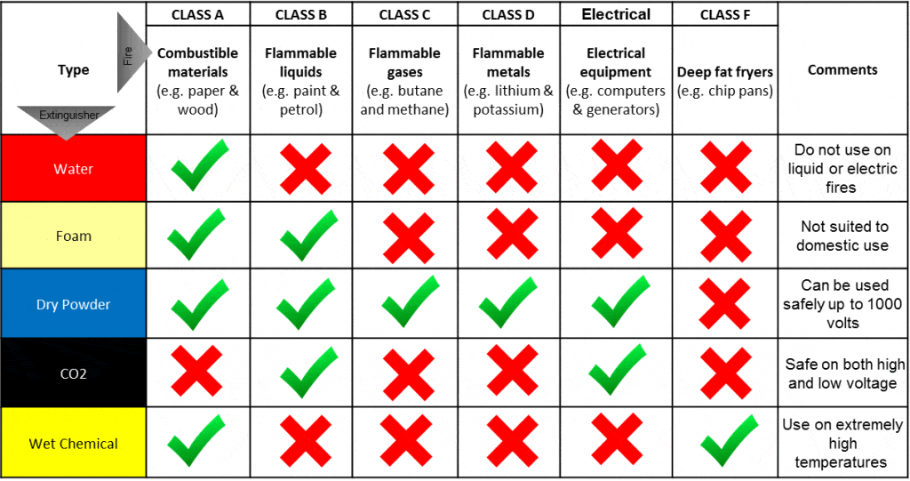

Source: [surreyfire.co.uk](https://surreyfire.co.uk/types-of-fire-extinguisher/)

## Fire muster point and drills

All staff are to be aware of the fire muster point where all staff, patients and visitors must proceed towards immediately on hearing the fire alarm.

## Automatic sprinkler system

An automatic sprinkler is designed to spray a designated area in which a fire has been detected to douse the fire. They are not commonly fitted in general practice buildings as they are expensive to fit and maintain.

## Fire assembly point

The fire assembly point is the location at which all evacuees of the building are to congregate so that the fire marshal who is responsible for a particular area of the building is able to confirm that all employees have left the building and report the fact to the person in charge – usually the responsible person. For Sheerwater Health Centre, the fire assembly point is situated at the Car Park in front of the Health Centre.

## Fire evacuation chair

Although there is nolegal requirement for any organisation to provide fire evacuation chairs, the most relevant piece of legislation is the RRFSO which states under article 9 that the findings of the fire risk assessment will help the responsible person decide if evacuation chairs are required.

## Other fire equipment

Other fire equipment with which the fire marshals/wardens should be familiar with depending on the recommendations of the fire risk assessment include:

* [Walkie talkie](https://bestsurvival.org/best-walkie-talkie/) radio if it is a particularly large building. This will enable the fire marshal/warden to keep the responsible person/chief fire officer informed of the progress of the evacuation and any problems that may arise
* [Fire masks](https://firemask.co.uk/) provide anything from 15 to 60 minutes breathable air but are not considered a necessity in general practice
* [Fire blankets](https://en.wikipedia.org/wiki/Fire_blanket) are usually found in kitchens and are placed over a fire to smother it. Their use is controversial as the fire may quickly reignite when the fire blanket is removed, even after 15 minutes.

# Fire marshal/warden tasks

## Routine tasks

Routine tasks to be performed by a fire marshal/warden are as follows:

* Monitor standards of housekeeping and take action where rubbish accumulates
* Regularly check that fire exits and escape routes are clear and not blocked. This includes checking both sides of an exit to ensure there are no obstructions
* Ensure fire doors remain closed
* Monitor escape routes and assembly points to ensure they are accessible and free from obstructions
* Ensure storage is managed well, particularly where combustible material is involved. Combustible materials should not be stored near a fixed source of ignition
* Check that fire extinguishers have not been moved and that servicing is up to date

* Report any fire protection defects
* Ensure that there is clear access to any break glass emergency alarm points
* Ensure all electrical equipment has been PAT tested and testing is up to date
* Monitor weekly alarm testing and assist with arrangements for practice fire evacuations
* Ensure all new employees have received fire safety procedures as part of their induction including details of escape routes, assembly points and how to raise the alarm
* Nominate a deputy fire marshal for periods of absence
* Assist with the completion of any personal emergency evacuation plans (PEEPs) for any employees who require evacuation assistance

## Emergency tasks

The emergency tasks to be performed by a fire marshal/warden in the event of a fire being discovered are:

* Put on a hi-vis jacket, ensure that the alarm has been raised and the emergency services have been contacted
* Evacuate people from the building as quickly and safely as possible
* Ensure that anyone with a disability is assisted in accordance with their PEEP
* Ensure that if a disabled person requires to be evacuated in accordance with their PEEP using a fire evacuation chair that the designated member of staff or their deputy is available to assist
* Ensure that all areas are cleared during the evacuation and toilets and storerooms are empty and fire doors are closed
* Mark all doors to offices and other places of work with a chalk mark “checked” to indicate it has been checked and all occupants have left for the assembly point
* Ensure no re-entry into the building until advised by the fire service or, in the case of a fire evacuation practice without the fire service, the responsible person
* Attend the assembly point and either conduct a roll call procedure or inform the responsible person/chief fire officer that all areas inside have been cleared and checked

## Mandatory fire safety training

At Sheerwater Health Centre, fire safety training is to be conducted annually for all staff.

For fire marshals/wardens, the frequency of their training is based upon the level of risk within the building and is as detailed within the fire risk assessment.

Whilst there is a low likelihood of a fire within these premises, there is a higher level of potential harm due to a longer than usual evacuation involving elderly or immobile patients and therefore fire evacuation drills will be conducted within a reasonable timescale. At Sheerwater Health Centre, this is not normally less than annually.

Further advice can be sought from [Health and Safety Executive](https://www.hse.gov.uk/toolbox/fire.htm) guidance.

# Summary

Fire marshals/wardens have key responsibilities for ensuring that the day-to-day state of the work place is kept in as safe as possible condition to reduce/eliminate all possible fire risks. In the event of a fire, they are responsible for ensuring the

safe evacuation of the workplace.

By following this guidance, they will be able to fulfil these responsibilities.

1. [Health and Social Care Act 2008 (Regulated Activities) Regulations 2014](https://www.legislation.gov.uk/uksi/2014/2936/regulation/12/made)
2. [CQC Key Lines of Enquiry](https://www.cqc.org.uk/sites/default/files/20180628%20Healthcare%20services%20KLOEs%20prompts%20and%20characteristics%20showing%20changes%20FINAL.pdf)
3. [Network DES Contract specification 2021/22](https://www.england.nhs.uk/publication/network-contract-des-specification-2021-22/)
4. [Health and Safety Executive Fire Safety](https://www.hse.gov.uk/toolbox/fire.htm)