**Medical Emergencies Policy**

|  |  |  |  |  |
| --- | --- | --- | --- | --- |
| **Version:** | **Review date:** | **Edited by:** | **Approved by:** | **Comments:** |
| v1 | 09/03/2021 | Sultan Mohamed |  | Under review |
|  |  |  |  |  |
|  |  |  |  |  |
|  |  |  |  |  |

**Table of contents**

1 Introduction 3

1.1 Policy statement 3

1.2 Principles 3

1.3 KLOE 3

1.4 Status 5

1.5 Training and support 5

1.6 Mandatory training during COVID-19 5

2 Scope 6

2.1 Who it applies to 6

2.2 Why and how it applies to them 6

3 Definition of terms 6

3.1 Medical emergency 6

3.2 Urgent care 6

3.3 Resuscitation Council UK (RCUK) 6

3.4 Treatment Escalation Plan (TEP) 7

3.5 DNACPR 7

3.6 ReSPECT 7

4 Emergencies in general practice 7

4.1 Early diagnosis 7

4.2 Classifications of medical emergencies 7

4.3 Initial management by clinicians 8

4.4 Non-clinical staff responsibilities 8

4.5 External emergencies 8

4.6 Conducting CPR during COVID-19 pandemic 9

4.7 DNACPR and TEP 9

4.8 ReSPECT 10

4.9 DNACPR during COVID-19 10

5 Emergency equipment 11

5.1 Oxygen, defibrillator and other emergency equipment 11

5.2 Emergency drugs 11

6 Management of specific medical emergencies 13

7 Further reading 14

8 Summary 14

Annex A – Advanced life support for adults (RCUK) 15

Annex B – Advanced life support for paediatrics (RCUK) 16

Annex C – Basic life support for adults (RCUK) 17

Annex D – Basic life support for paediatrics (RCUK) 18

Annex E – Basic life support for adults with COVID-19 (RCUK) 19

Annex F – ALS for paediatrics with COVID-19 (RCUK) 20

Annex G – Anaphylaxis (RCUK) 21

Annex H – Benzodiazepine overdose 22

Annex I – Breathing difficulties 23

Annex J – Chest pain 24

Annex K – Choking and aspiration 25

Annex L – Adult choking (RCUK) 26

Annex M – Paediatric choking (RCUK) 27

Annex N – Hypoglycaemia 28

Annex O – Opioid overdose 29

Annex P – Seizures 30

Annex Q – Syncope/Faint 31

# Introduction

## Policy statement

Patients may present with a medical emergency at any time. GPs, nurses and non-clinical staff at Sheerwater Health Centre may be faced with the challenge of dealing with, and appropriately managing, a medical emergency. It is therefore imperative that the organisation is prepared for such occurrences.

This policy will provide referenced guidance on the management of medical emergencies.

## Principles

Patient safety requires assurance that all doctors, including locums, are appropriately trained and qualified for the work they undertake. Furthermore, GPs need the knowledge, skills and equipment for managing the medical emergencies they are likely to face.[1]

## KLOE

The CQC would expect any primary care organisation to have a policy to support this process and this should be used as evidence of compliance against CQC Key Lines of Enquiry (KLOE)[2]

Specifically, Sheerwater Health Centre will need to answer the CQC Key Questions on “Safe”, “Responsive” and “Well-Led”.

The following is the CQC definition of Safe

*By safe, we mean people are protected from abuse* and avoidable harm. *Abuse can be physical, sexual, mental or psychological, financial, neglect, institutional or discriminatory abuse.*

|  |  |
| --- | --- |
| **CQC KLOE S2** | How are risks to people assessed, and their safety monitored and managed so they are supported to stay safe? |
| **S2.5** | Are comprehensive risk assessments carried out for people who use services and risk management plans developed in line with national guidance?  Are risks managed positively? |
| **S2.6** | How do staff identify and respond appropriately to changing risks to people, including deteriorating health and wellbeing, medical emergencies or behaviour that challenges?  Are staff able to seek support from senior staff in these situations? |
| **CQC KLOE S4** | How does the provider ensure the proper and safe use of medicines where the service is responsible? |
| **S4.1** | How are medicines and medicines-related stationery managed (that is, ordered, transported, stored and disposed of safely and securely)?  (This includes medical gases and emergency medicines and equipment) |

The following is the CQC definition of Responsive:

*By responsive, we mean that services meet people’s needs.*

|  |  |
| --- | --- |
| **CQC KLOE R3** | Can people access care and treatment in a timely way? |
| **R3.4** | Do people with the most urgent needs have their care and treatment prioritised? |

The following is the CQC definition of Well Led:

*By well-led, we mean that the leadership, management and governance of the organisation assures the delivery of high-quality and person-centred care, supports learning and innovation and promotes an open and fair culture.*

|  |  |
| --- | --- |
| **CQC KLOE W1** | Is there the leadership capacity and capability to deliver high-quality, sustainable care? |
| **W1.1** | Do leaders have the skills, knowledge, experience and integrity that they need – both when they are appointed and on an ongoing basis? |
| **CQC KLOE W4** | Are there clear responsibilities, roles and systems of accountability to support good governance and management? |
| **W4.1** | Are there effective structures, processes and systems of accountability to support the delivery of the strategy and good quality, sustainable services?  Are these regularly reviewed and improved? |
| **CQC KLOE W5** | Are there clear and effective processes for managing risks, issues and performance? |
| **W5.4** | Are there robust arrangements for identifying, recording and managing risks, issues and mitigating actions?  Is there alignment between the recorded risks and what staff say is ‘on their worry list’? |
| **W5.5** | Are potential risks taken into account when planning services, for example seasonal or other expected  or unexpected fluctuations in demand or disruption to staffing or facilities? |

## Status

The organisation aims to design and implement policies and procedures that meet the diverse needs of our service and workforce, ensuring that none are placed at a disadvantage over others, in accordance with the Equality Act 2010. Consideration has been given to the impact this policy might have with regard to the individual protected characteristics of those to whom it applies.

This document and any procedures contained within it are non-contractual and may be modified or withdrawn at any time. For the avoidance of doubt, it does not form part of your contract of employment.

## Training and support

The organisation will provide guidance and support to help those to whom it applies to understand their rights and responsibilities under this policy. Additional support will be provided to managers and supervisors to enable them to deal more effectively with matters arising from this policy.

Algorithms supporting the management of emergency treatment can be sought within the annexes.

## Mandatory training during COVID-19

Due to the limitations caused by COVID-19, resuscitation training during the pandemic needs to be altered. Therefore, the following [link from Resuscitation Council UK](https://www.resus.org.uk/covid-19-resources/statements-covid-19-hospital-settings/resuscitation-council-uk-statement-covid-1) should be read when planning any training.

Their advice outlines the requirement to ensure that safety has been considered when undergoing mandatory training in Basic Life Support (BLS), Automated External Defibrillator (AED) plus other training that supports resuscitation techniques.

Within this advice, there is specific guidance for all UK nations.

Consideration should be given for the practice to raise a risk assessment detailing actions that have been considered. For support on completing a risk assessment, refer to the [Risk Assessment Guidance Document](https://practiceindex.co.uk/gp/forum/resources/1519).

[Basic Life Support (BLS) (Adults)](https://practiceindex.co.uk/gp/forum/threads/basic-life-support-adults.13910/)

[Basic Life Support (BLS) (Children and Infants)](https://practiceindex.co.uk/gp/forum/threads/basic-life-support-infants-and-children.14410/)

[Anaphylaxis](https://practiceindex.co.uk/gp/forum/threads/anaphylaxis.13912/)

[Mental capacity act](https://practiceindex.co.uk/gp/forum/threads/mental-capacity-act.13877/)

# Scope

## Who it applies to

This document applies to all employees, partners and directors of the organisation. Other individuals performing functions in relation to the organisation, such as agency workers, locums and contractors, are encouraged to use it.

## Why and how it applies to them

It is the responsibility of all staff to ensure they recognise, respond to and take the necessary actions when dealing with any medical emergency.

It remains the responsibility of the practice management team to ensure that all staff have undertaken the necessary training to be able to respond to a medical emergency within the organisation.

# Definition of terms

## Medical emergency

A serious and unexpected situation involving illness or injury and requiring immediate action

## Urgent care

Acute and chronic medical conditions or injuries which do not require hospital admission and can be managed without a trip to an emergency department

## Resuscitation Council UK (RCUK)

RCUK[3] develops guidelines that inﬂuence emergency care policy. They provide education, training and research to support the skills needed to save a life.

## Treatment Escalation Plan (TEP)

TEP should be considered for those patients whose condition is likely to significantly deteriorate and it is especially important for any TEP to be discussed for those patients whose mental capacity is likely to diminish.

## DNACPR

Do not attempt cardio-pulmonary resuscitation or DNACPR is a pre-arranged agreement between patients, family and friends and clinical staff should the patient have capacity. If the patient does not have capacity, then this will be agreed between all other parties should there be not be any previously agreed TEP in place.

Further advice can be sought in the [Mental Capacity Act Policy](https://practiceindex.co.uk/gp/forum/resources/mental-capacity-act-policy.1105/).

## ReSPECT

The Recommended Summary Plan for Emergency Care and Treatment (ReSPECT) is a process which records recommendations to guide immediate decision-making about a person’s care and treatment, including about CPR, in case of a future emergency in which they lack capacity.

# Emergencies in general practice

## Early diagnosis

GPs have more contact with patients than any other element of the NHS. Early diagnosis and treatment in the primary care setting will reduce harm and distress for the patient. Effective and timely responses can avoid unwell adults and children being driven to use emergency departments.[4]

## Classifications of medical emergencies

In general practice, medical emergencies have been classified as:[5]

* Cardiovascular
* Respiratory
* Gastrointestinal
* Endocrine
* Neurological
* Overdoses and poisoning

In addition to the above, the following have been classified as ‘other’ medical emergencies:

* Sickle cell crisis
* Acute renal failure
* Delirium tremens

## Initial management by clinicians

Clinicians presented with such emergencies should determine whether it is appropriate to manage the patient in the practice setting or if the patient should be referred to hospital via emergency ambulance.

Some medical emergencies can be managed completely within the practice setting whilst others will require hospital referral following initial management. The determining factors for on-site management are:

* Level of clinical expertise available
* Severity of the presenting condition
* Proximity of the nearest secondary care facility
* Availability of paramedical crews to transfer the patient

The responsibility for the management of the patient rests with the clinician.

## Non-clinical staff responsibilities

Non-clinical staff are to be trained to recognise patients who may present with medical emergencies and, in particular, identify patients who show signs of:

* Shortness of breath
* Wheezing
* Dizziness
* Obvious signs of distress/pain
* Sweating profusely and/or paleness
* Appearing confused or disorientated

NB: This list is not exhaustive.

In such instances, non-clinical staff should alert a clinical colleague to ensure that patients are afforded the most appropriate level of care in a distressing situation.

## External emergencies

If an incident arises within close proximity to the practice, clinical staff should provide the appropriate assistance until specialist help arrives (Ambulance Service). For nurses, the NMC Code places a professional duty on a nurse to provide appropriate assistance, within their sphere of knowledge and competence. It must be stressed that there is **no legal duty** to volunteer to help in an emergency situation.[6]

Similarly, GPs have an ethical duty to provide what assistance they can if an emergency situation arises. The GMC guidelines state:[7]

* *You must offer help if emergencies arise in clinical settings or in the community, taking account of your own safety, your competence and the availability of other options for care.*

On occasion, members of the public may ask the organisation to provide a defibrillator whilst they await the Ambulance Service. In such instances, it would be appropriate for a clinician and a non-clinical member of staff to attend the incident with the emergency equipment (defibrillator) to provide support within the scope of their clinical competence until specialist help arrives.

Clinicians should ensure that they record their involvement at the incident accurately, as this information may be required at a later date by the patient’s GP, hospital staff or possibly legal representatives.

Staff must ensure that any emergency equipment is returned to the organisation as soon as it is no longer needed at the scene of the emergency. This will ensure that the equipment can be prepared for future use immediately.

## Conducting CPR during COVID-19 pandemic

COVID-19 is spread in a way similar to seasonal influenza, from person-to-person, through close contact and droplets.

Therefore, standard principles of infection control and droplet precautions are the main control strategies and should be followed rigorously. As aerosol transmission can occur, attention to hand hygiene and containment of respiratory secretions produced by coughing and sneezing are the cornerstones of effective infection control.

RCUK have provided the following [information](https://www.resus.org.uk/covid-19-resources/statements-covid-19-coronavirus-primary-care-settings/resuscitation-council-uk) with CPR in a primary care setting. In addition, information and algorithms are available within the annexes.

Further advice was provided by [RCUK](https://www.resus.org.uk/about-us/news-and-events/resuscitation-council-uk-position-covid-19-guidance-september-2020) in September 2020.

Additional support and guidance relating to maintaining infection control principles during COVID-19 can be found at:

[Pandemic Management Policy](https://practiceindex.co.uk/gp/forum/resources/pandemic-management-policy.1439/)

[Pandemic Management Policy (Scotland)](https://practiceindex.co.uk/gp/forum/resources/pandemic-management-policy-scotland.1466/)

[Pandemic Management Policy (Wales)](https://practiceindex.co.uk/gp/forum/resources/pandemic-management-policy-wales.1565/)

[Infection Prevention Control Policy](https://practiceindex.co.uk/gp/forum/resources/infection-prevention-control-policy-ipc.700/)

[Infection Prevention Control Policy (Scotland)](https://practiceindex.co.uk/gp/forum/resources/infection-prevention-control-policy-scotland.1570/)

[Cleaning Standards and Schedule Policy](https://practiceindex.co.uk/gp/forum/resources/cleaning-standards-and-schedule-policy.1388/)

## DNACPR and TEP

Conversations about Do Not Attempt Cardiopulmonary Resuscitation (DNACPR) should not happen in isolation and should involve a multi-disciplinary process. As such, DNACPR decisions must take place as part of broader conversations about the treatment and future care of patients.

The BMJ[8] advises that systems should have a broad approach to advance care planning and suggest a Treatment Escalation Plan (TEP).The TEP should be considered for those patients whose condition is likely to significantly deteriorate and it is especially important for any TEP to be discussed for those patients whose mental capacity is likely to diminish.

DNACPR should be part of the TEP and any consultation in regards to ongoing treatment, including the level of life sustaining therapeutic interventions or actions, must involve the patient and their family and friends in addition to any health and care professionals directly involved in their care.

Importantly, the TEP must be an individual plan and it is to guide health and care staff so that the wishes are considered to reduce harm from over-treatment in people for whom death is inevitable and under-treatment in people who need symptomatic relief at the end of life.

## ReSPECT

The ReSPECT process is increasingly being adopted within health and care communities around the UK. The process supports conversations about care in a future emergency and is now being used by the majority of communities within England.

The aim is to develop a shared understanding between the healthcare professional and the patient of their condition, the outcomes the patient values, their concerns and then how treatments and interventions, such as cardiopulmonary resuscitation (CPR), fit into this. It supports the important principle of personalised care.

The RCUK latest version (v3) of the ReSPECT [form](https://www.coventryrugbygpgateway.nhs.uk/resources/respect-form-v3/?gpage_id=10329) should be used to document conversations and recommendations made for care and treatment in an emergency. RCUK advise that this latest version is more patient-centered and contains more prompts for explicit clinical reasoning.

Further reading from RCUK:

* [Detailed](https://www.resus.org.uk/respect) information on ReSPECT
* Information on how v3 of the ReSPECT form coupled with FAQs can be sought [here](https://www.resus.org.uk/about-us/news-and-events/resuscitation-council-uk-introduces-version-3-respect-form)
* [Advice](https://www.resus.org.uk/library/publications/publication-decisions-relating-cardiopulmonary) on decisions relating to cardiopulmonary resuscitation (CPR)

## DNACPR during COVID-19

The COVID-19 pandemic has highlighted the importance of sensitive and well-structured conversations regarding a patient’s realistic healthcare choices and the need for a shared understanding between all involved persons.

The Resus Council UK has created a range of resources about decision making during COVID-19.[9]

Do Not Attempt Cardiopulmonary Resuscitation (DNACPR) decisions during the COVID-19 pandemic raised concerns that a blanket application of DNACPR decisions applied to groups of people rather than on an assessment of each person’s individual circumstances.

As such, the CQC have explored the implementation of best practice DNACPR

Guidance and the key points raised was that *“conversations about DNACPR should not happen in isolation”* and that the CQC expects *“DNACPR decisions to take place as part of broader conversations about future care and treatment.”*

See further reading from the CQC in regards to DNACPR:

1. [Announcement](https://www.cqc.org.uk/news/releases/cqc-finds-combination-increasing-pressures-rapidly-developing-guidance-may-have) dated 3 December 2020
2. [Interim report](https://www.cqc.org.uk/sites/default/files/20201204%20DNACPR%20Interim%20Report%20-%20FINAL.pdf) dated November 2020

The CQC considers the ReSPECT process as being best practice in advance care planning.

# Emergency equipment

## Oxygen, defibrillator and other emergency equipment

To enable Sheerwater Health Centre to deal with an emergency effectively, processes are in place to ensure that emergency equipment is serviceable and in date, including all ancillary equipment. Checklists are an effective way of ensuring compliance and they provide evidence of good practice.

At Sheerwater Health Centre oxygen, defibrillator and other emergency equipment are stored in the treatment room. Overall responsibility for this equipment rests with the practice nurse and the practice manager. This equipment must be routinely checked on a regular basis to ensure its serviceability.

Further detailed guidance is available in the [Emergency Equipment Checklist](https://practiceindex.co.uk/gp/forum/resources/emergency-equipment-checklist.1103/).

## Emergency drugs

The emergency drugs and doctor’s bag are held at [insert location], the monitoring of which is the responsibility of the [insert name/role, i.e. ANP].

[The following drugs form the suggested CQC list of emergency drugs as detailed within Nigel’s surgery 9. Should it be decided that this full list is not appropriate, then a risk assessment must be conducted].

|  |  |
| --- | --- |
| **Drug** | **Indication** |
| Adrenaline for injection | Anaphylaxis or acute angio-oedema |
| Antiemetic such as cyclizine, metoclopramide or prochlorperazine | Nausea and vomiting |
| Aspirin soluble tablets | Suspected myocardial infarction |
| Atropine for practices that fit coils or perform minor surgery | Bradycardia |
| Benzylpenicillin for injection/cefotaxime 1g for Injection | Suspected bacterial meningitis |
| Chlorphenamine for injection | Anaphylaxis or acute angio-oedema |
| Dexamethasone 5mg/2.5ml oral solution | Croup (children) |
| Diclofenac (intramuscular injection) | Analgesia |
| Furosemide or bumetanide | Left ventricular failure |
| Glucagon (needs refrigeration) or Glucogel  Note: Glucagon (needs refrigeration. GlucaGen® Hypokit® has an 18-month expiry out of fridge –  should be labelled with new expiry date) | Hypoglycaemia |
| Glyceryl trinitrate (GTN) spray or unopened in date GTN sublingual tablets | Chest pain of possible cardiac origin |
| Hydrocortisone for injection – soluble prednisolone | Acute severe asthma, severe or recurrent anaphylaxis |
| Midazolam (buccal) or diazepam (rectal) | Epileptic fit |
| Naloxone (see section below) | Opioid overdose |
| Opiates – diamorphine, morphine or pethidine ampoules for injection. (Water for injection may be required to reconstitute) | Severe pain including myocardial infarction |
| Salbutamol either nebules with a nebuliser or inhaler with volumatic ipratropium bromide (children) – consider strengths stocked. | Asthma |

**Notes:**

1. Naloxone is a medicine used to reverse the effects of opiates. Organisations that stock opiates (either in the practice or in the doctor’s bag) should also stock naloxone.
2. Other providers should risk assess the need to stock Naloxone based on their patient group. For example, do they provide services for patients with addiction? May patients present with opiate related problems?
3. This list is not exhaustive. It may be necessary for a GP surgery to carry additional medicines based on the needs of the local population and local arrangements for services, e.g. district nurses, palliative care and substance misuse.
4. The CQC would expect to see evidence that an appropriate risk assessment has been carried out. This is to identify a list of medicines that are not suitable for a practice to stock and how this is kept under review.
5. There should be a process and system in place to check that drugs are in date and equipment is well maintained.

Further advice can be sought from:

* [Drugs and Therapeutics Bulletin Drugs for the Doctors Bag:1 Adults Volume 53 Issue 5](http://dtb.bmj.com/content/53/5/56)
* [Drugs and Therapeutics Bulletin Drugs for the Doctors Bag:2 Children Volume 53 Issue 6](http://dtb.bmj.com/content/53/6/69)

# Management of specific medical emergencies

The Resuscitation Council UK produces guidelines approximately every five years. Within the annexes, specifically with RSUK algorithms, the latest versions (dates in brackets) have been used*.

The annexes detail the management of the following emergencies:

* ALS (Adults) (2015)
* ALS (Paediatric) (2015)
* BLS (Adults) (2015)
* BLS (Paediatric) (2015)
* BLS – Process for adults during COVID (2020)
* BLS – Process for paediatrics during COVID (2020)
* Anaphylaxis (2021)
* Benzodiazepine overdose
* Breathing difficulties
* Chest pain
* Choking
* RCUK Choking (Adults) (2015)
* RCUK Choking (Paediatrics) (2015)
* Hypoglycemia
* Opioid overdose
* Seizures
* Syncope/fainting

*Due to COVID-19, RCUK have delayed releasing the expected 2020 updates.

# Further reading

The following can support additional training and guidance with the management of medical emergencies:

* NHS E publication [Talking do not attempt cardiopulmonary resuscitation](https://www.england.nhs.uk/publication/talking-do-not-attempt-cardiopulmonary-resuscitation-dnacpr/)
* [www.resus.org.uk](https://www.resus.org.uk/)
* [RCGP](https://elearning.rcgp.org.uk/mod/page/view.php?id=11672?utm_source=resuscounciluk_medium=tw_date=211220) e-Learning on the new anaphylaxis guidelines dated Dec 20
* For anaphylaxis in children support see [www.sparepensinschools.uk](http://www.sparepensinschools.uk)

# Summary

All staff have an essential role to play in identifying, responding to and managing medical emergencies at Sheerwater Health Centre and therefore training is an essential component to ensure an appropriate response to a medical emergency.

Early recognition and summoning help are key if further distress and harm are to be prevented in medical emergencies.

# Annex A – Advanced Life Support for adults (RCUK)

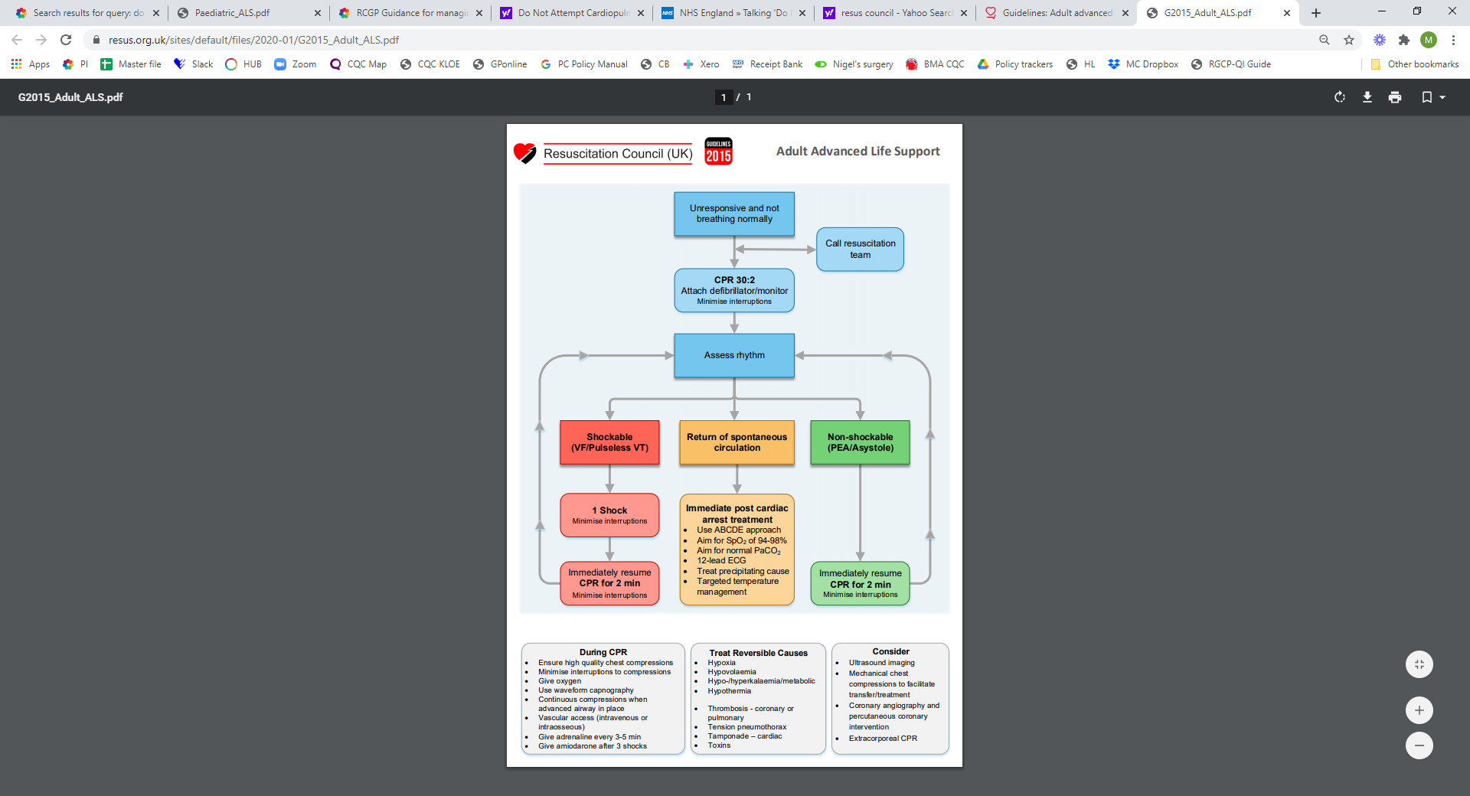

Source: [www.resus.org.uk](https://www.resus.org.uk/sites/default/files/2020-01/G2015_Adult_ALS.pdf)

RCUK guidelines: [Adult Advanced Life Support](https://www.resus.org.uk/library/2015-resuscitation-guidelines/guidelines-adult-advanced-life-support#5-treat-reversible-causes)

# Annex B – Advanced Life Support for paediatrics (RCUK)

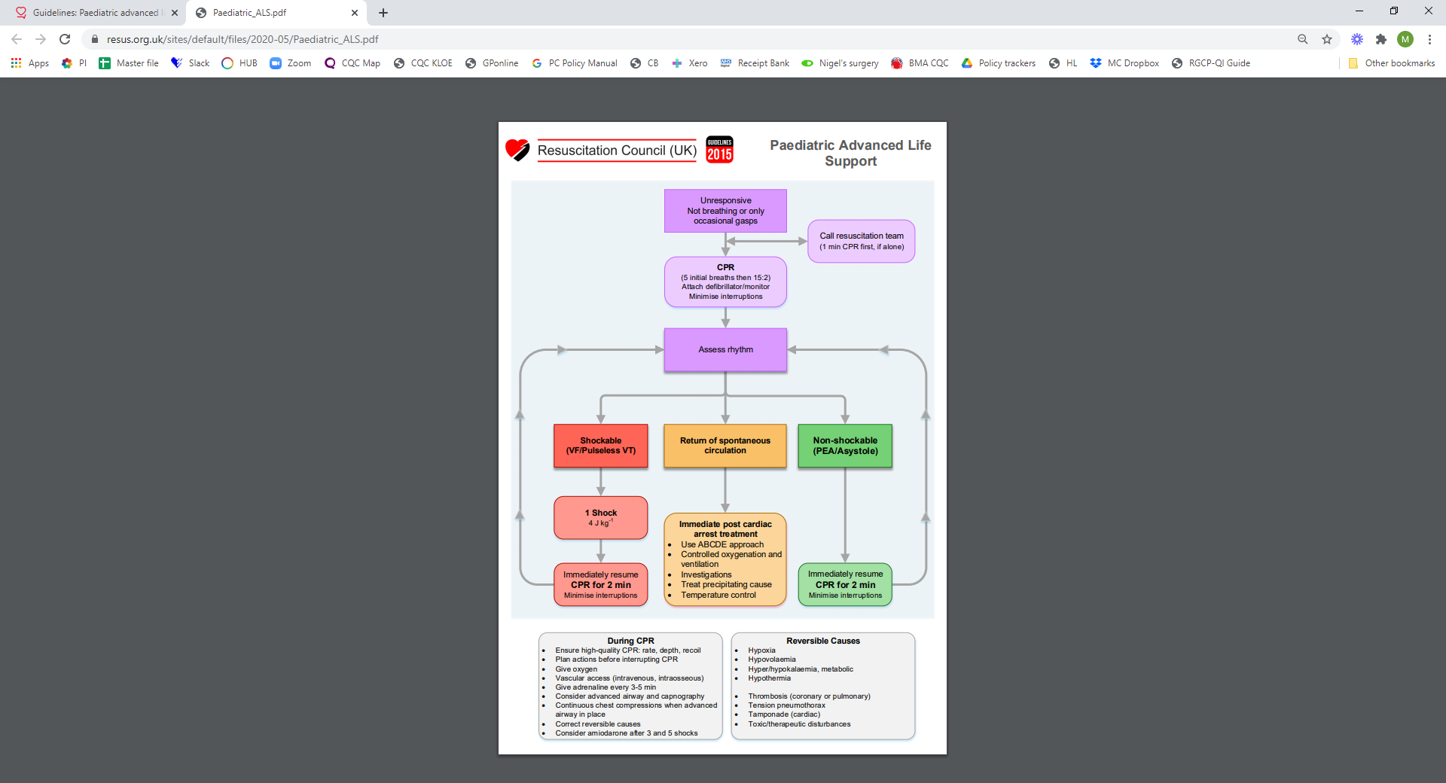

Source: [www.resus.org.uk](https://www.resus.org.uk/sites/default/files/2020-05/Paediatric_ALS.pdf)

RCUK guidelines: [Paediatric Advanced Life Support](https://www.resus.org.uk/library/2015-resuscitation-guidelines/paediatric-advanced-life-support)

# Annex C – Basic Life Support for adults (RCUK)

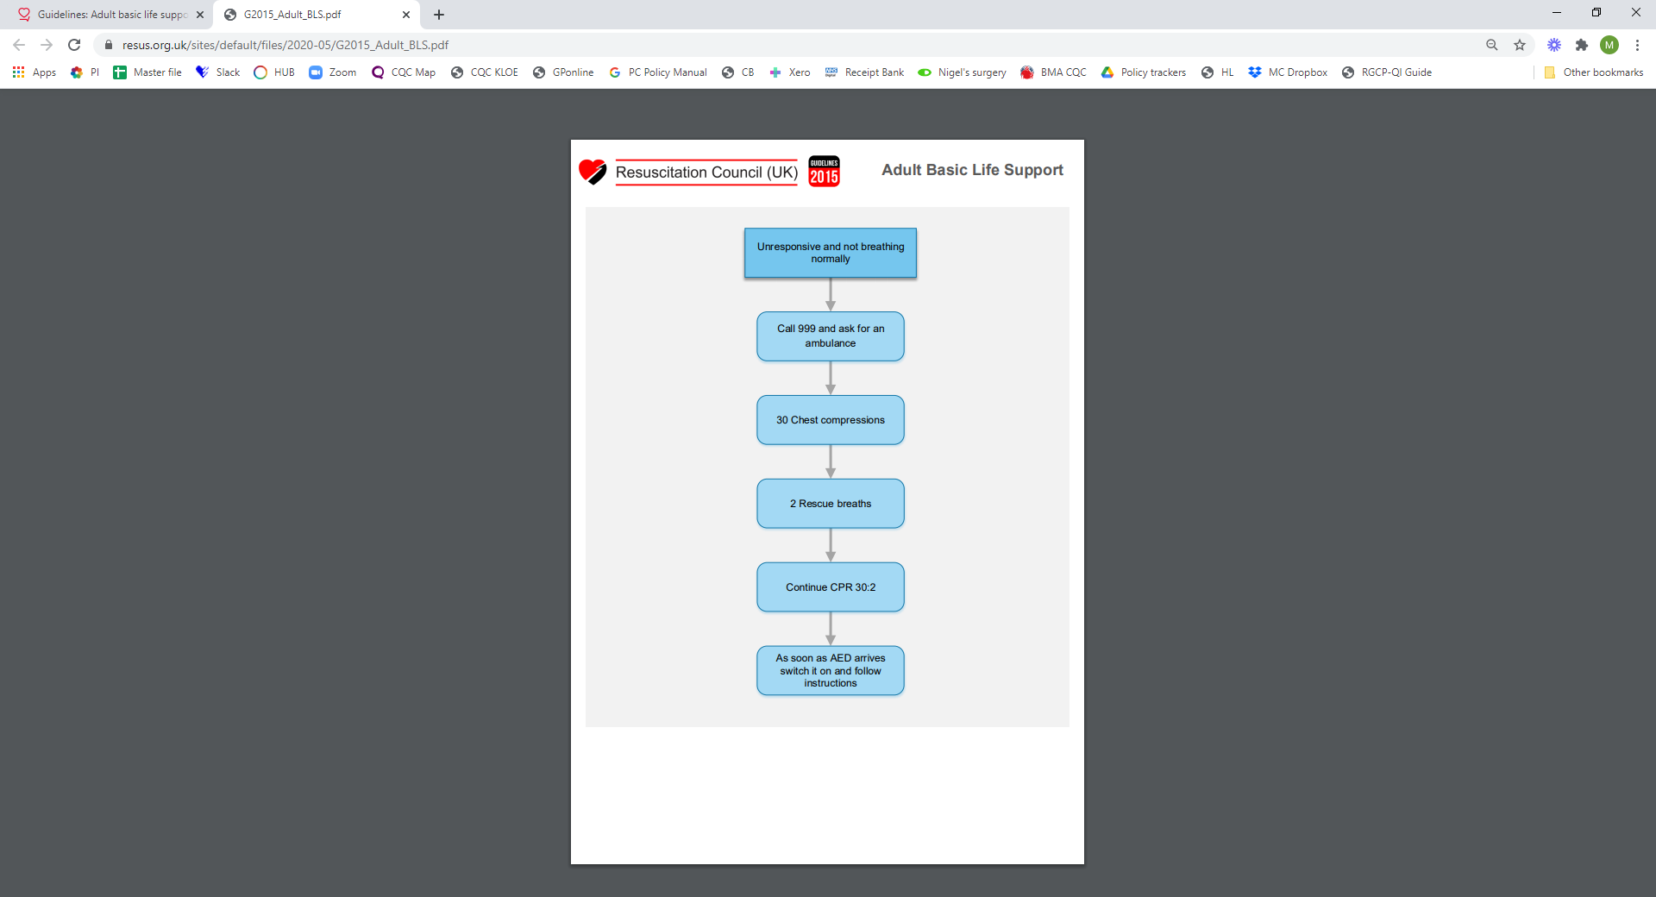

Source: [www.resus.org.uk](https://www.resus.org.uk/sites/default/files/2020-05/G2015_Adult_BLS.pdf)

# Annex D – Basic Life Support for paediatrics (RCUK)

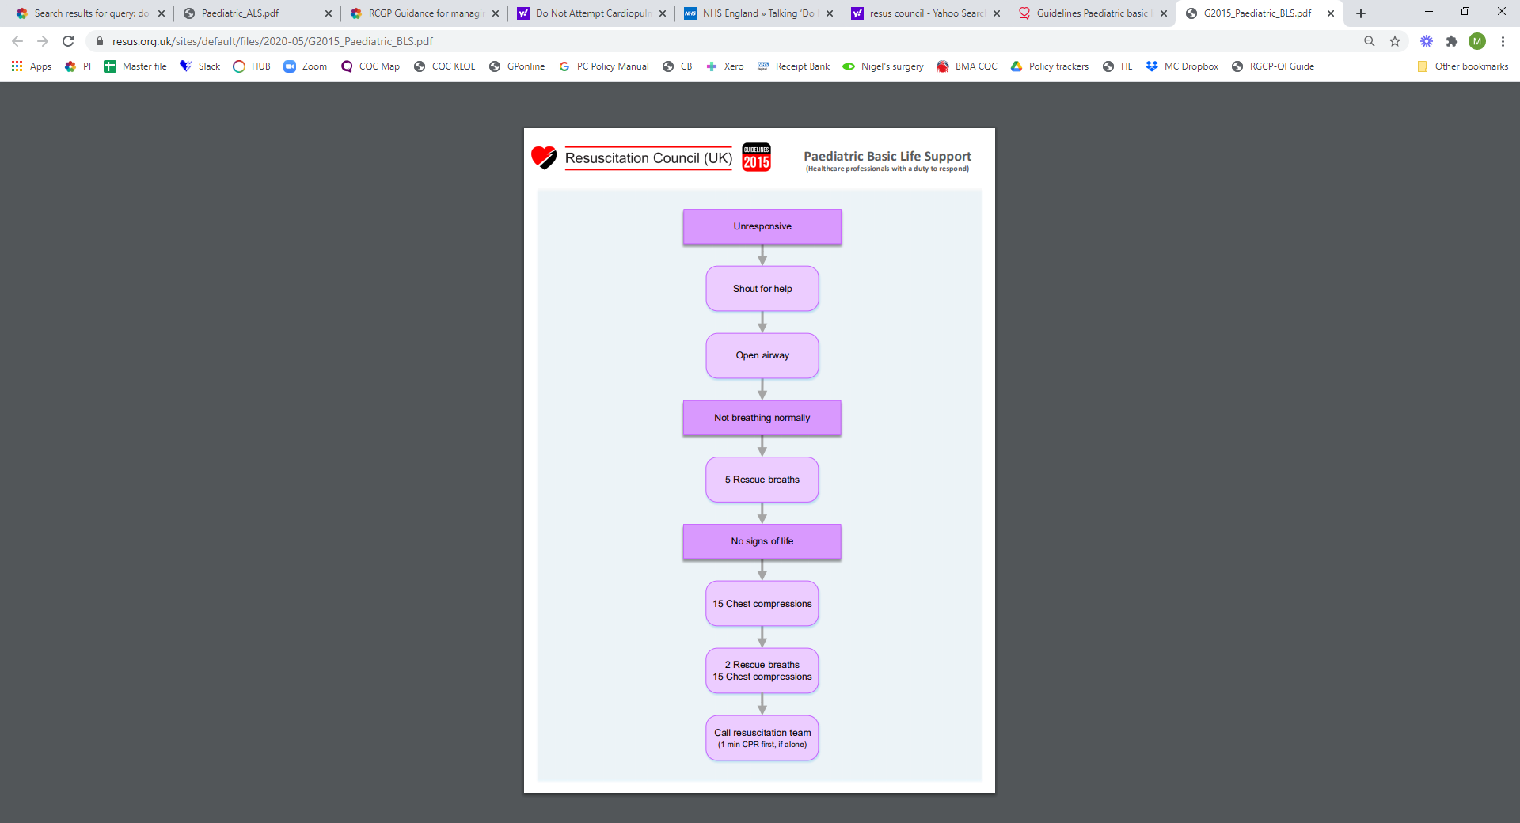

Source:[www.resus.org.uk](https://www.resus.org.uk/sites/default/files/2020-05/G2015_Paediatric_BLS.pdf)

# Annex E – BLS for adults with COVID-19 (RCUK)

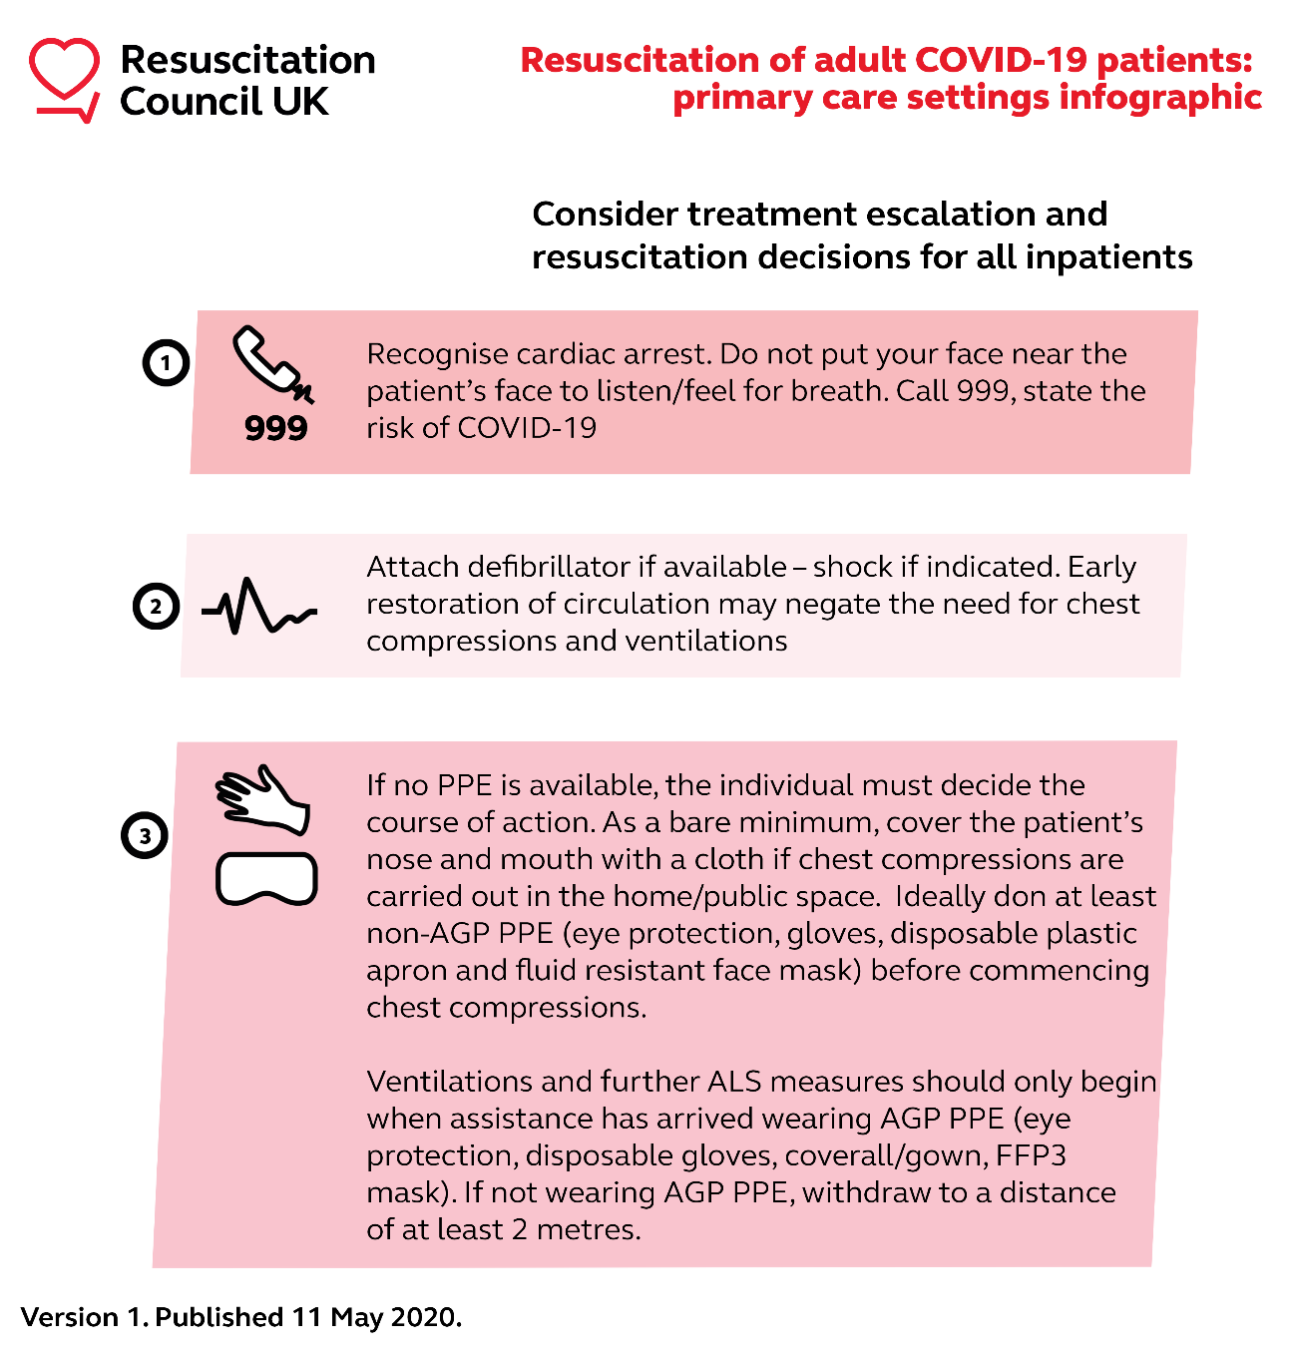

Source: [www.resus.org.uk](http://www.resus.org.uk)

RCUK [Statements](https://www.resus.org.uk/covid-19-resources/statements-covid-19-coronavirus-primary-care-settings) on resuscitation in a primary care setting

# Annex F – ALS for paediatrics with COVID-19 (RCUK)

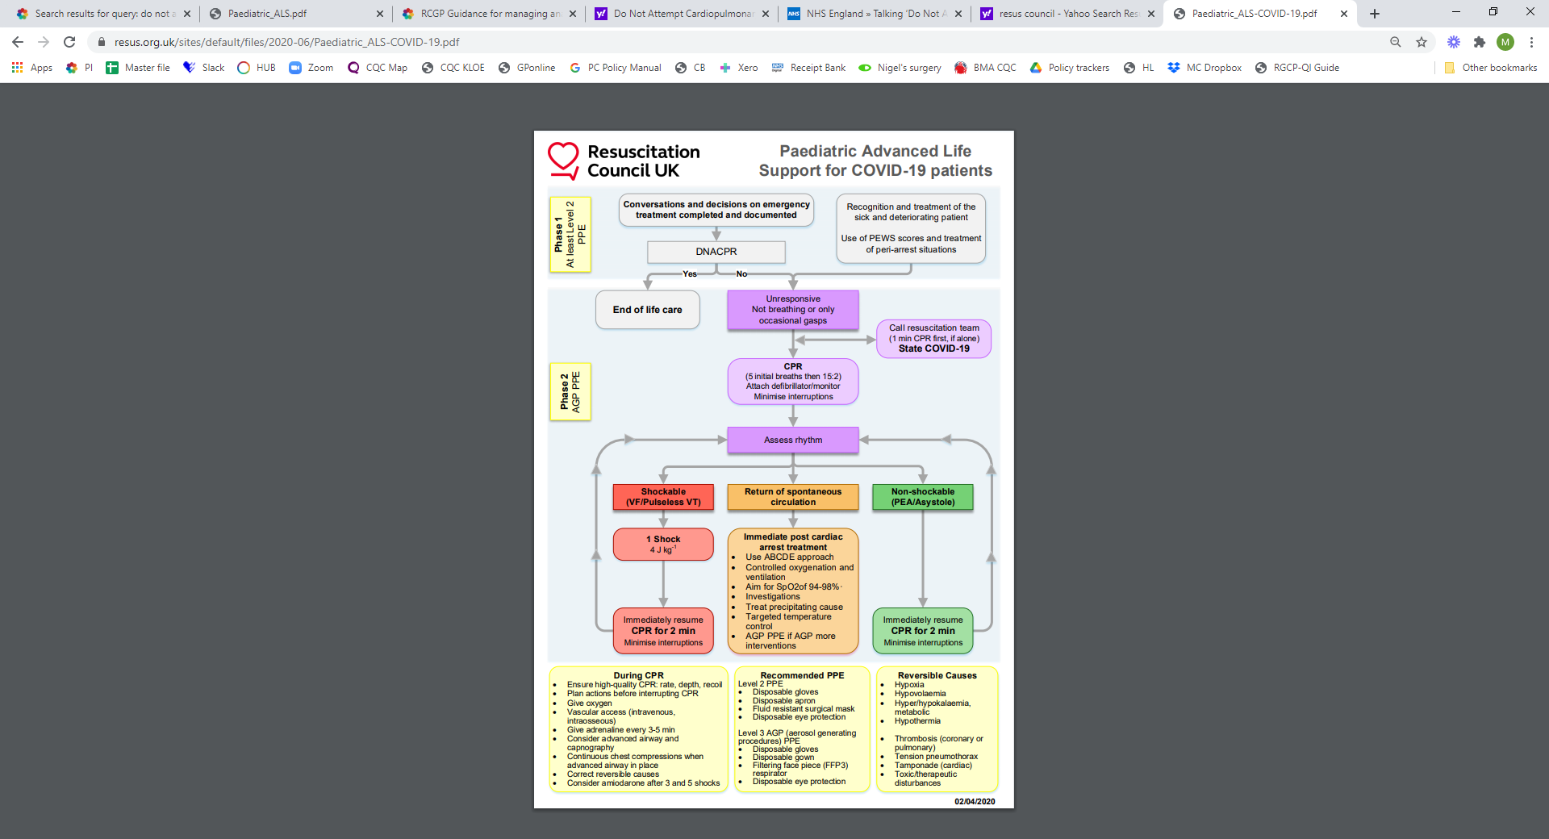

Source: [www.resus.org.uk](https://www.resus.org.uk/sites/default/files/2020-06/Paediatric_ALS-COVID-19.pdf)

RCUK guidelines: [Paediatric ALS with COVID-19](https://www.resus.org.uk/sites/default/files/2020-06/COVID%20Paediatric%20Guidance%20and%20Flowchart.pdf)

# Annex G – Anaphylaxis (RCUK)

The following anaphylaxis algorithm has been released by the Resus Council UK in December 2020 to support of flu and COVID-19 vaccination clinics.

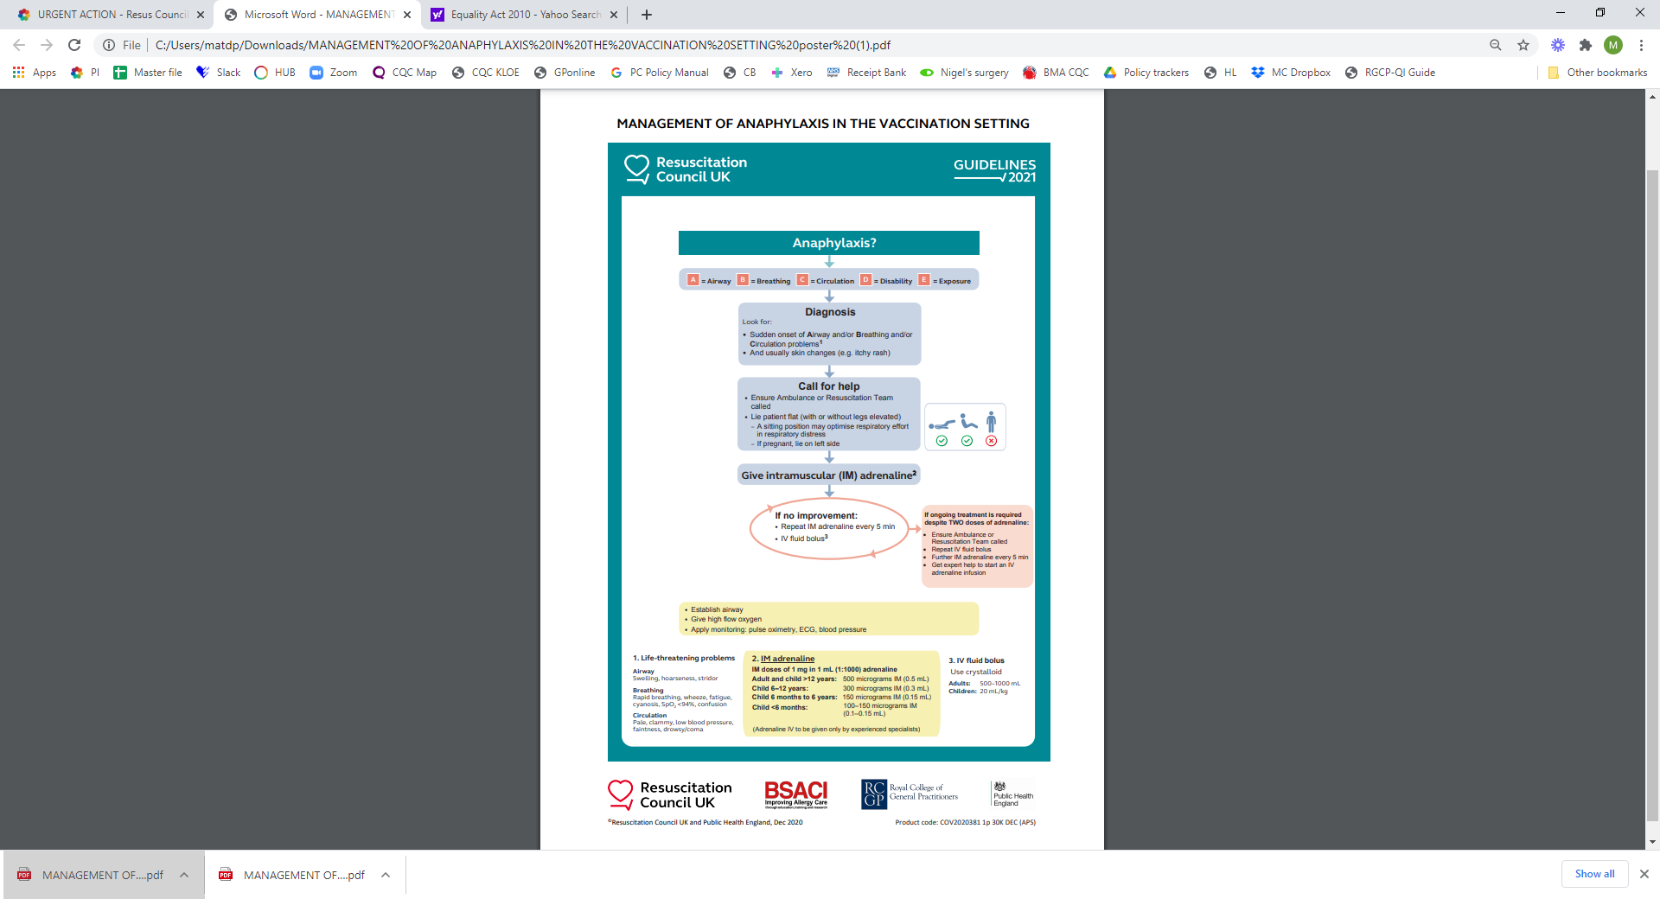

Source: [www.resus.org.uk](https://www.resus.org.uk/media/288/download)

The full guidelines are expected early 2021

# Annex H – Benzodiazepine overdose

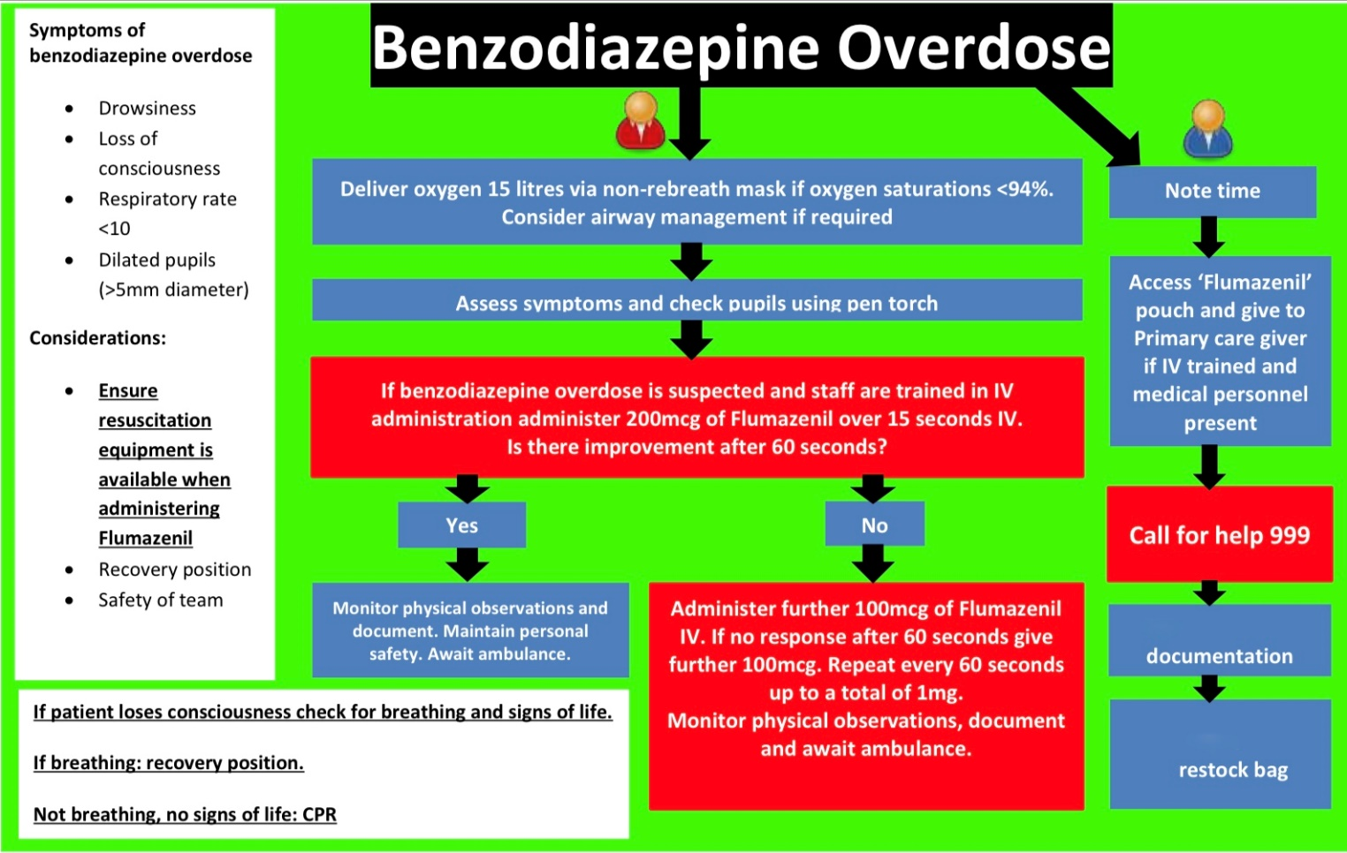

Source: Southern Health NHS Medical Emergencies & Resuscitation Policy V4, October 2017

Further guidance: [BMJ.com](https://bestpractice.bmj.com/topics/en-gb/343)

# Annex I – Breathing difficulties

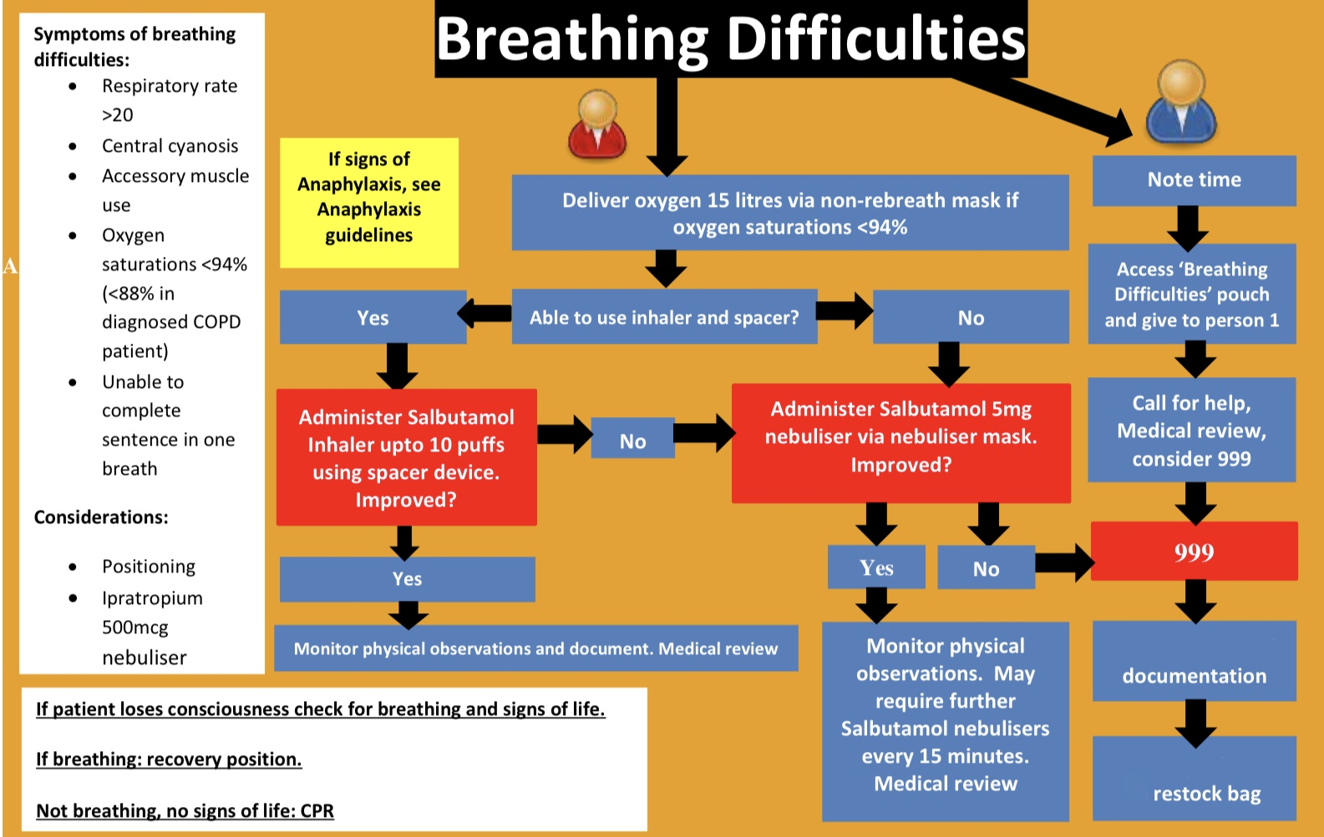

Source: Southern Health NHS Medical Emergencies & Resuscitation Policy V4, October 2017

# Annex J – Chest pain

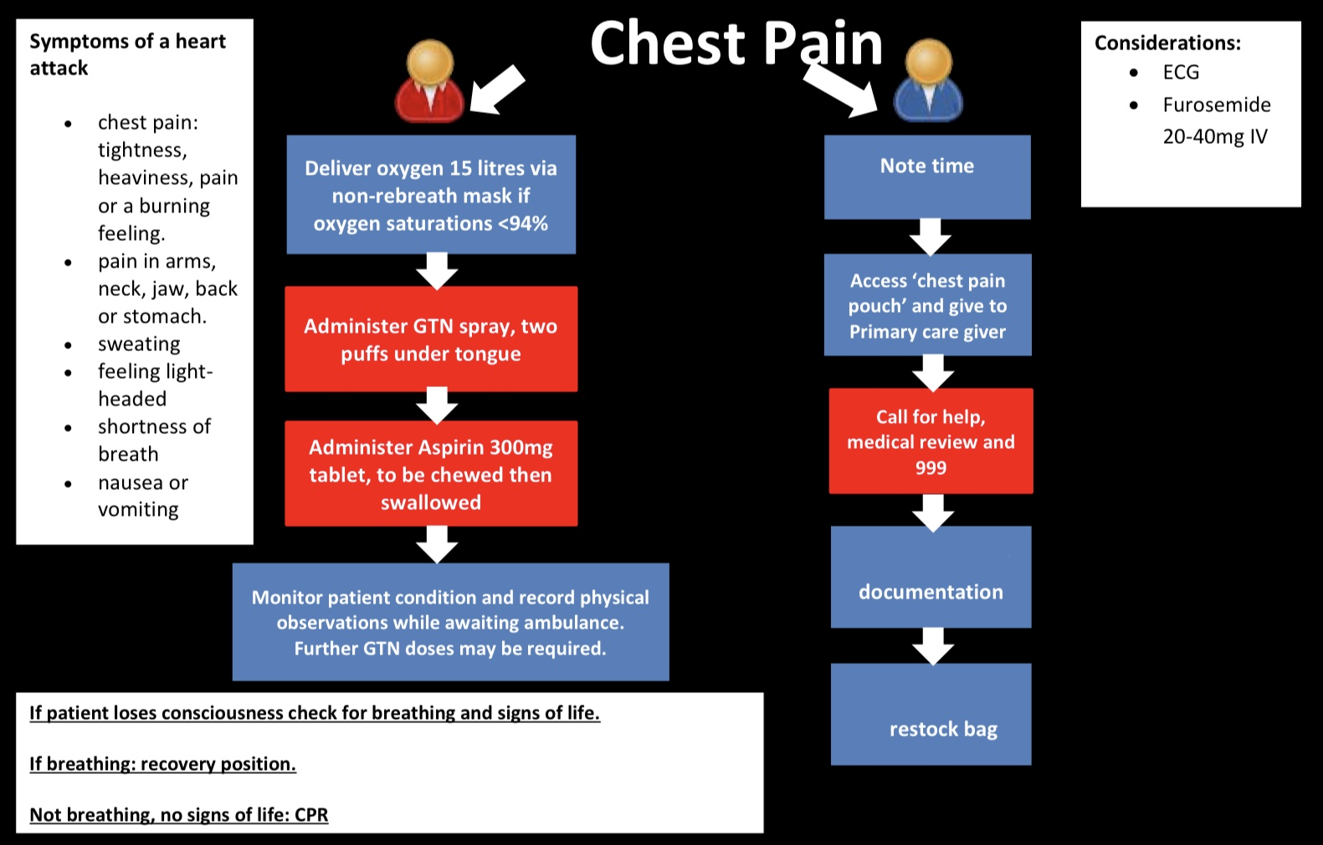

Source: Southern Health NHS Medical Emergencies & Resuscitation Policy V4, October 2017

# Annex K – Choking and aspiration

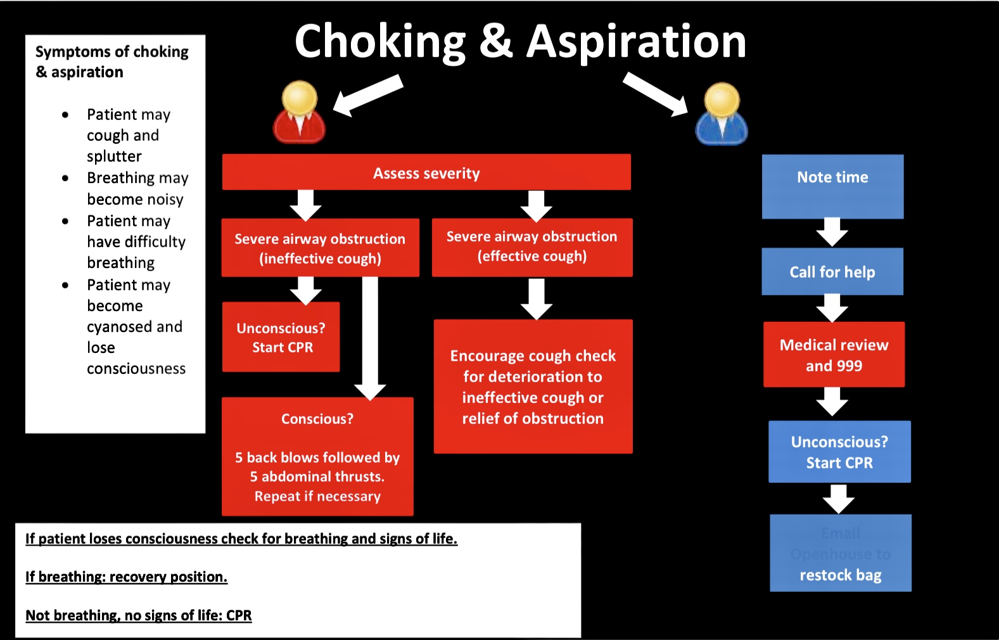

Source: Southern Health NHS Medical Emergencies & Resuscitation Policy V4, October 2017

# Annex L – Adult choking (RCUK)

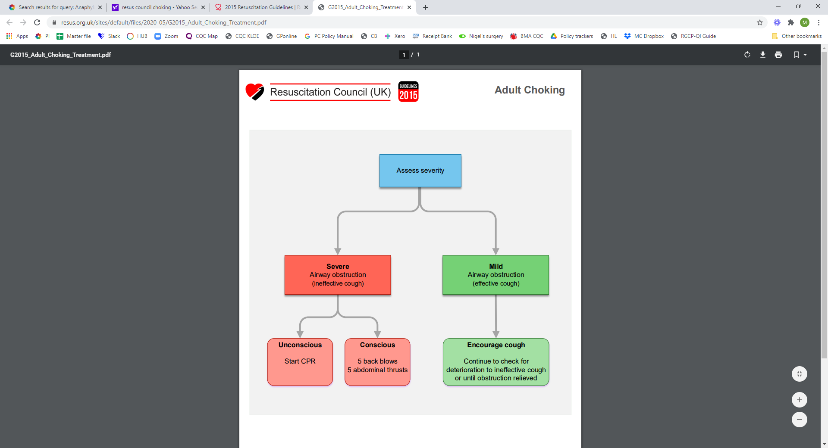

Source: [www.resus.org.uk](https://www.resus.org.uk/sites/default/files/2020-05/G2015_Adult_Choking_Treatment.pdf)

RCUK guidelines: [Choking](https://www.resus.org.uk/library/additional-guidance/guidance-choking)

# Annex M – Paediatric choking (RCUK)

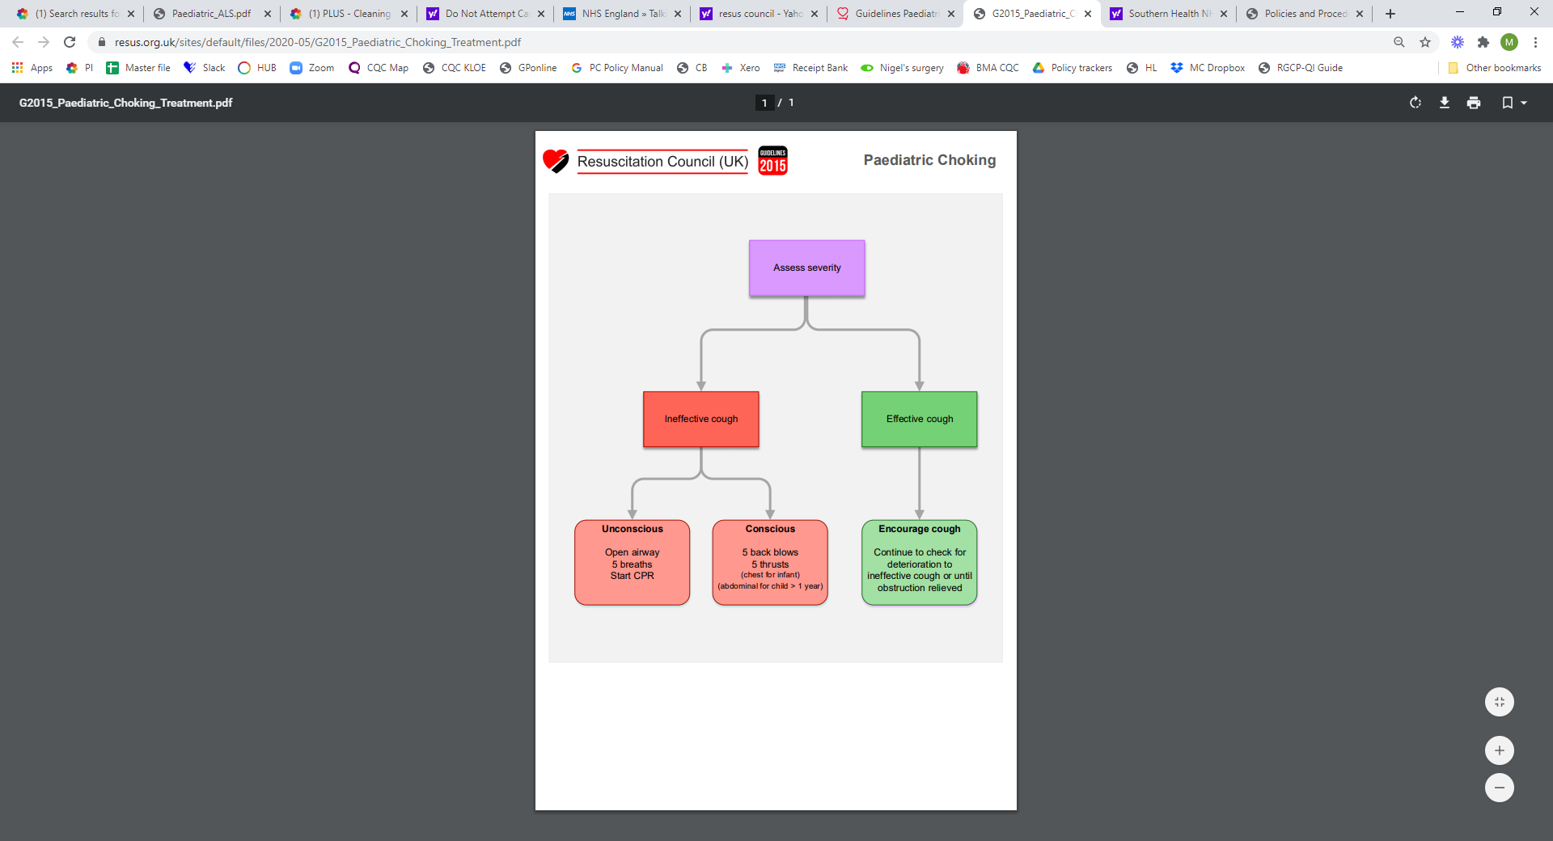

Source: [www.resus.org.uk](http://www.resus.org.uk)

RCUK guidelines: [Choking](https://www.resus.org.uk/library/additional-guidance/guidance-choking)

# Annex N – Hypoglycaemia

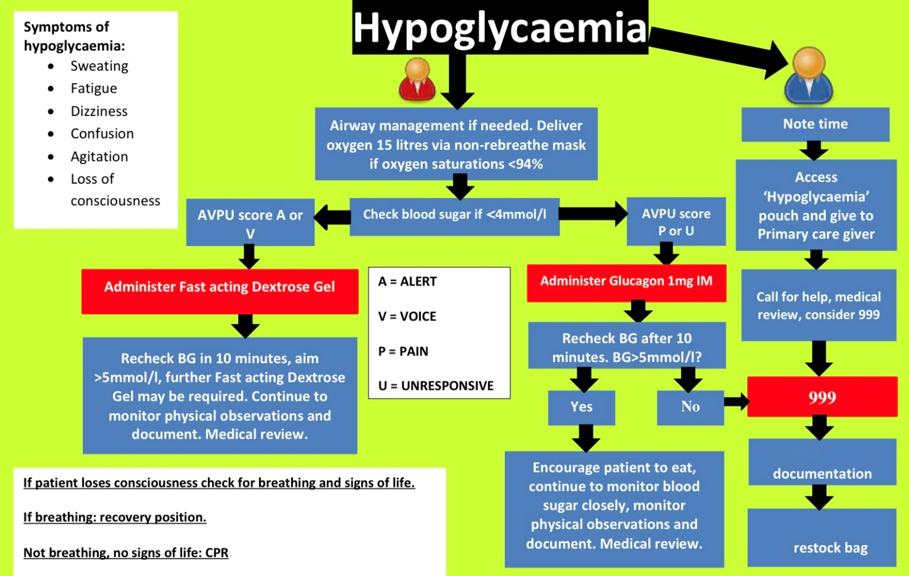

Source: Southern Health NHS Medical Emergencies & Resuscitation Policy V4, October 2017

# Annex O – Opioid overdose

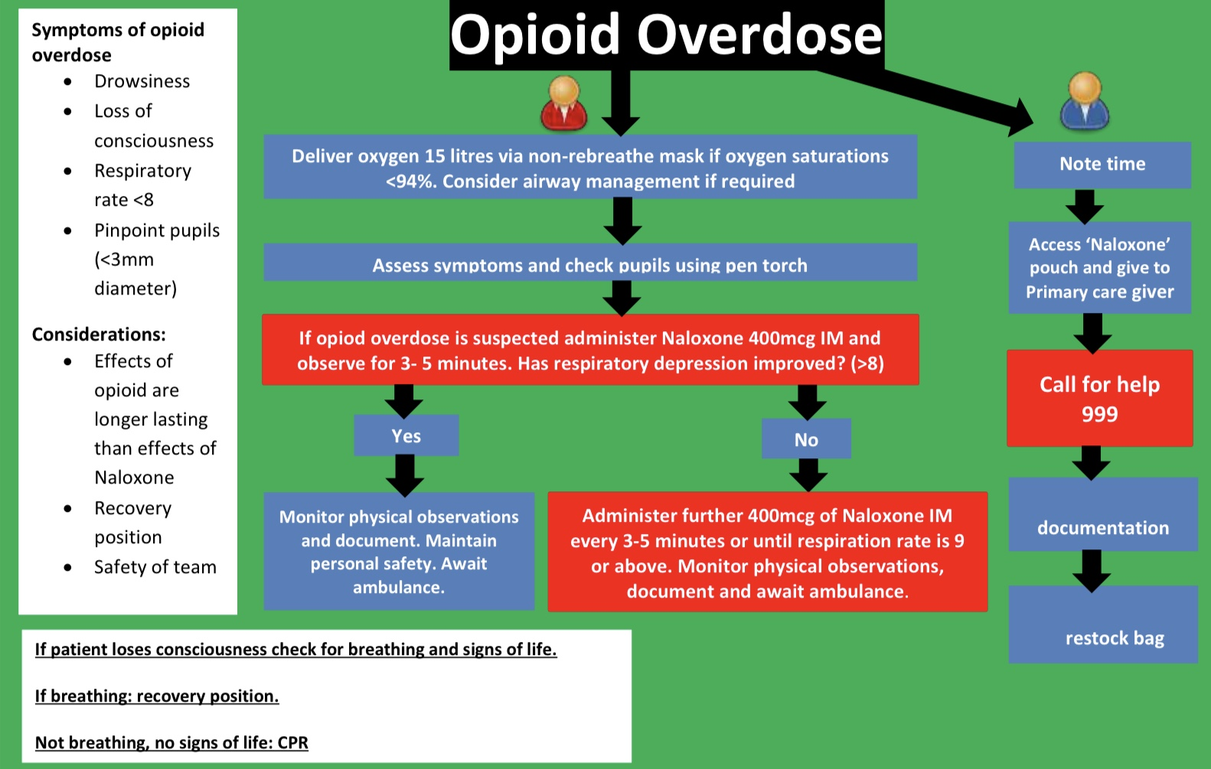

Source: Southern Health NHS Medical Emergencies & Resuscitation Policy V4, October 2017

# Annex P – Seizures

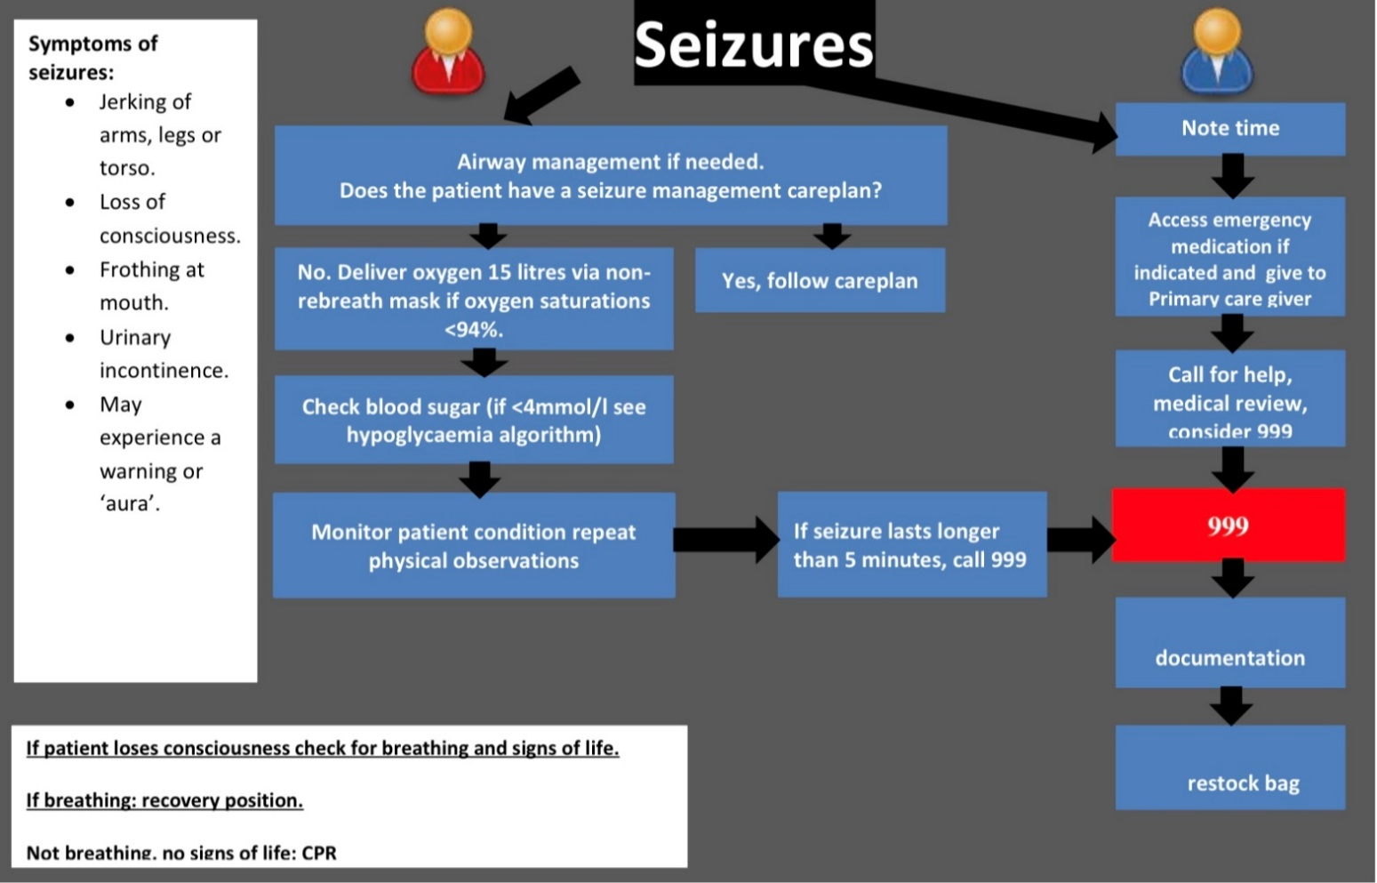

Source: Southern Health NHS Medical Emergencies & Resuscitation Policy V4, October 2017

# Annex Q – Syncope/Faint

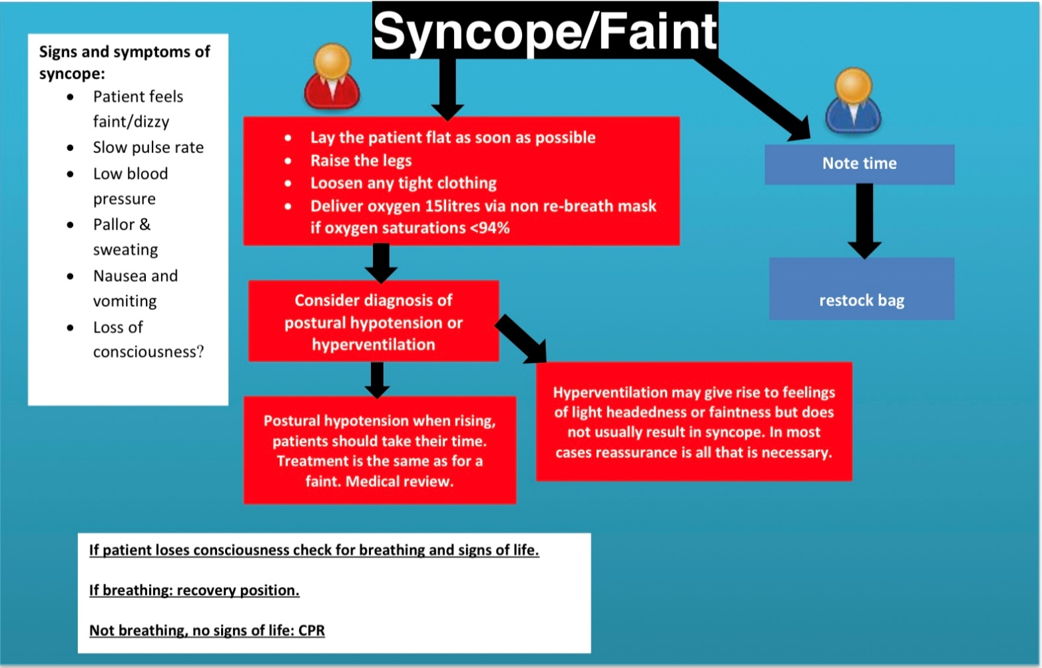

Source: Southern Health NHS Medical Emergencies & Resuscitation Policy V4, October 2017

1. www.cqc.org.uk - Nigel's surgery 9
2. [www.cqc.org.uk - KLOE](https://www.cqc.org.uk/sites/default/files/20180628%20Healthcare%20services%20KLOEs%20prompts%20and%20characteristics%20FINAL.pdf)
3. [Resuscitation Council UK](http://www.resus.org.uk/)
4. [Transforming urgent and emergency care services in England](https://www.england.nhs.uk/wp-content/uploads/2015/06/trans-uec.pdf)
5. [GP notebook medical emergencies](https://www.gpnotebook.co.uk/simplepage.cfm?ID=-919273443)
6. [RCN – Duty of Care](https://www.rcn.org.uk/get-help/rcn-advice/duty-of-care)
7. [GMC – Good medical practice](https://www.gmc-uk.org/ethical-guidance/ethical-guidance-for-doctors/good-medical-practice/domain-2----safety-and-quality)
8. [www.bmj.com](https://www.bmj.com/content/371/bmj.m4563)
9. [RCUK - Decision making and COVID-19](https://www.resus.org.uk/covid-19-resources/covid-19-resources-decision-making)