**Pandemic Management Policy**

|  |  |  |  |  |
| --- | --- | --- | --- | --- |
| **Version:** | **Review date:** | **Edited by:** | **Approved by:** | **Comments:** |
|  |  |  |  |  |
| v1 | May 2021 | Sultan Mohamed | Nine Swift |  |
| v2 | 27/09/2023 | Sultan Mohamed | Nine Taylor | Reissued with minor changes |
|  | December 2025 |  |  | Next review |

**Table of contents**

1 Introduction 3

1.1 Policy statement 3

1.2 Status 3

1.3 Training and support 3

2 Scope 3

2.1 Who it applies to 3

2.2 Why and how it applies to them 4

3 Definition of terms 4

3.1 Pandemic 4

3.2 Influenza 4

3.3 Uncomplicated influenza 4

3.4 Complicated influenza3 4

3.5 Swine flu 5

3.6 Coronavirus 5

3.7 COVID-19 (Wuhan Coronavirus) 5

4 Guidance 6

4.1 Incident levels 6

4.2 Communication 7

4.3 Reporting process 7

4.4 Infection control 8

4.5 Personal Protective Equipment (PPE) 8

4.6 Using PPE appropriately 10

4.7 Wearing of scrubs 12

4.8 Cleaning of clinical uniforms 13

4.9 Patient segregation 13

4.10 Clinical and non-clinical waste 15

4.11 Cleaning procedures 15

4.12 Antivirals 15

4.13 Vaccines 15

4.14 Practice action plan 16

4.15 Signage 16

4.16 Public Health England contact information 16

5 Summary 16

Annex A – Practice action plan (pandemic outbreak) 17

Annex B – Pandemic signage 24

# Introduction

## Policy statement

To enable Sheerwater Health Centre to support the wider NHS in effectively managing the response to any pandemic outbreak, including influenza or any other worldwide spread of a disease, processes are in place to ensure that staff fully understand the threat and potential impact of any pandemic which remains the top risk on the UK Cabinet Office National Risk Register.

This policy has been adapted from the Pandemic Influenza Policy in light of the COVID-19 outbreak to ensure that current Public Health England advice is provided. In addition, it is not too specific regarding any one particular pandemic virus.

At the time of updating this policy in May 2020, most available references for any pandemic outbreak and its subsequent management are directed towards pandemic influenza. Therefore, whilst specific detail has been given to other forms of pandemic outbreaks, throughout this policy influenza will predominantly be the referenced material.

## Status

The practice aims to design and implement policies and procedures that meet the diverse needs of our service and workforce, ensuring that none are placed at a disadvantage over others, in accordance with the Equality Act 2010. Consideration has been given to the impact this policy might have in regard to the individual protected characteristics of those to whom it applies.

This document and any procedures contained within it are non-contractual and may be modified or withdrawn at any time. For the avoidance of doubt, it does not form part of your contract of employment.

## Training and support

The practice will provide guidance and support to help those to whom it applies to understand their rights and responsibilities under this policy. Additional support will be provided to managers and supervisors to enable them to deal more effectively with matters arising from this policy.

# Scope

## Who it applies to

This document applies to all employees, partners and directors of the practice. Other individuals performing functions in relation to the practice, such as agency workers, locums and contractors, are to use it.

## Why and how it applies to them

All staff have a role to play in supporting the wider NHS in response to a pandemic outbreak and will be required to provide guidance and support to patients at Sheerwater Health Centre and the wider community.

With the inception of PCNs, practices now have closer alliances within the local healthcare community. This policy can support a greater collaborative approach that may be needed to ensure that, in responding to any pandemic outbreak, all practices align with the aim of NHS England which is to enable patients to receive the most appropriate care during a pandemic and to ensure that staff are supported to do their jobs.[1]

# Definition of terms

## Pandemic

A pandemic is the worldwide spread of a disease, including influenza. An influenza pandemic occurs when a new influenza virus emerges and spreads around the world and, as such, most people do not have immunity.[2]

## Influenza

Influenza is a highly contagious viral infection that affects the respiratory system.

## Uncomplicated influenza[3]

This is influenza presenting with fever, coryza, generalised symptoms (headache, malaise, myalgia, arthralgia) and sometimes gastrointestinal symptoms but without any features of complicated influenza.

## Complicated influenza3

This is influenza requiring hospital admission and/or with symptoms and signs of lower respiratory tract infection (hypoxaemia, dyspnoea, lung infiltrate), central nervous system involvement and/or a significant exacerbation of an underlying medical condition.

## Swine flu

Swine flu is classified as A/H1N1pdm09 virus and is now one of the seasonal flu viruses that circulate each winter. The symptoms are the same as per normal flu, usually mild and passing within a week.[4]

A swine flu leaflet has been produced by NHS England and is available via [here](https://www.nhs.uk/news/2009/04april/documents/swine%20flu%20leaflet_web%20version.pdf).

## Coronavirus[5]

Coronaviruses (CoV) are a large family of viruses that cause illness ranging from the common cold to more severe diseases such as [Middle East Respiratory Syndrome (MERS-CoV)](https://www.who.int/emergencies/mers-cov/en/) and [Severe Acute Respiratory Syndrome (SARS-CoV)](https://www.who.int/csr/sars/en/).

[A novel coronavirus (nCoV)](https://www.who.int/emergencies/diseases/novel-coronavirus-2019) such as COVID-19 is a new strain that has not been previously identified in humans.

Coronaviruses are zoonotic, meaning they are transmitted between animals and people.  Detailed investigations found that SARS-CoV was transmitted from civet cats to humans and MERS-CoV from dromedary camels to humans. Several known coronaviruses are circulating in animals that have not yet infected humans.

Common signs of infection include respiratory symptoms, fever, cough, shortness of breath and breathing difficulties. In more severe cases, infection can cause pneumonia, severe acute respiratory syndrome, kidney failure and even death.

## COVID-19 (Wuhan Coronavirus)

COVID-19 is the infectious disease caused by the most recently discovered coronavirus. This new virus and disease were unknown before the outbreak began in Wuhan, China in December 2019.

The most common symptoms of COVID-19 are fever, tiredness and a dry cough. Some patients may have aches and pains, nasal congestion, runny nose, sore throat or diarrhoea. These symptoms are usually mild and begin gradually.

Some people become infected but do not develop any symptoms and do not feel unwell and approximately 80% recover from the disease without needing any special treatment.

Approximately 17% (or 1 in 6 people) of those who get COVID-19 become seriously ill and develop difficulty breathing. Elderly patients, or those with an underlying medical problem such as high blood pressure, heart problems or diabetes, are more likely to develop serious illness with a mortality rate of 1 in 50 people.

The WHO recommends that those with a fever, cough and difficulty breathing should seek medical attention.

# Guidance

## Incident levels

NHS England uses the [Emergency Preparedness, Resilience and Response guidelines](https://www.england.nhs.uk/ourwork/eprr/) dated June 2019 to provide strategic guidance to enable an effective response to incidents and emergencies which may affect health and patient care.

Depending on the nature of the event (or incident), it will be graded using an incident level as illustrated below:

|  |  |
| --- | --- |
| **Incident level** | |
| Level 1 | An incident that can be responded to and managed by a local health provider organisation within their respective business as usual capabilities and business continuity plans in liaison with local commissioners |
| Level 2 | An incident that requires the response of a number of health providers within a defined health economy and will require NHS coordination by the local commissioner(s) in liaison with the NHS England local office |
| Level 3 | An incident that requires the response of a number of health organisations across geographical areas within an NHS England region  NHS England to coordinate the NHS response in collaboration with local commissioners at the tactical level |
| Level 4 | An incident that requires NHS England National Command and Control to support the NHS response  NHS England to coordinate the NHS response in collaboration with local commissioners at the tactical level |

*Source – NHS England Incident Response Plan, V2.0December 2017*

The UK’s overall objectives in preparation for a pandemic are to:

* Minimise the potential health impact of a future influenza pandemic
* Minimise the potential impact of a pandemic on society and the economy
* Instill and maintain trust and confidence

The UK response phases to a pandemic are[6]:

Detection

Assessment

Treatment

Escalation

Recovery

Each phase details the response, priorities and actions to be taken as the pandemic affects the UK. Detailed information for each phase can be found [here](https://www.gov.uk/government/uploads/system/uploads/attachment_data/file/344695/PI_Response_Plan_13_Aug.pdf).

## Communication

Excellent communication is of paramount importance in response to a pandemic. NHS England has identified the following as key communication priorities:[7]

* Support operational delivery
* Keep staff well informed
* Ensure that the public know how, where and when to access services
* Reassure the public in order to maintain confidence in the NHS and the wider health system’s ability to manage the situation

Sheerwater Health Centre will ensure that all communication regarding pandemic influenza is disseminated accordingly, maintaining whole-team situational awareness at all times.

The [Business Continuity Policy](https://practiceindex.co.uk/gp/forum/resources/business-continuity-policy.1056/) includes the need to consider both management and staffing issues as a result of any pandemic outbreak.

Each pandemic concern will have a significant amount of information detailing the importance of containment.[8] To ensure that Sheerwater Health Centre is following the correct guidance, the Infection Prevention and Control Lead, Wendy Mayne, will follow all Public Health England advice and advise clinical teams and management accordingly.

Specific guidance for primary care will be provided by Public Health England and ordinarily this will differ from other healthcare providers. Advice for COVID-19 can be sought [here](https://www.england.nhs.uk/coronavirus/primary-care/general-practice/) and RCGP are also providing regular updates.[9]

NHS England and Public Health England will provide direction for primary care which may be regularly updated. To ensure that current advice is being followed, Nine Swift, the practice manager, will make sure that they are familiar with the current guidance and will brief the respective teams regarding any requirement.

There may be a need to escalate the response due to the level of information and/or the regular update advice. Should there be an excessive level of information, Nine Swift, the practice manager, will discuss the need for structured ‘pandemic’ meetings.

## Reporting process

To maintain an accurate overview of the number of cases, there will be a requirement to provide NHSEngland with regular reports. However, in order to reduce the administrative burden during the acute phase, specific reporting requirements will be communicated once determined.

Sheerwater Health Centre will ensure that accurate clinical records are kept using the appropriate read codes and reports will be submitted as requested.

## Infection control

Public Health England and other agencies will provide stringent advice on infection control measures to reduce any risk of further contamination and/or the loss of an important community asset such as this practice.

Current IPC advice from Public Health England for COVID-19 can be found [here](https://www.gov.uk/government/publications/wuhan-novel-coronavirus-infection-prevention-and-control/covid-19-personal-protective-equipment-ppe).

## Personal Protective Equipment (PPE)

PPE for all staff is located at the treatment room and will be monitored by Nine Swift who is responsible for the replenishment of the equipment. PPE is worn to protect staff from contamination and to reduce the risk of transmission of influenza.

Advice can be sought from Public Health England and the Health and Safety Executive (HSE)[10] on PPE that is required for any respective pandemic outbreak.

The PPE required will vary depending on the level of contact with the patient.

PPE is to be worn as directed by the guidance issued by Public Health England and illustrated overleaf.

Note: Whilst the poster does not state that hands should be washed before donning PPE, it would be appropriate to do so.

In order to minimise the spread of the disease, risk assessments have been undertaken at Sheerwater Health Centre.

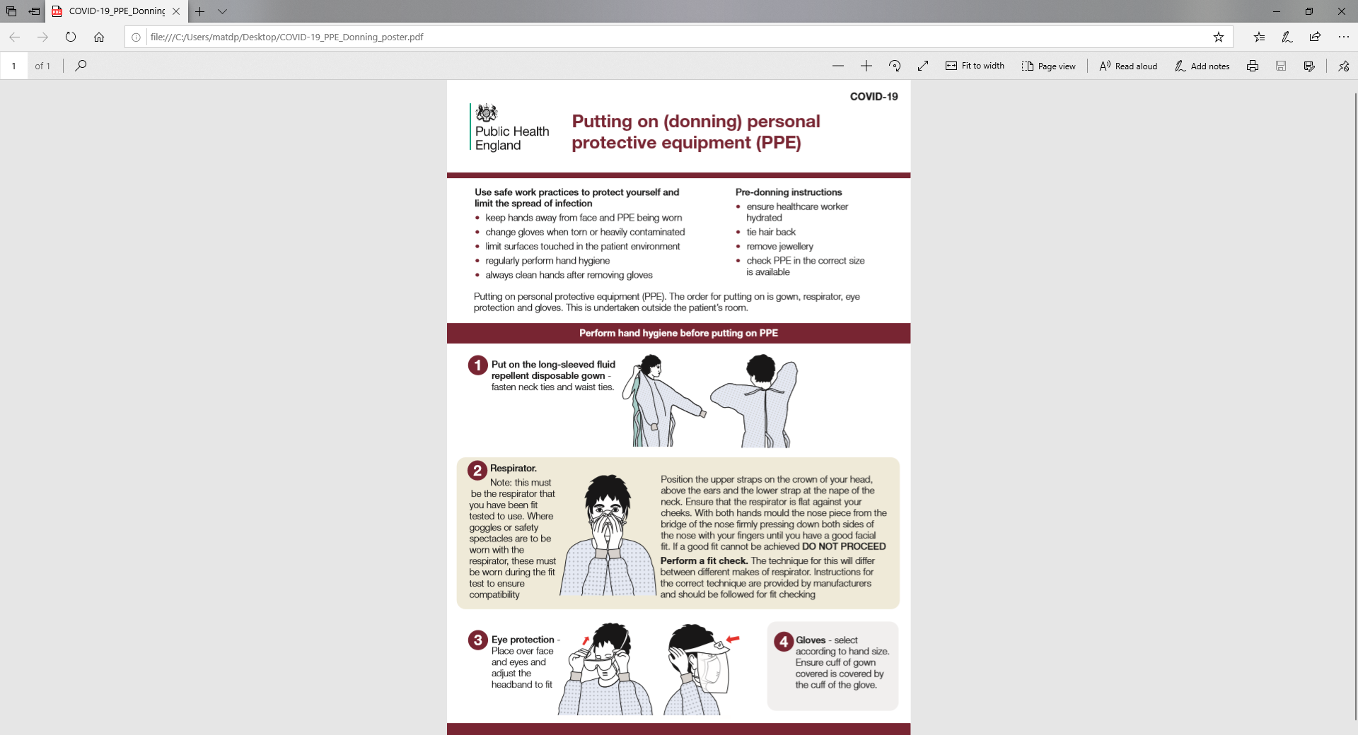

## Using PPE appropriately

PPE is to be worn in the following order:

1. Apron
2. FFP3 respirator or surgical mask
3. Eye protection
4. Disposable gloves

PPE is to be removed in the following order which will reduce the risk of cross-contamination:[11][12]

*Gloves*

1. Hold the outside of the glove with the opposite gloved hand and peel off
2. Hold the removed glove in the gloved hand
3. Slide the fingers of the ungloved hand under the remaining glove at the wrist and peel off the second glove over the first glove and dispose accordingly

*Apron*

1. Unfasten or break ties
2. Pull apron away from the neck and shoulders, touching the inside of the apron only
3. Turn the apron inside out, fold/roll into a bundle and dispose

*Eye protection*

1. Handle by headband or earpieces and dispose

*Respirator or surgical mask*

1. Untie or break bottom ties followed by top ties or elastic; remove by handling ties only and dispose

*Disposal*

PPE is to be disposed of as infectious clinical waste (orange bag).

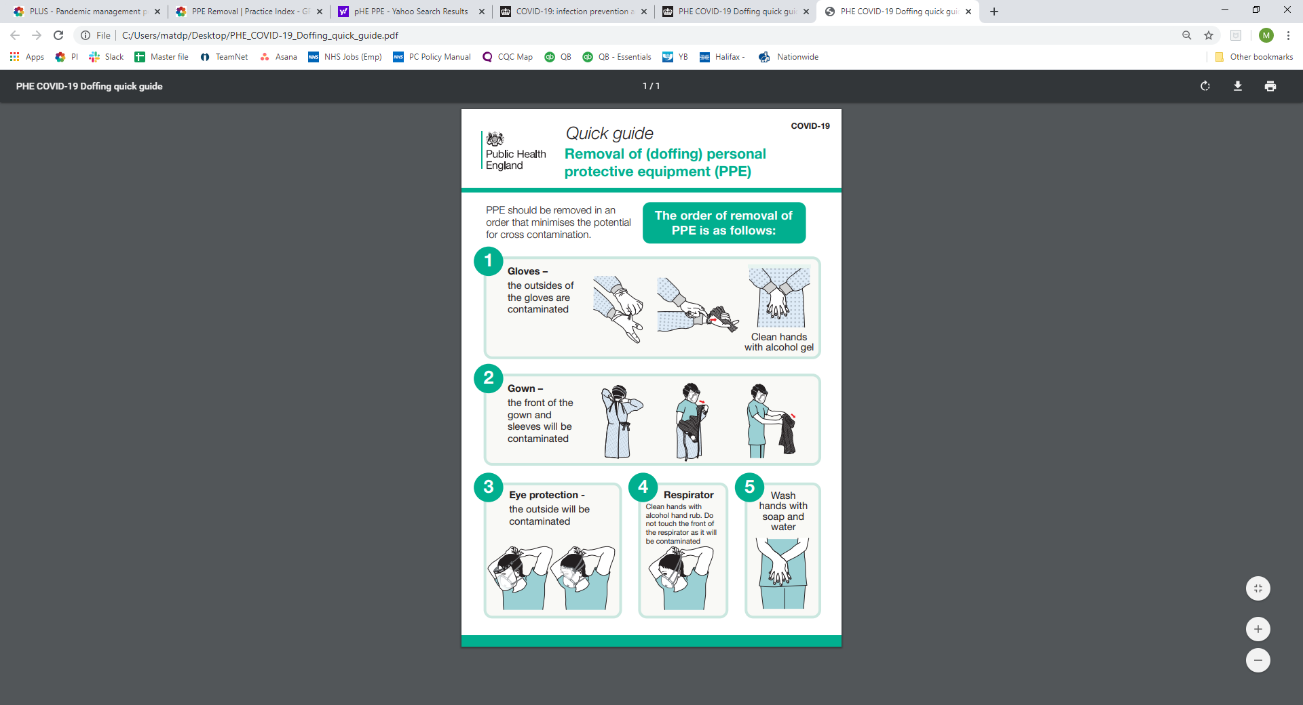

## Wearing of scrubs

There may be a need to wear scrubs should the pandemic be particularly lengthy or if there is a lack of disposable PPE.

Should this be the case, then consideration must be given to how these are stored, worn and cleaned.

1. Storage of clean linen

When not having been distributed to staff members and not in use, clean linen must be stored preferably in a designated cupboard. Should this not be available, then an area within a cupboard would be sufficient, although clean scrubs should be placed within a sealed plastic bag to minimise any risk of contamination.

Clean linen must never be stored within a bathroom, sluice or clinical room.

If clean linen is taken into an isolation or ‘dirty’ area and not used, the linen must be laundered again before storage or use. (See laundry process below).

Linen storage facilities must be kept clean. This includes cupboard shelves

and a trolley, should one be used.

1. Storage of dirty scrubs

Used linen, including contaminated items when removed, are to be placed immediately into a water-soluble laundry bag* and then further placed into a sealed plastic bag.

Items must be handled with care to minimise the transmission of

micro-organisms via dust and skin scales and gloves must be worn throughout when disposing items.

If being stored in a communal area, then the double-bagged scrubs should have the wearer’s name written with a permanent marker on the outside bag to save any later confusion upon collection. Storage should be in a secure area.

Any torn or damaged linen should be placed and sealed into an orange clinical waste plastic bag and removed to the external clinical waste bin as per normal clinical waste protocols.

*Water-soluble laundry bags are readily available online

1. Wearing of clinical scrubs

Clinical uniforms must be changed daily and changed into when at work.

Ideally, scrubs should only be worn in a clinical setting.

Refer to the [Risk Assessment and COSHH Policy](https://practiceindex.co.uk/gp/forum/resources/risk-assessment-and-coshh-policy.1006/) for a risk assessment template.

During the course of the working day, should a uniform become contaminated with blood or body fluids, it is to be changed for a clean one as soon as practicable.

## Cleaning of clinical uniforms

As detailed above, all clinical uniforms should be ‘double-bagged’ prior to being taken home to be washed. The outside bag should be normal plastic and sealed, preferably with a tie-wrap, and the inner bag should be a machine washable disposable laundry bag.

Following scientific advice, NHS England’s *Good practice for uniforms and workwear[13]* dated 2nd April 2020 states that:

* There is little effective difference between domestic and commercial

laundering in terms of removing micro-organisms from uniforms and

workwear

* Washing with detergents at 30ºC will remove most Gram-positive microorganisms including methicillin-resistant Staphylococcus aureus (MRSA)
* A ten-minute wash at 60ºC is sufficient to remove almost all microorganisms. In tests, only 0.1% of any Clostridioides difficile spores remained.

Scrubs need to be washed separately from other items and on a machine cycle that reaches either 71°C (for not less than three minutes) or 65°C (for not less than ten minutes).

Note: It is important that when uniforms are being considered, it should be confirmed that they can withstand laundering at 65°C.

## Patient segregation

This will be determined by PHE as to the type of disease and how it is spread.

Influenza

To further minimise the risk of the transmission of a pandemic influenza, suspected patients will be segregated from non-infected patients. This is achieved at Sheerwater Health Centre by having set appointment times for patients with suspected illness.

Suspected influenza patients will be met by a member of staff wearing PPE who will take the patient to treatment room for assessment.

All patients with suspected influenza will be assessed in treatment room; no other patients will be seen in this room. This area will be controlled and access restricted with signage in place to warn patients and staff of the segregated area.

COVID-19

Refer to the current advice from Public Health England dated 30 April 2020:

<https://www.england.nhs.uk/coronavirus/wp-content/uploads/sites/52/2020/03/C0429-gp-support-information-for-shielding-and-non-shielding-patients.pdf>

Additionally, general practice should concentrate on the following workloads to support segregation and to ensure that regular and non COVID-19 workstreams are still being considered.

See extract from the [NHS England letter dated 29 April 2020](https://www.england.nhs.uk/coronavirus/wp-content/uploads/sites/52/2020/04/second-phase-of-nhs-response-to-covid-19-letter-to-chief-execs-29-april-2020.pdf) which outlines the role of primary care over the next six weeks during what is being considered as the second phase of managing COVID-19

1. Ensure patients have clear information on how to access primary care services and are confident about making appointments (virtual or, if appropriate, face-to-face) for current concerns.
2. Complete work on implementing digital and video consultations so that all patients and practices can benefit.
3. Given the reduction of face-to-face visits, stratify and proactively contact their high-risk patients with ongoing care needs to ensure appropriate care and support plans are delivered through multidisciplinary teams. In particular, proactively contact all those in the ‘shielding’ cohort of patients who are clinically extremely vulnerable to COVID-19, ensure they know how to access care, are receiving their medications and provide safe home visiting wherever clinically necessary.
4. To further support care homes, the NHS will bring forward a package of support to care homes drawing on key components of the Enhanced Care in Care Homes service and delivered as a collaboration between community and general practice teams. This should include a weekly virtual ‘care home round’ of residents needing clinical support.
5. Make two-week wait cancer, urgent and routine referrals to secondary care as normal, using ‘advice and guidance’ options where appropriate.
6. Deliver as much routine and preventative work as can be provided safely including vaccinations, immunisations and screening.

## Clinical and non-clinical waste

All waste should be disposed of in accordance with the practice’s Infection Prevention Control Policy. There are no additional control measures required.

## Cleaning procedures

Influenza

The designated influenza treatment room and walkways will require daily cleaning. Cleaning staff should ensure they clean the area using warm water and detergent whilst wearing the appropriate PPE including a surgical mask. Particular attention should be paid to door handles, edges of chairs, couches, etc. – that is, all areas that come into contact with potentially infected patients.

At Sheerwater Health Centre, the cleaner(s) will be given a brief regarding pandemic influenza and the additional requirements specific to their role. This will support the team in minimising the risk of spreading influenza.

COVID -19

The full cleaning schedule for COVID-19 can be found within the Public Health England information [here](https://www.gov.uk/government/publications/wn-cov-guidance-for-primary-care/wn-cov-interim-guidance-for-primary-care).

## Antivirals

For influenza, symptomatic patients will be able to access antivirals in a timely manner as these will be issued to practices at the start of a pandemic. Patients will also be able to access antivirals using the National Pandemic Flu Service (NPFS) via the NHS 111 service. This will serve as an easy point of access for patients.

Public Health England has issued guidance on the use of antiviral agents for the treatment of seasonal influenza 2019 which can be accessed [here](https://assets.publishing.service.gov.uk/government/uploads/system/uploads/attachment_data/file/773369/PHE_guidance_antivirals_influenza.pdf). Clinical staff should ensure that they read the guidance detailed in this document when considering the treatment of patients.

## Vaccines

Generally, Pandemic Specific Vaccines (PSV) will be available four to six months after a pandemic virus has been identified. Vaccines will be offered to those people who, through their immune disposition or long-term illness (CHD, COPD, diabetes, over 65s, under 5s and pregnant women), are deemed to be at an increased risk as well as to healthcare workers.

Specific vaccine guidance and supplementary information will be issued once available.

COVID – 19

There is currently no vaccine to prevent coronavirus disease 2019 (COVID-19). The best way to prevent illness is to avoid being exposed to this virus.

## Practice action plan

Pandemic influenza planning is based on the “reasonable worst case” derived from experience which indicates that up to 50% of the population could experience symptoms of pandemic influenza during one or more pandemic wave lasting 15 weeks.

The practice action plan for dealing with pandemic influenza can be found at Annex A to this policy. In addition to the plan, an action card for key staff members can also be found at Annex A.

## Signage

Signage for displaying throughout the practice can be found at Annex B.

## Public Health England contact information

Further guidance and advice for infectious disease can be sought from Public Health England on **020 8200 4400** or **020 7654 8000**

The local area team for Public Health England can be found at:

<https://www.gov.uk/guidance/contacts-phe-regions-and-local-centres>

At Sheerwater Health Centre, our local Public Health England team is:

PHE Surrey & Sussex Health Protection Team who can be contacted on 0344 225 3861

# Summary

Any pandemic outbreak is a realistic threat to general practice and is likely to have a significant impact on the patient population.

It is essential that all staff are aware of their individual responsibilities and the information contained within this policy to ensure that Sheerwater Health Centre effectively supports the wider NHS and delivers safe and effective care.

# Annex A – Practice action plan (pandemic outbreak)

* *Suspending services will enable the practice to deliver vaccines (if available) to the at-risk groups and healthcare workers if directed to do so by NHS(E), PHE and sub-regional teams.*

The practice management team will review this action plan on a daily basis and consider each element, taking action where necessary to meet patient needs.

Individual action cards are detailed overleaf.

**ACTION CARD A – PRACTICE MANAGER**

In the event of any pandemic being declared, the practice manager is to:

1. Liaise with the partners to discuss the facts
2. Call a practice meeting (all staff must attend) explaining that a pandemic has been declared
3. Ensure that all staff are aware of their individual roles and responsibilities and issue action cards
4. Post-meeting, contact the CCG to determine the communication strategy of NHS(E) and the CCG
5. Once the communication strategy has been confirmed, brief the team by calling a snap meeting (all staff to attend). The practice manager is to reiterate the communication strategy to all staff via email to ensure whole-team awareness
6. Write a notice for the practice website – using any local guidance or specific guidance provided by PHE, NHS(E) or the WHO. This should be supported by a partner for any clinical advice
7. Ensure the following actions have been completed:
   1. The practice nurse has ordered sufficient supplies of PPE and antivirals (if authorised)
   2. Signage has been displayed appropriately throughout the practice
   3. Cleaning staff have been briefed and are aware of their responsibilities
   4. The segregated area is ready to deal with any suspected or confirmed cases of influenza
8. Determine the requirement to review the clinical rota in conjunction with the senior partner, allocating resources appropriately
9. Determine the requirement to review sessions in conjunction with the partners, cancelling, suspending, etc. accordingly
10. Ensure that all staff are happy with their individual responsibilities whilst providing reassurance and maintaining morale

**ACTION CARD B – DEPUTY PRACTICE MANAGER\***

In the event of any pandemic being declared, the deputy practice manager is to:

1. In the absence of the practice manager, carry out all of the actions on Action Card A
2. Liaise with the practice manager and partners to discuss the facts
3. Print and display influenza signage (Annex B) in the appropriate locations throughout the practice
4. Contact the cleaning staff and brief them accordingly. If more than one cleaner is employed, ensure that all cleaning staff are contacted
5. Liaise with the HCA to ensure the segregated area is prepared as required
6. Liaise with the practice manager to gain an awareness regarding the requirement to:
   1. Amend the clinical rota
   2. Amend the session structure
7. Support the PM on an as-required basis, ensuring that all actions have been completed
8. Ensure that all staff are happy with their individual responsibilities whilst providing reassurance and maintaining morale

**ACTION CARD C – NOMINATED PARTNER**

In the event of any pandemic being declared, the nominated partner is to:

1. Ascertain the scale of the pandemic, numbers affected, geographical outbreaks, etc. and prepare a short brief for the team
2. Liaise with the practice manager to confirm a practice meeting time and confirm that they have all of the necessary information
3. Liaise with the practice manager to determine:
   1. The requirement to review and amend the clinical rota
   2. The requirement to review and amend the session structure
4. Read the guidance at the hyperlink in paragraph 4.10, ensuring that all clinical staff are aware of the extant treatment protocols
5. Maintain open communication with the practice manager, deputy practice manager and other key staff, attending internal meetings when required
6. Ensure that all staff are happy with their individual responsibilities whilst providing reassurance and maintaining morale

**ACTION CARD D – INFECTION PREVENTION CONTROL LEAD**

In the event of any pandemic being declared, the IPC Lead is to:

1. Review stocks of PPE and antivirals (where appropriate), ordering additional stocks as necessary/authorised
2. Place sufficient stocks of PPE in the segregated area
3. Issue masks to staff members
4. Place a box of masks at the entrance to the reception to be given to patients with suspected influenza (or other disease)
5. Ensure that the cleaning staff have sufficient PPE
6. Liaise with HCA to ensure that a segregated area is ready to receive patients
7. Liaise with the practice manager and nominated partner to discuss the impact of suspending nurse-led clinics
8. Provide support to colleagues, offering advice and reassurance where necessary and maintaining morale

**ACTION CARD E – HEALTHCARE ASSISTANT**

In the event of any pandemic being declared, the HCA is to:

1. Ensure that the designated treatment area is ready for use by:
   1. Removing any unnecessary equipment
   2. Liaising with the deputy practice manager to ensure that the appropriate signage is in place
   3. Liaise with the IPC Lead to ensure that PPE and other essential equipment is relocated to the area
2. Check that the appropriate examination equipment is available in the treatment area
3. Ensure that clinical waste and non-clinical waste bins are available
4. Ensure that adequate stocks of hand soaps, etc. are available
5. Discuss the impact of HCA-led clinics being cancelled with the practice nurse
6. Support the practice nurse as required, ensuring that all tasks are achieved

**ACTION CARD F – SENIOR RECEPTIONIST**

In the event of any pandemic being declared, the senior receptionist is to:

1. Deputise for the deputy practice manager in their absence, ensuring that all actions on Action Card B are completed
2. Ensure they have PPE at the reception desk
3. Be aware of the preferred strategy for dealing with patients who attend reception with symptoms of influenza (or other disease)
4. Understand the requirement to ask all patients who request an appointment via telephone if they have similar symptoms (if so, advise the patient to call 111)
5. Liaise with the practice manager and practice nurse to determine if appointments are to be cancelled or suspended and also to discuss amendments to the clinical rota
6. Liaise with deputy practice manager to ensure that adequate staffing levels are maintained at all times
7. Support administrative and reception staff, providing reassurance and maintaining morale

# Annex B – Pandemic signage



**PANDEMIC OUTBREAK**

**If you are experiencing the following symptoms:  
  
 fever, headache, aching body, tired/exhausted, dry, chesty cough, sore throat, difficulty sleeping, loss of appetite, diarrhoea or stomach pain, nausea and being sick [adjust to suit]**

**DO NOT ENTER RECEPTION – USE THE SIDE ENTRANCE (FOLLOW THE ARROWS)**

**RING THE BELL AND A MEMBER OF STAFF WILL ESCORT YOU TO A TREATMENT AREA WHERE YOU WILL BE ASSESSED BY A GP OR A NURSE**

**THIS PROCESS WILL REDUCE THE RISK OF SPREADING THE FLU VIRUS AT THE PRACTICE**



**PANDEMIC OUTBREAK**

**AUTHORISED**

**PERSONNEL**

**ONLY**

**WHAT TO DO IF WE ARE CLOSED**

**IF YOU SUSPECT YOU MAY HAVE FLU, PLEASE GO HOME AND CALL 111**

**THE NHS OPERTATIVE WILL ADVISE YOU WHAT TO DO NEXT**



**TO PREVENT THE SPREAD OF THE VIRUS PLEASE DO NOT ATTEND THE PRACTICE**

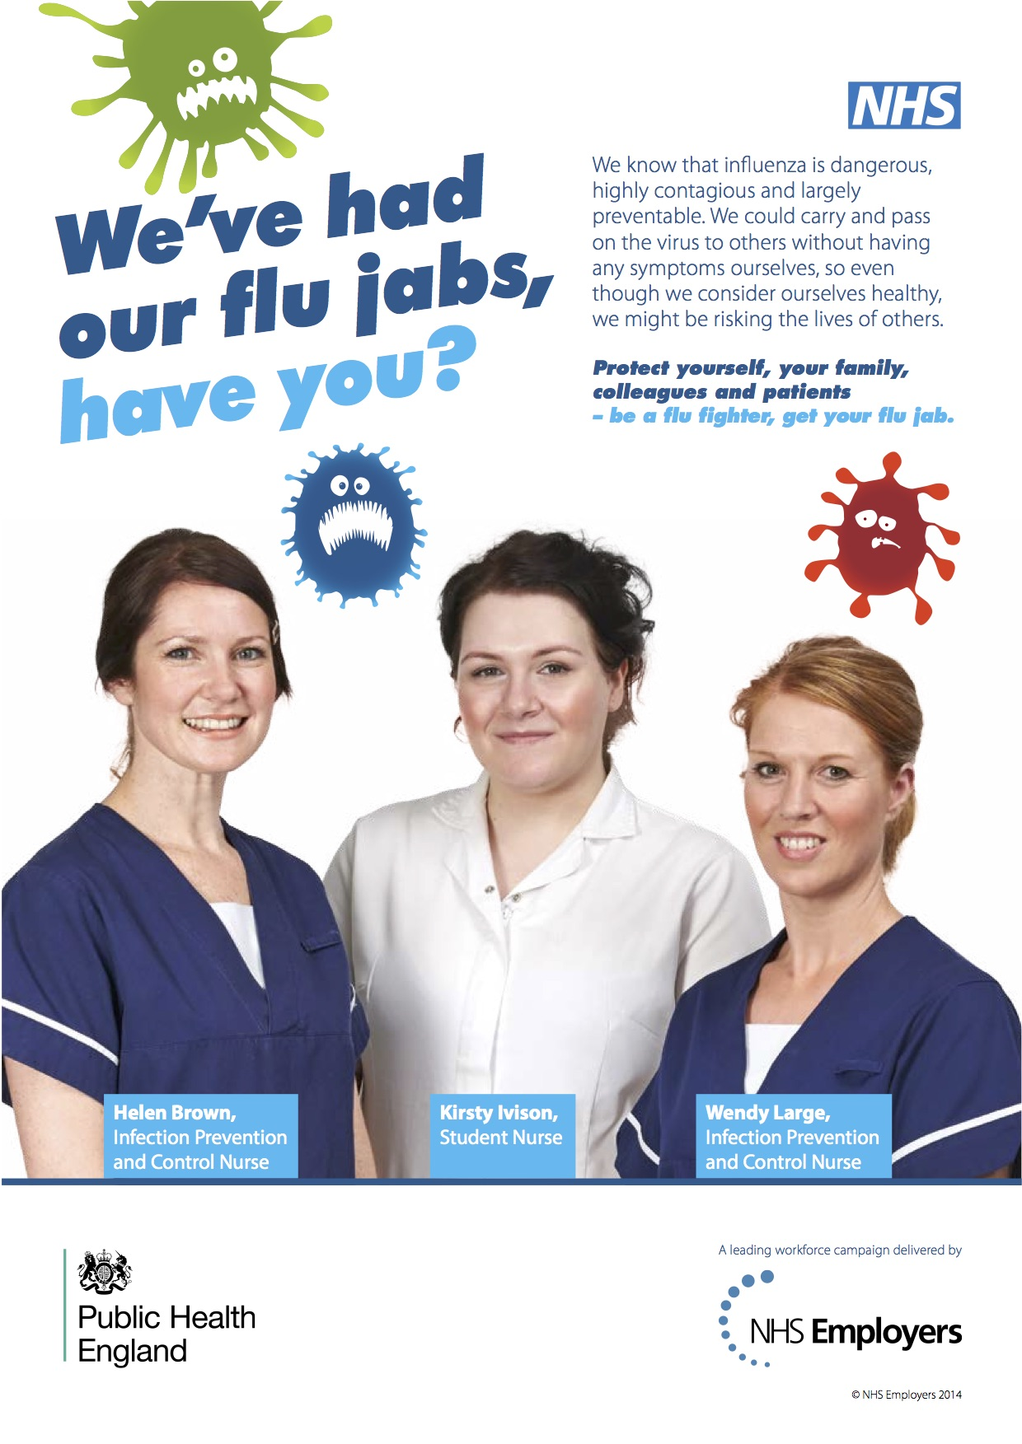

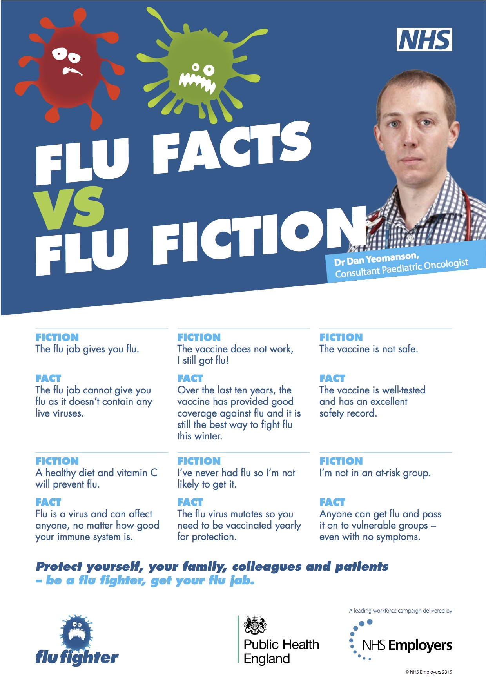

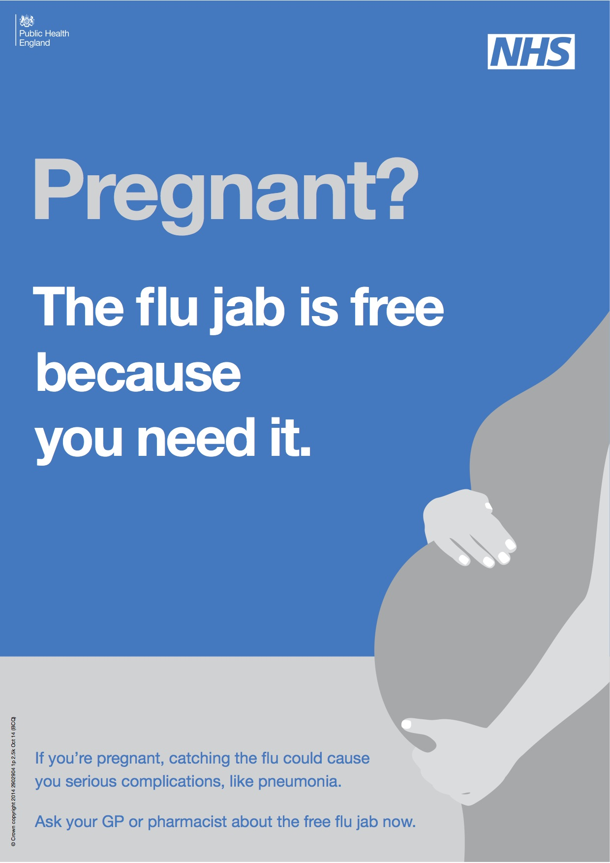

1. [NHS (E) Operating Framework for Managing the Response to Pandemic Influenza](https://www.england.nhs.uk/wp-content/uploads/2017/12/nhs-england-pandmic-influenza-operating-framework-v2.pdf)
2. [WHO – What is a pandemic?](https://www.who.int/csr/disease/swineflu/frequently_asked_questions/pandemic/en/)
3. [PHE guidance on use of antiviral agents for the treatment and prophylaxis of seasonal influenza](https://assets.publishing.service.gov.uk/government/uploads/system/uploads/attachment_data/file/773369/PHE_guidance_antivirals_influenza.pdf)
4. [NHS - Swine Flu H1N1](https://www.nhs.uk/conditions/swine-flu/)
5. <https://www.who.int/health-topics/coronavirus>
6. [Pandemic Influenza Response plan](https://www.gov.uk/government/publications/pandemic-influenza-response-plan)
7. [Operating Framework for Managing the Response to Pandemic Influenza](https://www.england.nhs.uk/wp-content/uploads/2017/12/nhs-england-pandmic-influenza-operating-framework-v2.pdf)
8. [PHE - COVID-19 Infection prevention and control guidance](https://www.gov.uk/government/publications/wuhan-novel-coronavirus-infection-prevention-and-control/wuhan-novel-coronavirus-wn-cov-infection-prevention-and-control-guidance)
9. <https://www.rcgp.org.uk/policy/rcgp-policy-areas/covid-19-coronavirus.aspx>
10. <https://www.hse.gov.uk/biosafety/diseases/pandflu.htm>
11. [Pandemic Influenza – A summary of guidance for infection control in healthcare settings](https://www.gov.uk/government/uploads/system/uploads/attachment_data/file/357401/Infection_control_in_healthcare_settings.pdf)
12. [COVID-19 IPC Guidance](https://www.gov.uk/government/publications/wuhan-novel-coronavirus-infection-prevention-and-control/wuhan-novel-coronavirus-wn-cov-infection-prevention-and-control-guidance#anchor)
13. <https://www.england.nhs.uk/wp-content/uploads/2020/04/Uniforms-and-Workwear-Guidance-2-April-2020.pdf>